
Flood Risk Assessment and Management Plan for the Meath CDP 2020-2026

SFRA Report

December 2019


County Hall
Navan
Meath

JBA Project Manager
Ross Bryant BSc MSc CEnv MCIWEM C.WEM
24 Grove Island
Corbally
Limerick
Ireland
Revision History
Revision Ref / Date Issued | Amendments | Issued to
v3.0 September 2019 | New draft SFRA (previous versions under 2013 MCDP) | Meath County Council
v4.0 October 2019 | Amended zonings | Meath County Council
V5.0 December 2019 | Additional amendments | Meath County Council
Contract
This report describes work commissioned by Meath County Council, by a Notice of Appointment dated 18 May 2017. Ross Bryant, Tim Cooke, Elizabeth Russell and Jonathan Cooper of JBA Consulting carried out this work.

Prepared by Ross Bryant BSc MSc CEnv MCIWEM C.WEM
Principal Analyst | Team Leader
Reviewed by Jonathan Cooper BEng MSc DipCD CEng MICE MCIWEM C.WEM MloD
Director
Purpose
This document has been prepared as an SFRA for Meath County Council.
Copyright
© JBA Consulting Engineers and Scientists Ltd 2019
Carbon Footprint
A printed copy of the main text in this document will result in a carbon footprint of 132g if 100% post-consumer recycled paper is used and 168g if primary-source paper is used. These figures assume the report is printed in black and white on A4 paper and in duplex.
JBA is aiming to reduce its per capita carbon emissions.

1 Introduction 1

1.1 SFRA Legacy in County Meath 1

1.2 Terms of Reference 1

1.3 Report Structure 1

2 The Planning System and Flood Risk Management Guidelines 3

2.1 Introduction 3

2.2 Definition of Flood Risk 3

2.3 Likelihood of Flooding 4

2.3.1 Consequences of Flooding 4

2.4 Definition of Flood Zones 4

2.5 Objectives and Principles of the Planning Guidelines 5

2.6 The Sequential Approach and Justification Test 6

2.7 Scales and Stages of Flood Risk Assessment 7

3 Settlements & Flooding 8

3.1 Data Collection Review 8

3.1.1 CFRAM Flood Outlines 10

3.1.2 Swan River Flood Risk Assessment 11

3.1.3 FEM FRAMS Flood Outlines 11

3.1.4 Tolka River Flooding Study & CFRAM update 11

3.1.5 Flood Risk Assessment and Management Study for the River Rye Water, Kilcock 11

3.1.6 Clonard Flood Mapping Study 12

3.1.7 Kilbride FRA 12

3.1.8 Newrath Stream Flood Study – Kells 12

3.1.9 The Mornington District Surface Water and Flood Protection Scheme 13

3.1.10 Ashbourne Flood Alleviation Scheme 14

3.1.11 Additional Modelling of the Brookside Stream (R151 culvert) - Laytown 14

3.1.12 Northlands Estate Flood Alleviation Study - Bettystown 14

3.1.13 National PFRA Study Flood Outlines 14

3.1.14 JFLOW® Flood Mapping 15

3.2 Flood Zone Mapping 15

3.2.1 Map Compilation 15

3.3 Sources of Flooding 19

3.3.1 Fluvial 19

3.3.2 Tidal and Coastal Flooding 19

3.3.3 Surface Water/Pluvial 19

3.3.4 Flooding from Flood Defence Overtopping or Breach 19

3.3.5 Climate Change 20

4 Flood Risk Management 22

4.1 Flood Risk Policies and Objectives 22

4.2 FEM FRAMS Recommendations 24

4.3 CFRAM Recommendations 25

4.4 Development Management and Flood Risk 28

4.5 Requirements for a Flood Risk Assessment 28

4.6 Drainage impact assessment 29

4.7 Development proposals in Flood Zone C 29

4.8 Applications for Developments in Flood Zone A or B 29

4.8.1 Minor Developments 29

4.8.2 Highly vulnerable development in Flood Zone A or B 30

4.8.3 Less vulnerable development in Flood Zone A or B 31

4.9 Key points for FRAs for all types of development 31

4.10 Incorporating Climate Change into Development Design 31

4.11 Flood Mitigation Measures at Site Design 32

4.11.1 Site Layout and Design 33

4.11.2 Ground levels, floor levels and building use 33

4.11.3 Raised Defences 34

5 Settlement Zoning Review 35

5.1 Land Use Zoning Objectives 35

5.2 Ashbourne 37

5.3 Athboy 39

5.5 Baile Gibb 41

5.6 Ballivor 42

5.7 Bettystown/ Laytown/ Mornington East/ Donacarney/ Mornington 43

5.8 Carlanstown 45

5.9 Carnaross 46

5.10 Clonard 47

5.11 Crossakeel 48

5.12 Donore 49

5.13 Drumconrath 50

5.14 Duleek 51

5.15 Dunboyne/ Clonee/ Pace 52

5.16 Dunshaughlin 54

5.17 Enfield 55

5.18 Gormanston 56

5.19 Julianstown 57

5.20 Kells 58

5.21 Kentstown 59

5.22 Kilbride 60

5.23 Kilcock Environs 61

5.24 Kildalkey 63

5.25 Kilmainhamwood 64

5.26 Kilmessan 65

5.27 Longwood 66

5.28 Maynooth Environs 67

5.29 Moynalty 68

5.30 Navan 69

5.31 Nobber 71

5.32 Oldcastle 72

5.33 Rathcairn 73

5.34 Rathmolyon 74

5.35 Ratoath 75

5.36 Slane 77

5.37 Southern Environs of Drogheda 78

5.38 Stamullen 79

5.39 Summerhill 80

5.40 Trim 81

List of Figures
Figure 2-1 Source Pathway Receptor Model 3
Figure 2-2 Sequential Approach Principles in Flood Risk Management 6
Figure 3-1 Settlement Map 8
Figure 3-2 Mornington District Surface Water and Flood Protection Scheme Design Drawing (now all built) 13

List of Tables
Table 1-1 Settlements contained within the MCDP 2020-2026 1
Table 2-1 Probability of Flooding 4
Table 2-2 Definition of Flood Zones 5
Table 2-3 Matrix of Vulnerability versus Flood Zone 6
Table 3-1 Model Data Available 9
Table 3-2 Other Data Available 10
Table 3-3 Model Data used in the Preparation of SFRA Flood Zone Maps 16
Table 3-4 Allowances for Future Scenarios (100 Year Time Horizon) 21
Table 4-1 Review of FEM FRAMS management report recommendations 26
Table 4-2 Review of CFRAM management plan (flood relief schemes) for Meath 27
Table 5-1 Land Zoning Objectives and Vulnerabilities 36

Abbreviations
1D One Dimensional (modelling)
2D Two Dimensional (modelling)
AEP Annual Exceedance Probability
AFA Area for Further Assessment
CFRAM Catchment Flood Risk Assessment and Management
DTM Digital Terrain Model
EPA Environmental Protection Agency
FEH Flood Estimation Handbook
FEM FRAMS Fingal East Meath Flood Risk Assessment and Management Study
FRA Flood Risk Assessment
FRMP Flood Risk Management Plan
FRR Flood Risk Review
FSU Flood Studies Update
GIS Geographical Information System
HEFS High End Future Scenario
HPW High Priority Watercourse
JFLOW 2-D hydraulic modelling package developed by JBA
LA Local Authority
MCC Meath County Council
MCDP Meath County Development Plan
MPW Medium Priority Watercourse
MRFS Medium Range Future Scenario
OPW Office of Public Works
OSi Ordnance Survey Ireland
PFRA Preliminary Flood Risk Assessment
SEA Strategic Environmental Assessment
SFRA Strategic Flood Risk Assessment
SPR Standard percentage runoff
Tp Time to Peak

Introduction
JBA Consulting was commissioned by Meath County Council (MCC) to provide assistance in the preparation of the Strategic Flood Risk Assessment (SFRA) to incorporate the Meath County Development Plan 2020-2026 (MCDP).
The SFRA is a live document that is designed to be updated as further flood risk information becomes available and changes to the development plan are proposed under any future variations.

SFRA Legacy in County Meath
The 2020 MCDP SFRA represents an update to Variation 3 of the 2013 MCDP, and it also incorporates SFRA content from the Navan Development Plan 2013, the Trim Development Plan 2014, the Kells Development Plan 2013 and the East Meath LAP 2014.

Terms of Reference
Under the "Planning System and Flood Risk Management" guidelines, the purpose for a Strategic Flood Risk Assessment (SFRA) is detailed as being "to provide a broad (wide area) assessment of all types of flood risk to inform strategic land-use planning decisions. SFRAs enable the LA to undertake the sequential approach, including the Justification Test, allocate appropriate sites for development and identify how flood risk can be reduced as part of the development plan process".
More specifically the SFRA will complete the following tasks;
- Undertake a flood risk assessment for the settlements within the MCDP,
- Review and update Flood Zone mapping to include the CFRAM mapping,
- Assist MCC in the review of land use zoning objectives and the application of the sequential approach and justification test;
- Prepare flood risk management policies, objectives and recommendations.
The settlements contained within the MCDP 2020-2026 are listed in Table 1-1 below.
Table 1-1 Settlements contained within the MCDP 2020-2026
Ashbourne | Dunshaughlin | Moynalty
Athboy | Enfield | Navan
Baile Gibb | Gormanston | Nobber
Ballivor | Julianstown | Oldcastle
Bettystown/Laytown/Mornington East /Donacarney/ Mornington | Kells | Rathcairn
Carlanstown | Kentstown | Rathmolyon
Carnaross | Kilbride | Ratoath
Clonard | Kilcock Environs | Slane
Crossakeel | Kildalkey | Southern Environs of Drogheda
Donore | Kilmainhamwood | Stamullen
Drumconrath | Kilmessan | Summerhill
Duleek | Longwood | Trim
Dunboyne/ Clonee/ Pace | Maynooth Environs | Rural Area

Report Structure
Section 2 of this report, provides an introduction to the Planning System and Flood Risk Management and covers important information on the philosophy and approach of the guidelines.
Section 3 provides a review of data collection, flood history and predicted flood extent (including climate change impacts) in each of the settlements.
Section 4, provides guidance and suggested approaches to managing flood risk and development; the contents of this section will be of particular use in informing the policies and objectives within the development plan.
Section 5 discusses development zoning and the Justification Test.

The Planning System and Flood Risk Management Guidelines

Introduction
Prior to discussing the management of flood risk, it is helpful to understand what is meant by the term. It is also important to define the components of flood risk in order to apply the principles of the Planning System and Flood Risk Management Guidelines in a consistent manner.
The Planning System and Flood Risk Management: Guidelines for Planning Authorities, published in November 2009, describe flooding as a natural process that can occur at any time and in a wide variety of locations. Flooding can often be beneficial, and many habitats rely on periodic inundation. However, when flooding interacts with human development, it can threaten people, their property and the environment.
This Section will firstly outline the definitions of flood risk and the Flood Zones used as a planning tool; a discussion of the principles of the planning guidelines and the management of flood risk in the planning system will follow.

Definition of Flood Risk
Flood risk is generally accepted to be a combination of the likelihood (or probability) of flooding and the potential consequences arising. Flood risk can be expressed in terms of the following relationship:
Flood Risk = Probability of Flooding x Consequences of Flooding

The assessment of flood risk requires an understanding of the sources, the flow path of floodwater and the people and property that can be affected. The source - pathway - receptor model, shown below in Figure 2-1, illustrates this and is a widely used environmental model to assess and inform the management of risk.
Figure 2-1 Source Pathway Receptor Model
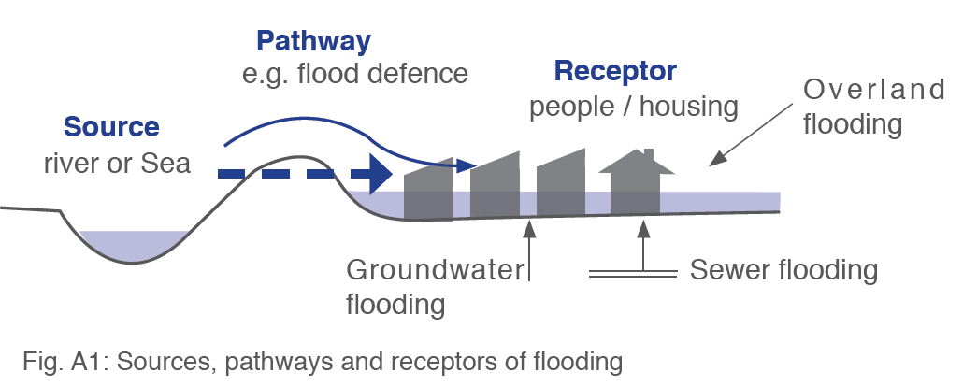
Source: Figure A1 The Planning System and Flood Risk Management Guidelines Technical Appendices

Principal sources of flooding are rainfall or higher than normal sea levels while the most common pathways are rivers, drains, sewers, overland flow and river and coastal floodplains and their defence assets. Receptors can include people, their property and the environment. All three elements must be present for flood risk to arise. Mitigation measures, such as defences or flood resilient construction, have little or no effect on sources of flooding but they can block or impede pathways or remove receptors.
The planning process is primarily concerned with the location of receptors, taking appropriate account of potential sources and pathways that might put those receptors at risk.

Likelihood of Flooding
Likelihood or probability of flooding of a particular flood event is classified by its annual exceedance probability (AEP) or return period (in years). A 1% AEP flood indicates the flood event that will occur or be exceeded on average once every 100 years and has a 1 in 100 chance of occurring in any given year.
Return period is often misunderstood to be the period between large flood events rather than an average recurrence interval. Annual exceedance probability is the inverse of return period as shown in Table 2-1.
Table 2-1 Probability of Flooding
Return Period (Years) | Annual Exceedance Probability (%)
2 | 50
100 | 1
200 | 0.5
1000 | 0.1

Considered over the lifetime of development, an apparently low-frequency or rare flood has a significant probability of occurring. For example:
- A 1% flood has a 22% (1 in 5) chance of occurring at least once in a 25-year period - the period of a typical residential mortgage;
- And a 53% (1 in 2) chance of occurring in a 75-year period - a typical human lifetime.

Consequences of Flooding
Consequences of flooding depend on the hazards caused by flooding (depth of water, speed of flow, rate of onset, duration, wave-action effects, water quality) and the vulnerability of receptors (type of development, nature, e.g. age-structure, of the population, presence and reliability of mitigation measures etc).
The Planning System and Flood Risk Management guidelines provide three vulnerability categories, based on the type of development, which are detailed in Table 3.1 of the Guidelines, and are summarised as:
- Highly vulnerable, including residential properties, essential infrastructure and emergency service facilities;
- Less vulnerable, such as retail and commercial and local transport infrastructure;
- Water compatible, including open space, outdoor recreation and associated essential infrastructure, such as changing rooms.

Definition of Flood Zones
In the Planning System and Flood Risk Management guidelines, Flood Zones are used to indicate the likelihood of a flood occurring. These Zones indicate a high, moderate or low probability of flooding from fluvial or tidal sources and are defined below in Table 2-2.

It is important to note that the definition of the Flood Zones is based on an undefended scenario and does not take into account the presence of flood protection structures such as flood walls or embankments. This is to allow for the fact that there is a residual risk of flooding behind the defences due to overtopping or breach and that there may be no guarantee that the defences will be maintained in perpetuity.

It is also important to note that the Flood Zones indicate flooding from fluvial and tidal sources and do not take other sources, such as groundwater or pluvial, into account, so an assessment of risk arising from such sources should also be made.
Table 2-2 Definition of Flood Zones
Zone | Description
Zone A  High probability of flooding. | This zone defines areas with the highest risk of flooding from rivers (i.e. more than 1% probability or more than 1 in 100) and the coast (i.e. more than 0.5% probability or more than 1 in 200).
Zone B  Moderate probability of flooding. | This zone defines areas with a moderate risk of flooding from rivers (i.e. 0.1% to 1% probability or between 1 in 100 and 1 in 1000) and the coast (i.e. 0.1% to 0.5% probability or between 1 in 200 and 1 in 1000).
Zone C  Low probability of flooding. | This zone defines areas with a low risk of flooding from rivers and the coast (i.e. less than 0.1% probability or less than 1 in 1000).

Objectives and Principles of the Planning Guidelines
The Planning System and Flood Risk Management Guidelines describe good flood risk practice in planning and development management. Planning authorities are directed to have regard to the guidelines in the preparation of Development Plans and Local Area Plans, and for development control purposes.
The objective of the Planning System and Flood Risk Management Guidelines is to integrate flood risk management into the planning process, thereby assisting in the delivery of sustainable development. For this to be achieved, flood risk must be assessed as early as possible in the planning process. Paragraph 1.6 of the Guidelines states that the core objectives are to:
- "avoid inappropriate development in areas at risk of flooding;
- avoid new developments increasing flood risk elsewhere, including that which may arise from surface run-off;
- ensure effective management of residual risks for development permitted in floodplains;
- avoid unnecessary restriction of national, regional or local economic and social growth;
- improve the understanding of flood risk among relevant stakeholders; and
- ensure that the requirements of EU and national law in relation to the natural environment and nature conservation are complied with at all stages of flood risk management".
The guidelines aim to facilitate 'the transparent consideration of flood risk at all levels of the planning process, ensuring a consistency of approach throughout the country.’ SFRAs therefore become a key evidence base in meeting these objectives.
The 'Planning System and Flood Risk Management' works on a number of key principles, including:
- Adopting a staged and hierarchical approach to the assessment of flood risk;
- Adopting a sequential approach to the management of flood risk, based on the frequency of flooding (identified through Flood Zones) and the vulnerability of the proposed land use.

The Sequential Approach and Justification Test
Each stage of the FRA process aims to adopt a sequential approach to management of flood risk in the planning process.
Where possible, development in areas identified as being at flood risk should be avoided; this may necessitate de-zoning lands within the development plan. If de-zoning is not possible, then rezoning from a higher vulnerability land use, such as residential, to a less vulnerable use, such as open space may be required.
Figure 2-2 Sequential Approach Principles in Flood Risk Management
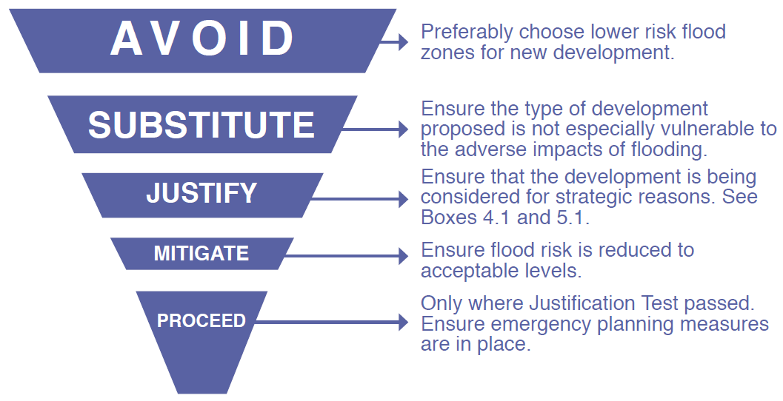
Source: The Planning System and Flood Risk Management (Figure 3.1)

Where rezoning is not possible, exceptions to the development restrictions are provided for through the application of the Justification Test. Many towns and cities have central areas that are affected by flood risk and have been targeted for growth. To allow the sustainable and compact development of these urban centres, development in areas of flood risk may be considered necessary. For development in such areas to be allowed, the Justification Test must be passed.
The Justification Test has been designed to rigorously asses the appropriateness, or otherwise, of such developments. The test is comprised of two processes; the Plan-making Justification Test, and the Development Management Justification Test. The latter is used at the planning application stage where it is intended to develop land that is at moderate or high risk of flooding for uses or development vulnerable to flooding that would generally be considered inappropriate for that land.
Table 2-3 shows which types of development, based on vulnerability to flood risk, are appropriate land uses for each of the Flood Zones. The aim of the SFRA is to guide development zonings to those which are 'appropriate' and thereby avoid the need to apply the Justification Test.
Table 2-3 Matrix of Vulnerability versus Flood Zone
 | Flood Zone A | Flood Zone B | Flood Zone C
Highly vulnerable development (Including essential infrastructure) | Justification Test | Justification Test | Appropriate
Less vulnerable development | Justification Test | Appropriate | Appropriate
Water-compatible development | Appropriate | Appropriate | Appropriate
Source: Table 3.2 of The Planning System and Flood Risk Management

The application of the Justification Test in the context of specific development sites within the settlements is discussed in Section 5.

Scales and Stages of Flood Risk Assessment
Within the hierarchy of regional, strategic and site-specific flood-risk assessments, a tiered approach ensures that the level of information is appropriate to the scale and nature of the flood-risk issues and the location and type of development proposed, avoiding expensive flood modelling and development of mitigation measures where it is not necessary. The stages and scales of flood risk assessment comprise of:
- Regional Flood Risk Appraisal (RFRA) – a broad overview of flood risk issues across a region to influence spatial allocations for growth in housing and employment and to identify where flood risk management measures may be required at a regional level to support the proposed growth. This should be based on readily derivable information and undertaken to inform the Regional Planning Guidelines.
- Strategic Flood Risk Assessment (SFRA) – an assessment of all types of flood risk informing land use planning decisions. This will enable the Planning Authority to allocate appropriate sites for development, whilst identifying opportunities for reducing flood risk. This SFRA will revisit and develop the flood risk identification undertaken in the RFRA, and give consideration to a range of potential sources of flooding. An initial flood risk assessment, based on the identification of Flood Zones, will also be carried out for those areas zoned for development. Where the initial flood risk assessment highlights the potential for a significant level of flood risk, or there is conflict with the proposed vulnerability of development, then a site specific FRA will be recommended, which will necessitate a detailed flood risk assessment.
- Site Specific Flood Risk Assessment (FRA) – site or project specific flood risk assessment to consider all types of flood risk associated with the site and propose appropriate site management and mitigation measures to reduce flood risk to and from the site to an acceptable level. If the previous tiers of study have been undertaken to appropriate levels of detail, it is highly likely that the site specific FRA will require detailed channel and site survey, and hydraulic modelling.

Settlements & Flooding
This section reviews the data collection and flood history for the settlements so that any additional information on flooding can be included within this SFRA. It will confirm the extent of extreme flooding (through the Flood Zone mapping), key sources of flood risk and discuss the potential impacts of climate change.
Figure 3-1 Settlement Map
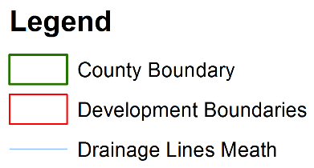
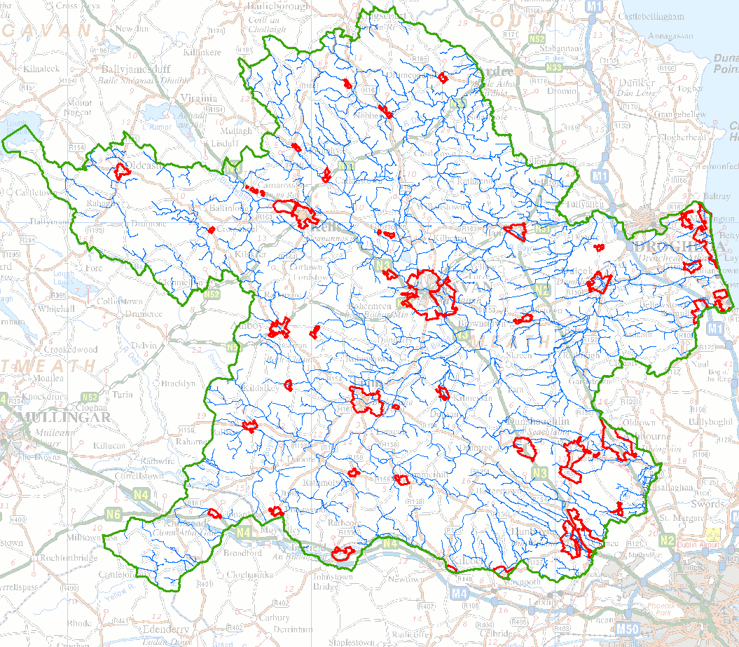
©Ordnance Survey Ireland.
All rights reserved. Licence number 2019/31/CCMA Meath County Council

Data Collection Review
There are a number of valuable sources of flood data for County Meath, including major projects such as the CFRAM, Fingal East Meath FRAMS and broadscale flood mapping such as the national PFRA study. Table 3-1 and Table 3-2 (over page) list the datasets used to compile the flood mapping for the settlements and LAPs and give an assessment of the data quality and the confidence in its accuracy. The sources of information from the previous iterations of the SFRAs have been reviewed and relevant updates have been added/reviewed from the CFRAM flood mapping and the Tolka Flood Study mapping.
Table 3-1 Model Data Available
Description | Coverage | Quality | Confidence | Used
CFRAM Flood Mapping | Countrywide - specific settlements | High | High | Yes
FEM FRAMS Flood Outlines | Fingal East Meath - specific settlements | High | High | Yes
Tolka River Flooding Study – updated to CFRAM | Tolka - Dunboyne, Clonee, Pace | High | High | Yes
Flood Risk Assessment and Management Study for the River Rye Water - Kilcock | Kilcock | High | High | Yes with current CFRAM maps
Clonard Flood Mapping Study | Clonard | High | High | Yes
Swan River FRA | Balreask – Navan | High | High | Yes, included in CFRAM
Kells Flood Mapping Study | Kells (Newrath Stream) | High | High | Yes
Kilbride FRA | Kilbride | High /Moderate | High /Moderate | Yes
Newrath Stream Flood Mapping Study | Kells | High | High | Yes
Mornington District Surface Water and Flood Protection Scheme | Bettystown & Mornington East | High | High | Yes
Ashbourne Flood Relief Scheme | Ashbourne | High | High | Yes
Brookside Stream Mapping Study - Laytown | Laytown | High | High | Yes
National PFRA Study Flood Outlines | Countywide | Moderate | Moderate | Yes
JFLOW® Flood Mapping | Countywide | Moderate | Moderate | Yes
Eastern CFRAM FRR and North West Neagh Bann CFRAM FRR (Verified PFRA) | Countywide | Moderate | Moderate | Yes

Table 3-2 Other Data Available
Description | Coverage | Quality | Confidence | Used
Regional Flood Risk Appraisal | Midlands and South East Region | Moderate (but broadscale) | Low | Reviewed
Alluvial Soil Maps | Full Study Area | Moderate | Low | Used in the RFRA to provide initial assessment
Groundwater vulnerability maps | Broadscale, County wide | Moderate | Low | Initial assessment of groundwater vulnerability.
Historic Flood Records including photos, aerial photos and reports. | Broad, spot coverage | Various | Various | Yes, indirectly to validate Flood Zones & identify other flood sources
Historic Flood Outlines | Tolka River | Unknown | Unknown | Yes, indirectly to validate Flood Zones
Benefiting Land Maps and Drainage Districts | Whole county | Low | Low | Indirectly to validate modelled outlines.
Walkover Survey | Selected locations | Moderate | Low | Yes, to validate outlines at key settlements

A description of the main modelling datasets is given in the following sections. This data has been reviewed and combined in order to form Flood Zone mapping for the settlements. More information on how the Flood Zone mapping is compiled is given in Section 3.2.

CFRAM Flood Outlines
In 2011 the OPW commenced appointment of consultants to carry out a more detailed flood risk assessment on key flood risk areas. This work was undertaken under the national CFRAM programme across seven river basin districts in Ireland. The CFRAM programme commenced with three pilot studies covering the River Lee, Fingal East Meath area and the River Dodder. A further 6 studies were carried out in the East, South-East, South-West, West and the combined North-West and Neagh-Bann regions.
County Meath mainly falls within the Eastern CFRAM (E CFRAM) area, with parts also within the study areas of the Fingal East Meath (FEM FRAMS), the North West and Neagh-Bann CFRAM (NWNB CFRAM) and the Shannon CFRAM. The FEM FRAMS was a pilot study that has been completed and detailed model output and flood maps are available for this area (see Section 3.1.3below). The initial Flood Risk Review (FRR) stage of the Eastern and North-West and Neagh-Bann CFRAM included a site-based review of the PFRA flood outlines at a number of settlements. Following this review, any sites recommended as an Area for Further Assessment (AFA) were included in the subsequent detailed assessment stage of each CFRAM study.

Swan River Flood Risk Assessment
The Swan River Flood Risk Assessment study was commissioned by Meath County Council to assess flood risk associated with the Swan River. The initial study assessed current flooding and was followed by a scenario impact analysis which looked at measures to alleviate flooding upstream of the old railway embankment. Options proposed included the replacement of under-capacity culverts and the construction of flood defences. Modelled flood extents, representing the existing flood scenario, were used to inform the preparation of the county wide flood zone map in the SFRA for the County Development Plan. The culvert upgrading works are now complete and offer a 1 in 100 year standard of protection for the Balreask Manor Estate. However, under the Planning Guidelines, the flood zones consider an ‘undefended’ scenario, and red hatching has been used to identify the area benefitting from the Swan River defences in the Flood Zone maps. The modelling study originally carried out for the Swan River FRA has been re-modelled under the Eastern CFRAM and CFRAM mapping has been provided by the OPW and used in the compilation of the Flood Zone mapping for this watercourse. The CFRAM uses linked 1D-2D hydraulic modelling, detailed hydrological analysis and mapping is composed using LiDAR data.

FEM FRAMS Flood Outlines
Fingal County Council, along with project partners MCC and the Office of Public Works (OPW), commissioned the Fingal East Meath Flood Risk Assessment and Management Study (FEM FRAMS) in 2008 to investigate the high levels of flood risk in the Fingal East Meath area. The study included detailed hydraulic modelling of 23 rivers and streams, 3 estuaries and the Fingal and Meath coastline. The watercourses are defined as High Priority Watercourses (HPW) or Medium Priority Watercourses (MPW) and modelled in according detail. The FEM FRAMS models developed consist of 1D river models, 1D-2D linked models and 2D coastal models. The model results were used to map flood outlines for a range of scenarios, including the current and future, defended and undefended scenarios.

Tolka River Flooding Study & CFRAM update
The Tolka study was commissioned by Dublin City Council, in association with Fingal County Council, Meath County Council and the Office of Public Works (OPW) in 2002. The recommendations for the flood relief scheme have now been constructed and protect a significant area in and around the Dunboyne, Clonee, Pace settlement. The standard of protection offered by the scheme is stated by OPW as the 1% AEP (1 in 100 year) based on design flows calculated in 2002.
Given the age of the mapping and the more recent construction of the M3 motorway a new flood study was commissioned by the OPW and Meath County Council to upgrade the flood mapping to CFRAM standard (full 1D-2D linked modelling and review of hydrology). The work took place in 2018/19 and the results of the new study have been incorporated into the Flood Zone mapping for the MCDP.

Flood Risk Assessment and Management Study for the River Rye Water, Kilcock
The River Rye Water study was commissioned by a consortium of landowners in Kilcock, It assessed the existing and future flood risk in the area and proposed a flood relief scheme to consist of walls, embankments and storage areas. The scheme has been approved by OPW, Kildare County Council and Meath County Council and has been granted planning permission by An Bord Pleanála. Those parts of the scheme in County Meath are practically completed. The CFRAMS study for Kilcock has also been published, however finalised Flood Zones for the scheme are not yet available.

Clonard Flood Mapping Study
The Clonard settlement was not included within the Eastern CFRAM Study and so the only flood mapping available for the settlement is the PFRA/JFlow flood mapping. Given the low confidence in these flood maps, the decision was taken for JBA to model the settlement using a 1D/2D model of the Clonard River catchment utilising the hydraulic modelling program ISIS/TUFLOW. The Clonard River is part of the Boyne catchment and flows in an easterly direction for approximately 20km from source to the town of Clonard, the channel is part of an Arterial Drainage Scheme and is managed by the OPW.
A 5m Digital Terrain Model (DTM) of the settlement area and surrounding land was provided by Meath County Council and was used as the basis of the 2D model. This was augmented with river channel survey data collected on site by a qualified surveyor. Flows were estimated using the Flood Studies Update (FSU) interval which was deemed the most appropriate based on the catchment areas. The resulting analysis provided Flood Zone outlines for the 1 in 100 year and 1 in 1000 year return period flow events (Flood Zone A and B). The analysis represents an increase in the confidence of the Flood Zones compared to OPW PFRA/JFlow outlines.

Kilbride FRA
Kilbride was previously covered by PFRA mapping which has been updated by a recent FRA using a more detailed approach. This new study was modelled using a 1D-2D hydraulic model. It allows for the modelling of river channels, streams, floodplains and hydraulic structures to predict water levels for a range of scenarios.
A 1D ESTRY model of the Ward River was created using a DTM and river channel survey data. A range of flow estimation methods were investigated and final flows were adopted from the conservative FSR Rainfall Runoff method. The existing structure (Den Bridge) at Kilbride Road was inserted into the model and hydraulic simulations were run to derive the existing flood extent to determine Flood Zones A, B and C at the site. The analysis represents an increase in the confidence of the Flood Zones compared to OPW PFRA outlines.

Newrath Stream Flood Study – Kells
The assessment of flood risk on the Newrath Stream had previously been undertaken in some detail by the Kells Stormwater Drainage Study. The former model was made available for use in the SFRA by Meath County Council and was subject to a thorough review by JBA to assess potential use in the production of Flood Zone mapping in line with current best practise.
The model review noted the following issues regarding update for use in 2013:
- The model did not represent a fully hydrodynamic model solution and contained some instabilities. As such the model required updates to include for full hydrographs and a hydrodynamic model solution in order to appropriately consider the attenuation and conveyance of flow volumes through the system.
- Many of the model cross sections did not extend across the full width of the floodplain and OSi LiDAR data was used to extend the cross sections to the appropriate width.
- Manning's N values were reviewed and subsequently increased.
- The representation of the Bective Street culvert was that prior to the current HSE building (former car showroom) and significant extension to the Bective Street culvert has since been constructed. As built details of the culvert extension were provided and the culvert is now fully represented.
- The model did not accurately represent the surcharging and potential bypassing of flow at the 650mm culvert close to the swimming pool. As a result an ISIS spill unit was added and the volume of surcharging flow was used to run a 2D model (JFLOW) representation of the resulting overland flow paths.
- The lengthy 650mm culvert did not include for a key stormwater inflow midway along its length. A hydrological input location was added to represent this.
With the above alterations in place the revised ISIS-TuFLOW models have been used to derive flood extents for the Newrath Stream.
ISIS is a one dimensional (1D) open channel and culverted flow simulation hydraulic model that allows the accurate representation of complex structures such as found along the Newrath Stream. TuFLOW has been used in combination with ISIS to provide an accurate estimation of the overland flow routes which in combination provide revised Flood Zone extents for the Newrath Stream.
The quality of data used for the model run is good. The impact of culvert capacity is the main trigger for flooding on the Newrath Stream and the model updates described above fully take the impacts of the respective culverts into account in a robust and comprehensive manner. The result is that the combined ISIS-TuFLOW model represents flood extents with greater detail and accuracy than any of the former studies and provide the best available information currently available for Kells.

The Mornington District Surface Water and Flood Protection Scheme
The study was commissioned to investigate the potential mitigation of Mornington East from the impacts of fluvial and tidal flooding. It was completed to feasibility phase in 2003 and has subsequently been constructed.
The scheme is now fully operational and offers significant benefits to existing development and has a design standard of 1 in 200 years for the tidal influence and 1 in 100 years for the fluvial sections of the watercourse. The flood mapping includes a hatched area that represents the area benefitting from defences.
Figure 3-2 below displays a design drawing indicating the extent of flood defences along the Mornington Stream. Formal protection begins on the watercourse in Bettystown, adjacent to Eastham House. The defences then continue downstream beyond the last of the existing properties in Mornington East, prior to the confluence with the River Boyne Estuary. The scheme has been re-modelled as part of the OPW CFRAM mapping and an additional scheme in Mornington was recommended to manage flood risk, this is part of the first 50 schemes to be progressed under the €1bn ten year programme of investment by the government.
Figure 3-2 Mornington District Surface Water and Flood Protection Scheme Design Drawing (now all built)
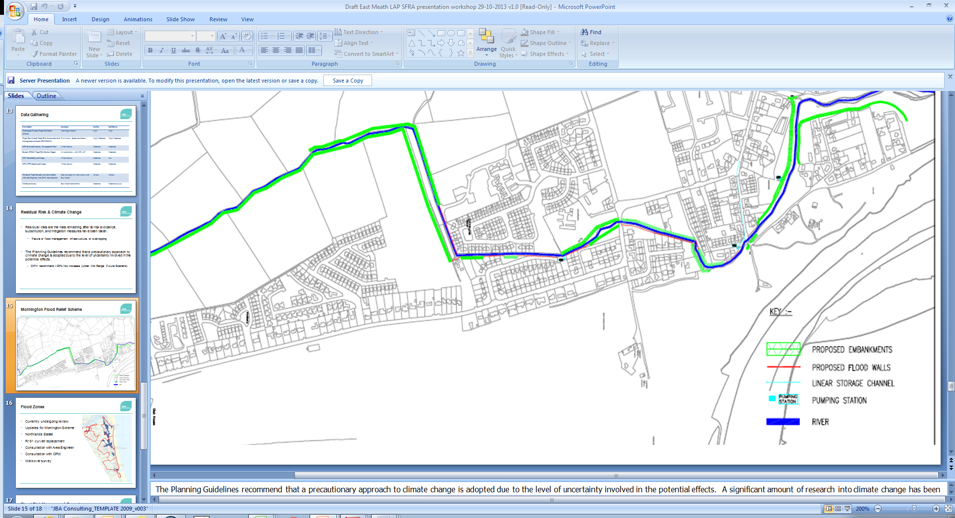
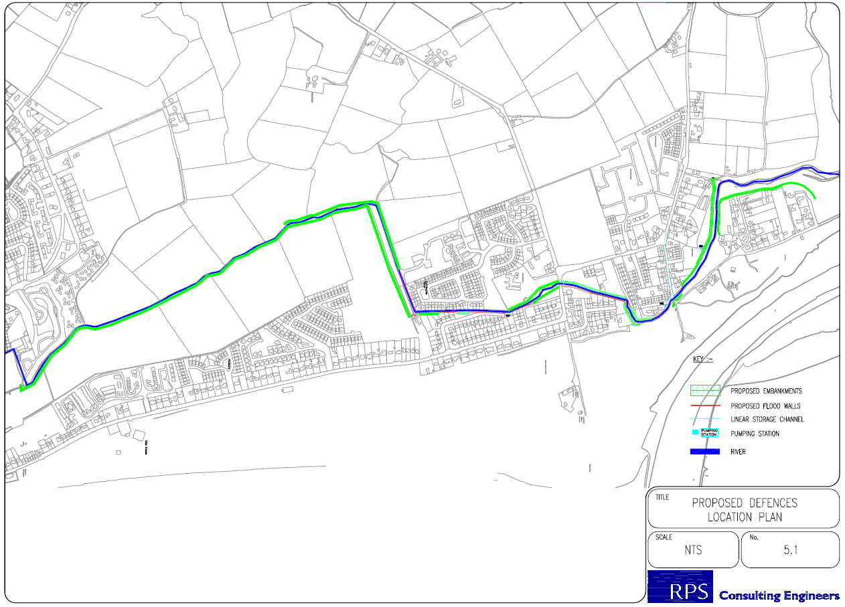
North

Ashbourne Flood Alleviation Scheme
Ashbourne is the subject of a flood alleviation scheme that is due for completion prior to the end of 2020. The alleviation scheme resulted in re-modelling of the watercourses within Ashbourne and the pre-scheme flood mapping has been used in the consideration of the Flood Zones.

Additional Modelling of the Brookside Stream (R151 culvert) - Laytown
The Brookside Stream was originally included within the FEM FRAMS study and identified the R151 culvert as being a constriction point that causes high upstream water levels.
The R151 culvert has since been replaced with a 1.5m diameter concrete pipe and this has greatly increased the capacity of the culvert. The impact of the increase in culvert size has been modelled using a 1D hydraulic model and results are incorporated in the Flood Zone mapping. Channel capacity upstream of the R151 is significant and flood extents have reduced accordingly.

Northlands Estate Flood Alleviation Study - Bettystown
Following flooding in late 2001 a scheme reducing flood risk to the Northlands Estate in Bettystown was completed. The latest CFRAM maps do not include any proposed defended area for the scheme.

National PFRA Study Flood Outlines
The Preliminary Flood Risk Assessment (PFRA) is a national screening exercise that was undertaken to identify areas at potential flood risk. The PFRA is a requirement of the EU Floods Directive and the publication of this work has led to, and has informed, more detailed assessment, which is being undertaken as part of the Catchment Flood Risk Assessment and Management (CFRAM) studies. The PFRA study considered flooding from a number of sources, including fluvial, tidal, pluvial and groundwater, and resulted in a suite of broadscale flood maps.
For the preparation of the PFRA fluvial flood maps, flood flow estimates were calculated at nodes every 500m intervals along the entire river network. The river network is the EPA 'blue-line' network, which, for the most part, matches the rivers mapped at the 1:50,000 scale Discovery Series OS mapping. This flow estimation was based on the OPW Flood Studies Update research programme. An assumption was made that the in-channel flow equates to the mean annual flood and so the out of bank flow for a particular AEP event was determined by deducting the mean annual flood from the flood flow estimate for that probability event.
Using the OPW's 5m national digital terrain model (DTM) a cross section was determined at 100m spacings. The Manning's equation, a hydraulic equation for normal flow was used to calculate a flood level which was then extrapolated across the DTM to determine the flood extent. This exercise was completed for all river catchments greater than 1km2.
This methodology does not take into account defences, channel structures or channel works. Potential sources of error in the mapping include local errors in the DTM or changes to the watercourse flow route due to an error in mapping or new development.
The PFRA mapping was completed as part of a desk based study and was put on display for public consultation and comment. A site based review of the PFRA, at selected sites, was undertaken at the early stages of the National CFRAM programme through the Flood Risk Review (FRR). In County Meath at selected Flood Risk Review Sites, the PFRA outlines have been reviewed and verified by RPS Consulting as part of the Flood Risk Review stage of the Eastern CFRAM and by JBA Consulting as part of the Flood Risk Review for the North-West and Neagh-Bann CFRAM. The verification process involved site walkover and review of historical flood data, and in some case resulted in refinements being made to the 'raw' PFRA outlines. The review of the PFRA outlines is in accordance with Circular PL 2/2014.

JFLOW® Flood Mapping
JBA developed software, known as JFLOW® to undertake multi-scale two dimensional hydraulic fluvial and tidal flood modelling. As with the PFRA method, the fluvial flood mapping process involved two stages; hydrology and hydraulic modelling. JBA developed in-house software tools to interpolate catchment descriptors from a number of environmental datasets and produced an automated method for calculating design flows. The method used to calculate flows was based on the Flood Estimate Handbook (FEH) Statistical Method and is in line with the methods of the Flood Studies Update (FSU). Index flows were generated at 300m intervals along the entire river network. Annual Maximum flow data from the OPW Hydrodata website was used to adjust the index flows by allocating 'donor' gauges, whereby local gauges are used to compare and adjust index flows for a given catchment. Pooled data was used to generate growth curves and determine flood flows for different return periods.
Cross sections were generated at each inflow point to define the extent of the area over which to route the flow. Flow was routed over a digital terrain model based on the OSi national 10m height model, with updated height data in over 30 urban areas. This process was undertaken for all river catchments greater than 10km2 and in some urban areas, including Drogheda and Dunboyne in Co. Meath, greater than 3km2.
JFLOW® results were subject to several iterations of manual checking and model re-runs. However, the accuracy of the flood mapping is directly correlated to the DTM and individual flow structures such as bridges, culverts, weirs and sluices are not explicitly modelled.
For the settlement of Kilmessan JFlow was run using improved quality OPW DTM and flow estimates derived using the OPW FSU methodology. The increased data quality increases the confidence in the Flood Zone mapping compared to other sites represented by JFlow derived Flood Zone mapping. The confidence in the mapped results is still moderate.

Flood Zone Mapping
The various sources of data are available and were used to update the countywide flood map originally presented in SFRAs for the various previous SFRAs undertaken for former development plans.
Updates to the Flood Zone map under the 2020-2026 MCDP were only undertaken where there have been significant changes in the base information, this is in Athboy, Ballivor, Clonard, Drogheda SE, Dunboyne Clonee Pace, Kilbride, Kilcock, Longwood, Maynooth Environs, Navan, Kells, Slane, Trim, and within the East Meath LAP. Dunboyne Clonee Pace was completed as part of a CFRAM upgrade to the Tolka Study. Clonard was completed under a commission by Meath County Council and Kilbride under a separate site specific FRA. The remaining settlements were updated by finalised CFRAM mapping. The revised flood mapping is presented in Section 5.

Map Compilation
Table 3-3 lists the settlements within the MCDP, identifies the source of modelled data available within each settlement, indicates where a site walkover was carried out and comments on the data used to define the Flood Zones for the purposes of this SFRA.
In Table 3-3, settlements that have been subject to revised mapping under the MCDP 2020-2026 are displayed in bold.

Table 3-3 Model Data used in the Preparation of SFRA Flood Zone Maps
LOCATION | FEM | OTHER MODEL | CFRAM | PFRA | JFLOW | SITE VISIT | SOURCE OF SFRA FLOOD ZONE MAPPING | COMMENT ON FLOOD HISTORY | SUMMARY OF MAIN FLOOD SOURCE(S)
Ashbourne | Y |  |  | Y | Y | Y | FEM FRAMS – updated for the flood relief scheme, OPW PFRA and JBA site visit. | Flooding occurred in August 1986 and November 2002. Gauge data for the events are available. | FLUVIAL
Athboy |  |  | Y | Y | Y | Y | CFRAM mapping verified on site by JBA. | Minor surface water issue on N51, flooding noted in Castletown (outside settlement boundary) Aug 2008. Athboy River subject to OPW arterial drainage scheme and FRR notes channel capacity may be as high as 1% AEP (1 in 100 years). | FLUVIAL & SURFACE WATER
Ballivor |  | Y | Y | Y | Y | Y | CFRAM mapping verified on site by JBA. | No flooding within urban area but a record of flooding to the southeast in Clonycavan occurred after prolonged rainfall in the Boyne Catchment. Possible residual risk of flooding culvert/bridge blockage. | FLUVIAL
Bettystown |  | Y | Y | Y | Y | Y | CFRAM mapping – as updated from the FRS model. | Flooding from the Mornington Stream has been recorded. Most recently Oct 2011 and flooding of the Northlands Estate. | FLUVIAL/TIDAL
Carlanstown |  |  |  | Y | Y | Y | Based on site walkover, PFRA outlines used in mapping | No historic records of flooding were found. | FLUVIAL
Carnaross |  |  |  |  |  |  | No significant fluvial flood risk identified. | No historic records of flooding were found.
Clonard |  |  |  | Y | Y | Y | Revised Flood Zone mapping using JFlow with improved DTM and FSU hydrology, site visit to assist verification. | No historic records of flooding were found. | FLUVIAL
Crossakiel |  |  |  |  |  |  | No significant fluvial flood risk identified. | No historic records of flooding were found.
Donacarney |  |  |  |  |  |  | No significant fluvial flood risk identified. | No flood history within the settlement boundary.
Drogheda Southern Environs |  |  | Y | Y | Y | Y | CFRAM mapping verified on site by JBA. | History of recurring flooding at Elmwood/McEvoy’s road, the R152, the Dublin Road and at Colp West. | FLUVIAL
Donore |  |  |  |  |  |  | No significant fluvial flood risk identified. | No flood history within the settlement boundary. | FLUVIAL
Drumconrath |  |  |  | Y | Y | Y | Map adjusted based on flood history and JFLOW outlines | Flooding reported in 1993, 2008 and 2011. Four private houses and a community centre flooded. | FLUVIAL
Duleek | Y |  |  | Y | Y | Y | FEM FRAMS and OPW PFRA | Flood event recorded in October 1993 from the River Nanny. Flood relief scheme carried out. | FLUVIAL
Dunboyne Clonee Pace |  | Y |  | Y | Y | Y | Tolka Flood Study, Flood Risk Review (PFRA), JFlow and JBA site visit. | Flooding from the River Tolka in November 2000 and November 2002. | FLUVIAL
Dunshaughlin | Y |  |  | Y | Y | Y | FEM FRAMS, OPW PFRA and JBA site visit. | Flooding event occurred in November 2000 from a tributary to the River Boyne. | FLUVIAL
Enfield |  |  |  |  |  | Y | Drainage channel to the east of the settlement inspected and flood outline estimated. | Flooding after heavy rainfall recurs. | FLUVIAL & SURFACE WATER
Gibbstown |  |  |  |  | Y |  | No significant fluvial flood risk identified. | No historic records of flooding were found.
Gormanstown | Y |  |  | Y | Y |  | FEM FRAMS | History of recurring flood event at Martin's Road. Cause of flooding sites as flat land with no drainage and therefore liable to flooding after prolonged rainfall. | FLUVIAL & SURFACE WATER
Julianstown | Y |  |  | Y | Y | Y | FEM FRAMS | Reports of recurring flooding in the reach between Julianstown and Beaumont. Flood waters from the River Nanny over onto floodplain 2-3 times per year. | FLUVIAL
Kells |  | Y |  | Y | Y | Y | JBA detailed modelling study (1D-2D) used to create Flood Zones. | Newrath Stream results in flooding of backlands and overland flow route downstream of an undersized culvert upstream of the church. Surface water flooding also. | FLUVIAL & SURFACE WATER
Kentstown | Y |  |  | Y | Y |  | FEM FRAMS | Reports of historic flooding from the River Nanny (impacting roads not houses). Recurring road flooding related to minor local drainage issue. | FLUVIAL & SURFACE WATER
Kilbride |  | Y |  | Y | Y | Y | JBA detailed modelling study (1D-2D) used to create Flood Zones. | One historic flood event, out of bank flows noted upstream of village. | FLUVIAL
Kilcock |  | Y | Y | Y | Y | Y | CFRAM mapping verified on site by JBA. Flood Risk Assessment & Management (FRAM) Study for River Rye Water.. | Recurring flooding from the River Rye Water is noted, along with events in November 2000 and August 2008.Flood defences have been constructed in County Meath. Flood Zone mapping for the scheme is not yet available. | FLUVIAL
Kildalkey |  |  |  | Y | Y |  | Eastern CFRAM Flood Risk Review (PFRA) | No historic records of flooding were found. | FLUVIAL
Kilmainhamwood |  |  |  | Y | Y |  | Verified PFRA from NWNB CFRAM FRR - Not subject to further CFRAM modelling. | Four residential properties recently flooded and remedial work (dredging) has been carried out on the watercourse by OPW. Local pluvial flooding noted near to football pitch. | FLUVIAL & SURFACE WATER
Kilmessan |  |  | Y | Y | Y | Y | Revised Flood Zone mapping using JFlow with improved DTM and FSU hydrology, site visit to assist verification. | Reports of recurring flood event from a stream to the north. Record states this occurs annually. Flood event in 2008 affected 1 property. | FLUVIAL
Laytown |  | Y | Y | Y | Y | Y | CFRAM mapping – as updated from the FRS model, and model of Brookside Stream. | Mouth of Nanny River subject to recurring flooding, some tidal flooding along coastline, but for most part inland levels are significant and risk is low. | FLUVIAL:/TIDAL
Longwood |  | Y | Y | Y | Y | Y | CFRAM mapping verified on site by JBA. Previous JBA model and mapping is superseded. | No history of flooding with the urban area of Longwood but a record of flooding recurring in Moyvalley. Possible residual risk of flooding culvert/bridge blockage. | FLUVIAL
Mornington |  |  | Y | Y | Y | Y | CFRAM mapping verified on site by JBA. | Limited flood history, likely surface water recurring (after heavy rainfall). | FLUVIAL/TIDAL & SURFACE WATER
Mornington East |  |  | Y | Y | Y | Y | CFRAM mapping verified on site by JBA. | Recurring surface water flooding and flooding from high tidal levels in Nov 2000. | FLUVIAL/TIDAL & SURFACE WATER
Maynooth Environs |  |  | Y | Y | Y | Y | CFRAM mapping verified on site by JBA. | A record of a flood event in November 2000 is noted. The source is the floodwater is the River Rye Water. | FLUVIAL
Moynalty |  |  |  | Y | Y | Y | Based on site walkover, JFLOW modified and used in mapping | Historic flooding from the Moynalty River is noted in 2009 and recurring. | FLUVIAL
Navan |  |  | Y | Y | Y | Y | CFRAM mapping verified on site by JBA. | Significant flood history in Navan from Swan River & Rivers Boyne/Blackwater. Significant events in 2013, 2009, 2008, 2002, 2000. | FLUVIAL
Nobber |  |  |  | Y | Y | Y | Based on site walkover, JFLOW outlines used in mapping with additional PFRA watercourses included | The River Dee is noted as causing flooding, as is the tributary entering the River Dee from the north east. | FLUVIAL
Oldcastle |  |  |  |  |  | Y | No significant fluvial flood risk identified. | Recurring surface water flooding on Store Road. | SURFACE WATER
Rathcairn |  |  |  |  |  |  | No significant fluvial flood risk identified. | No historic records of flooding were found.
Rathmolyon |  |  |  |  |  |  | No significant fluvial flood risk identified. | Recurring flood event on the R156 road to Cherryvalley. | SURFACE WATER
Ratoath | Y |  |  | Y | Y | Y | FEM FRAMS, OPW PFRA and JBA site visit. | No records of flooding were found. | FLUVIAL
Slane |  |  | Y | Y | Y | Y | CFRAM mapping verified on site by JBA. | History of flood events in February 1990, November 2000 and November 2002. Also, there is a recurring flood event at St. Patricks Terrace due to inadequate drainage. | FLUVIAL & SURFACE WATER
Stamullen | Y |  |  | Y | Y |  | FEM FRAMS | The River Delvin is recorded as overflowing its banks 2-3 times per year after heavy flooding. The road is also liable to flooding | FLUVIAL
Summerhill |  |  |  |  |  | Y | No significant fluvial flood risk identified. | Reports of a flooding event in August 2008. The source is this event was the River Moynalvy. | FLUVIAL
Trim |  |  | Y | Y | Y | Y | CFRAM mapping verified on site by JBA. | Significant flooding from the River Boyne in the centre of the town has been recorded for over 100 years. | FLUVIAL & SURFACE WATER

Sources of Flooding
Table 3-3 on the previous pages has identified the main sources of flood risk to the settlements contained within the MCDP. Fluvial flooding is the greatest source of flood risk and alongside this there is evidence to suggest that pluvial, or surface water, flooding is also an issue in many of the settlements. Only Drogheda Southern Environs and East Meath settlements are close enough to the tidal rivers and/or the coast to have any tidal/coastal flood risk, and this is only significant in Bettystown and Mornington East. There is also little evidence to suggest that groundwater flooding is an issue in the settlements.

Fluvial
Fluvial flooding is associated with the exceedance of river channel capacity during higher flows. The process of flooding on watercourses depends on a number of characteristics associated with the catchment including; geographical location and variation in rainfall, steepness of the channel and surrounding floodplain and infiltration and runoff rates associated with urban and rural catchments. Additional flood risk may present itself at bridges and culverts where blockage can lead to a local increase in water levels and exacerbate the impacts of flooding. Whilst flood mapping information provided for the SFRA does not include for the residual risk of culvert/bridge blockage it should be considered under more detailed site specific FRA at Development Management level.

Tidal and Coastal Flooding
Tidal and coastal flooding is caused by higher sea levels than normal, predominantly related to storm surges and results in the sea or tidally influenced rivers overflowing onto the land. This type of flooding is influenced by high tides, storm surges caused by low atmospheric pressure exacerbated by high winds and wave action.
County Meath has a small section of coastline only Southern Environs of Drogheda and Bettystown/Laytown/Mornington East /Donacarney/Mornington are impacted.

Surface Water/Pluvial
Flooding of land from surface water runoff is usually caused by intense rainfall that may only last a few hours. The resulting water follows natural valley lines, creating flow paths along roads and through and around developments and ponding in low spots, which often coincide with fluvial floodplains. Any areas at risk from fluvial flooding will almost certainly be at risk from surface water flooding.
The PFRA study considered pluvial flood risk and produced a national set of pluvial flood maps. This dataset was reviewed and used to identify development areas at particular risk of surface water and pluvial flooding. Further commentary is given in Section 5 for each settlement and an overall strategy for the management of pluvial risk is presented in Section 4.

Flooding from Flood Defence Overtopping or Breach
There are a number of formal OPW/Meath County Council flood relief schemes across County Meath, those within the MCDP settlements include;
- Ashbourne - River Broadmeadow and tributary;
- Bettystown/Mornington East – Mornington District Surface Water and Flood Protection Scheme & Northlands Scheme;
- Navan – Swan River Scheme;
- Ratoath - Broadmeadow River;
- Duleek - River Nanny and River Parmadden;
- Dunboyne Clonee Pace - River Tolka and Castle Stream.
In addition to these formal defences there will also be a number of walls and other structures which, whilst not designed to act as flood defences, provide a level of protection against flood water.
Existing development clearly benefits from the construction of defences, and new defences will be considered as one means of facilitating the redevelopment of the settlements. However, it is against sustainability objectives, and the general approach of the OPW, to construct defences with the intention of releasing greenfield land for development. It is also not appropriate to consider the benefits of schemes which have not been constructed or which may only be at pre-feasibility or design stage.
Residual risk is the risk that remains after measures to control flood risk have been carried out. Residual risk can arise from overtopping of flood defences and / or from the breach from structural failure of the defences.
The concept of residual risk is explained in ‘The Planning System and Flood Risk Management Guidelines for Planning Authorities and Technical Appendices, 2009' as follows:
"Although flood defences may reduce the risk of flooding, they cannot eliminate it. A flood defence may be overtopped by a flood that is higher than that for which it was designed, or be breached and allow flood water to rapidly inundate the area behind the defence. In addition, no guarantee can be given that flood defence will be maintained in perpetuity. As well as the actual risk, which may be reduced as a result of the flood defence, there will remain a residual risk that must be considered in determining the appropriateness of particular land uses and development. For these reasons, flooding will still remain a consideration behind flood defences and the flood zones deliberately ignore the presence of flood defences."
Overtopping of flood defences will occur during flood events greater than the design level of the defences. Overtopping is likely to cause lower levels of inundation of the floodplain than if defences had not been built, but the impact will depend on the duration, severity and volume of floodwater. However, and more critically, overtopping can destabilise a flood defence, cause erosion and make it more susceptible to breach or fail. Recovery time and drainage of overtopping quantities should also be considered. Overtopping may become more likely in future years due to the impacts of climate change and it is important that any assessment of defences includes an appraisal of climate change risks.
Breach or structural failure of flood defences is hard to predict and is largely related to the structural condition and type of flood defence. 'Hard' flood defences such as solid concrete walls are less likely to breach than 'soft' defence such as earth embankments. Breach will usually result in sudden flooding with little or no warning and presents a significant hazard and danger to life. There is likely to be deeper flooding in the event of a breach than due to overtopping.
Whilst it is important that residual risks are recognised and appropriate management measures put in place, it is also important to acknowledge the benefits that a flood relief scheme provides to those living and working behind it. In this regard, although ‘The Planning System and Flood Risk Management Guidelines for Planning Authorities and Technical Appendices, 2009' requires flood zones to be undefended, consideration should be given to the benefit provided by flood defences, but only once the Justification Test has been applied and passed. The benefit of defences has been reviewed in relation to specific sites, this is detailed in Section 5, and is addressed more generally in the development management guidance provided in Section 4.

Climate Change
The Planning System and Flood Risk Management guidelines recommends that a precautionary approach to climate change is adopted due to the level of uncertainty involved in the potential effects.
Specific advice on the expected impacts of climate change and the allowances to be provided for future flood risk management in Ireland is given in the OPW draft guidance. Two climate change scenarios are considered. These are the Mid-Range Future Scenario (MRFS) and the High-End Future Scenario (HEFS). The MRFS is intended to represent a "likely" future scenario based on the wide range of future predictions available. The HEFS represents a more "extreme" future scenario at the upper boundaries of future projections. Based on these two scenarios the OPW recommended allowances for climate change are given in Table 3-4 below.
Table 3-4 Allowances for Future Scenarios (100 Year Time Horizon)
Criteria | MRFS | HEFS
Extreme Rainfall Depths | +20% | +30%
Flood Flows | +20% | +30%
Mean Sea Level Rise | +500mm | +1000mm
Land Movement | -0.5mm / year* | -0.5mm / year*
Urbanisation | No General Allowance - Review on Case by Case Basis | No General Allowance - Review on Case by Case Basis
Forestation | -1/6 Tp** | -1/3 Tp**  +10% SPR***
Notes:
* Applicable to the southern part of the country only (Dublin - Galway and south of this)
** Reduce the time to peak (Tp) by a third; this allows for potential accelerated runoff that may arise as a result of drainage of afforested land
*** Add 10% to the Standard Percentage Runoff (SPR) rate; this allows for increased runoff rates that may arise following felling of forestry

Flood Risk Management
The Planning Guidelines recommend a sequential approach to spatial planning, promoting avoidance rather than justification and subsequent mitigation of risk. The implementation of the Planning Guidelines on a settlement basis is achieved through the application of the policies and objectives contained within the MCDP 2020-2026.
The use and application of the policies and guidelines constitutes the formal plan for flood risk management in County Meath. This approach has been achieved in the development plan making process in the settlements contained within the plan and covered in this SFRA.
The specific management of risk is discussed for each settlement in Section 5.2 to 5.39.

Flood Risk Policies and Objectives
The policies contained within Chapter 6 (Infrastructure Strategy) of the MCDP 2020-2026 are as follows:
INF POL 14 |  | To co-operate with the EPA and other authorities in the continued implementation of the EU Water Framework Directive.
INF POL 15 |  | To continue efforts to improve water quality under the Local Government (Water Pollution) Act 1977, as amended and by implementing the measures outlined under the Nitrates Directive (91/676/EEC) and complying with the requirements of the European Communities Environment Objectives (Surface Waters) Regulations 2009 and other relevant regulations.
INF POL 16 |  | To ensure that all planning applications for new development have regard to the surface water management policies provided for in the GDSDS.
INF POL 17 |  | To liaise and work in conjunction with Irish Water in the implementation of the Memorandum of Understanding (MOU) for surface water drainage and flood management, including the separation of foul and surface water drainage networks where feasible and undertake drainage network upgrades to help remove surface water misconnection and infiltration.
INF POL 18 | To implement the “Planning System and Flood Risk Management – Guidelines for Planning Authorities” (DoEHLG/OPW, 2009) through the use of the sequential approach and application of Justification Tests for Development Management and Development Plans, during the period of this Plan.
INF POL 19 | To implement the findings and recommendations of the Strategic Flood Risk Assessment prepared in conjunction with the County Development Plan review, ensuring climate change is taken into account.
INF POL 20 | To require that a Flood Risk Assessment is carried out for any development proposal, where flood risk may be an issue in accordance with the “Planning System and Flood Risk Management – Guidelines for Planning Authorities” (DoECLG/OPW, 2009). This assessment shall be appropriate to the scale and nature of risk to and from the potential development and shall consider the impact of climate change.
INF POL 21 | To consult with the Office of Public Works in relation to proposed developments in the vicinity of drainage channels and rivers for which the OPW are responsible.
INF POL 22 | To retain a strip of 10 metres on either side of all channels/flood defence embankments where required, to facilitate access thereto.
INF POL 23 | To consult, where necessary, with Inland Fisheries Ireland, the National Parks and Wildlife Service and other relevant agencies in the provision of flood alleviation measures in the County.
INF POL 24 | To ensure that flood risk management is incorporated into the preparation of Local Area Plans in accordance with 'The Planning System and Flood Risk Management - Guidelines for Planning Authorities (2009)'.
INF POL 25 | To have regard to the recommendations of the Fingal East Meath Flood Risk Assessment and Management Study (FEMFRAMS) and the Eastern Catchment Flood Risk Assessment and Management Study (CFRAMS).
INF POL 26 | To undertake a review of the ‘Strategic Flood Risk Assessment for County Meath’ in light of the completed flood mapping which has been developed as part of the Eastern Catchment Flood Risk Assessment and Management (CFRAM) Study.
INF POL 27 | To liaise with the Office of Public Works in relation to proposed developments in the vicinity of drainage channels and rivers for which the OPW are responsible, prior to the making of determinations/assumptions on surface water management proposals.
INF POL 28 | To consult with the Office of Public Works in relation to proposed developments which include the construction, replacement or alteration of a bridge or culvert and to require that the developers obtain consent from the OPW under Section 50 of the Arterial Drainage Act 1945, where appropriate.
INF POL 29 | To facilitate the provision of new, or the reinforcement of existing flood defences and protection measures where necessary and in particular to support the implementation of flood schemes being progressed through the planning process during the lifetime of the Plan.

The objectives contained within Chapter 6 of the MCDP 2020-2026 are as follows:
INF OBJ 14 | To require the use of SuDS within Local Authority Developments and other infrastructural projects in accordance with the Greater Dublin Regional Code of Practice for Drainage Works.
INF OBJ 15 | To require the use of SuDS in accordance with the Greater Dublin Regional Code of Practice for Drainage Works for new developments (including extensions).
INF OBJ 16 | To ensure that all new developments comply with Section 3.12 of the Greater Dublin Regional Code of Practice for Drainage Works V6 which sets out the requirements for new developments to allow for Climate Change.
INF OBJ 17 | To ensure that all new commercial developments provide on-site petrol/oil interceptors and silt traps as per Section 20 of the Greater Dublin Regional Code of Practice for Drainage Works V6.
INF OBJ 18 | To ensure that new developments provide for the separation of foul and surface water drainage networks within application site boundaries.
INF OBJ 19 | To ensure that developments permitted by the Council which involve discharge of wastewater to surface waters or groundwaters comply with the requirements of the EU Environmental Objectives (Surface Waters) Regulations and EU Environmental Objectives (Groundwater) Regulations.
INF OBJ 20 | To implement the Planning System and Flood Risk Management-Guidelines for Planning Authorities (DoEHLG/OPW 2009) or any updated guidelines. A site-specific Flood Risk Assessment should be submitted where appropriate.
INF OBJ 21 | To restrict new development within floodplains other than development which satisfies the Justification Test, as outlined in the Planning System and Flood Risk Management Guidelines 2009 for Planning Authorities (or any updated guidelines).
INF OBJ 22 | To ensure flood relief measures are suitably designed to protect the conservation objectives of Natura 2000 sites, and to avoid direct or indirect impacts upon qualifying interests or Natura 2000 sites.
INF OBJ 23 | To protect and enhance the County’s floodplains, wetlands and coastal areas subject to flooding as “green infrastructure” which provide space for storage and conveyance of floodwater and ensure that development does not impact on important wetland sites within river/stream catchments.
INF OBJ 24 | To identify existing surface water drainage systems vulnerable to flooding and develop proposals to alleviate flooding in the areas served by these systems in conjunction with the Office of Public Works.
INF OBJ 25 | To require the use of SuDS to minimise and limit the extent of hard surfacing and paving and require the use of sustainable drainage techniques where appropriate, for new development or for extensions to existing developments, in order to reduce the potential impact of existing and predicted flooding risks.
INF OBJ 26 | To discourage the use of hard non-porous surfacing and pavements within the boundaries of rural housing sites.
INF OBJ 27 | To encourage the use of Green Roof technology particularly on apartment, commercial, leisure and educational buildings.
INF OBJ 28 | To ensure that proposals for the development of solar farms are not located within areas identified as being within Flood zones A or B as per the Planning System and Flood Risk Management Guidelines 2009 for Planning Authorities (or any updated guidelines).

For proposed development outside a settlement boundary (not subject to zoning) the Policies and Objectives of the MCDP still apply.

FEM FRAMS Recommendations
As stated within Section 9 of the FEM FRAMS Draft Flood Risk Management Plan; The final objective of the FEM FRAMS is to prepare a strategic Flood Risk Management Plan (FRMP), and associated Strategic Environmental Assessment (SEA), that sets out the measures and policies that should be pursued by Fingal County Council (FCC), Meath County Council (MCC) and the Office of Public Works (OPW) to achieve the most cost effective and sustainable management of flood risk within the Fingal East Meath study area in the short, medium and long-term.
The purpose of the FRMP is to;
- Identify the measures and flood risk management options that have been shown to be viable in flood risk management terms by the analyses undertaken;
- Set the prioritisation/phasing in terms of development of these options;
- Indicate the further studies and work needed to move forward to implementation of the options; and
- Identify the requirements for future monitoring and review of the FRMP.
A flood risk management strategy may incorporate non-structural (flood forecasting, warning and preparedness) and structural measures (formal flood defence structures). These are specified for the County Meath FEM FRAMS settlements of; Duleek, Gormanston, Julianstown, Kentstown, Stamullen, Ashbourne, Dunshaughlin and Ratoath and are summarised in
Table 4-1, over page.
The findings and recommendations for the FEM FRAMS will be considered in a national context and assigned an order of priority at that level, subject to time-scale and budget considerations. Many of these measures are yet to be implemented, but it remains a key objective for Meath County Council to assist in the implementation of these measures.

Table 4-1 Review of FEM FRAMS management report recommendations
Settlement / Area | Summary of Flood Risk Management Plan
Duleek | The option to raise the existing flood defences to the 0.1% AEP standard in Duleek has a positive benefit cost ratio. While the standard of protection is the 1% AEP the FEM FRAMS has identified a high level of residual risk in Duleek when looking at the 0.1% AEP. Based on this it is considered that there may be some economic benefit in giving increased protection to Duleek. The option for increasing protection to properties in Duleek shall not be considered for implementation in the short term but shall be monitored and reviewed in the next cycle of the CFRAM process in 2015. The responsibility for this shall be with the OPW.
Julianstown | Flood forecasting and warning system was recommended for the Nanny River & Delvin River, with a positive benefit cost ratio, this would assist all of the listed Meath County Council settlements.
Kentstown
Gormanstown
Stamullen
Ashbourne | Recommendations included:  Determine defence asset monitoring and maintenance programme.  Proactive maintenance of existing defence assets in Ashbourne.  Flood forecasting and warning system was recommended for the Broadmeadow River with a positive benefit cost ratio.  The Ashbourne Flood Alleviation Scheme was subsequently designed and will be completed by the end of 2020.
Dunshaughlin | As for Ashbourne; flood forecasting and warning system was recommended for the Broadmeadow River with a positive benefit cost ratio.
Ratoath | FEM FRAMS identified issues with two structures and investigated improving channel conveyance by replacing a bridge on the Broadmeadow River at the R125 Ashbourne Road and replacing a culvert on a tributary of the Broadmeadow River. Neither of these measures were able to attract a positive benefit cost ratio and further work to determine if a positive benefit cost ratio could be achieved was recommended.  The Bridge on the Broadmeadow on the R125 has now been constructed  Proactive maintenance of existing defence assets in Ratoath was also recommended.

CFRAM Recommendations
Following the publication of the final Flood Risk Management Plans for the CFRAM Study in May 2018 a 10 year €1billion programme of works (for 118 schemes) was announced by the OPW.
Viable future schemes in Meath were identified as Mornington and Drogheda All other settlements were investigated but not found to have either any significant flood risk or no cost beneficial scheme to prevent flooding. More generic measures such as flood forecasting and warning only assist with planning and preparedness, the maintenance of Arterial Drainage Schemes and Drainage Districts are normal procedures that will maintain the existing level of flood risk.
Table 4-2 Review of CFRAM management plan (flood relief schemes) for Meath
Settlement or Area | Summary of Flood Risk Management Plan
Boyne Area  (Trim, Navan, Drogheda Southern environs) | Flood forecasting and warning system was recommended for the Boyne River basin, comprising of gauging stations (existing and new) and a forecasting model system. The development is planned as part of the development of the National Forecasting Service.  Maintenance of drainage districts.
Maynooth Environs | The proposed further measure for Maynooth will not affect the areas of the AFA within Meath County.  The cyclical Floods Directive (FD) process will mean that the need for action will be reviewed on a 6-year cycle, which would be the trigger to activate any potential future works based on ongoing assessment of the hazard/risk.
Athboy | There is no structural FRS proposed at this time for Athboy.  There is a relatively low level of flood risk to this community from rivers and/or the sea, and no structural flood relief measures are therefore proposed at this time. The current level of risk will be reviewed, along with all areas, on a regular basis into the future.  Athboy is considered to be at low risk during the present day 1%AEP fluvial event and optioneering has not been undertaken, consequently the existing regime should continue in order to maintain the current SoP.
Ballivor | There is no structural FRS proposed at this time for Ballivor.  There is a relatively low level of flood risk to this community from rivers and/or the sea, and no structural flood relief measures are therefore proposed at this time. The current level of risk will be reviewed, along with all areas, on a regular basis into the future.  Ballivor is considered to be at low risk during the present day 1%AEP fluvial event and optioneering has not been undertaken, consequently the existing regime should continue in order to maintain the current SoP.
Southern Environs of Drogheda | It is proposed to progress the development of a Flood Relief Scheme for Drogheda. Potentially viable flood relief works that may be implemented after project-level assessment and planning include hard defences shown in the figures below. The hard defences would protect to 1% AEP fluvial flood event and to the 0.5%AEP coastal flood event with an average height of 1.95m.  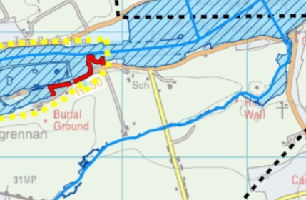  Hard defences on River Boyne  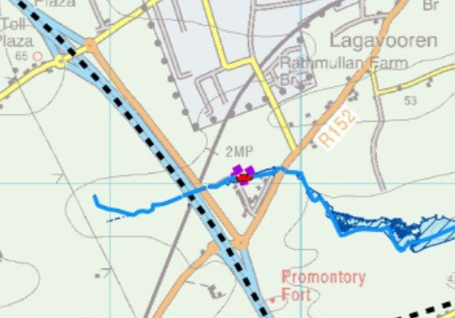  Hard defences on Stagrennan River
Kilcock Environs | It has been proposed to review the Kilcock Flood Risk Assessment and Management Study in light of recent amendments to development zoning.  The Kilcock Flood Risk Assessment and Management Study was initiated in February 2009 to address deficiencies highlighted by An Bord Pleanála with previous flood risk assessments in the area and was completed in August 2009. The developer led study proposed a flood risk management option, which would protect existing properties and proposed development areas against flooding from the River Rye Water. In light of significant changes to the zoning of land in Kilcock in 2014 by Meath County Council, the construction of a length of flood defences within the town, and the final water levels, flows and mapping produced by the Eastern CFRAM Study, a review of the existing conditions and relevant Flood Zone mapping is now recommended.
Longwood | There is no structural FRS proposed at this time for Longwood.  There is a relatively low level of flood risk to this community from rivers and/or the sea, and no structural flood relief measures are therefore proposed at this time. The current level of risk will be reviewed, along with all areas, on a regular basis into the future.  Longwood is considered to be at low risk during the present day 1%AEP fluvial event and optioneering has not been undertaken, consequently the existing regime should continue in order to maintain the current SoP.
Slane | No area specific flood risk management plans in place.
Navan | The proposed measure for Navan that may be implemented after project-level assessment and planning or Exhibition and confirmation might include physical works, such as a series of hard defences (flood embankments and walls), road raising and clearance of a 500m reach of the Abbeylands Tributary. The hard defences would protect to the 1% AEP fluvial flood event with a total wall length of 889m, a total embankment length of 340m and a total length of 986m of road to be raised.  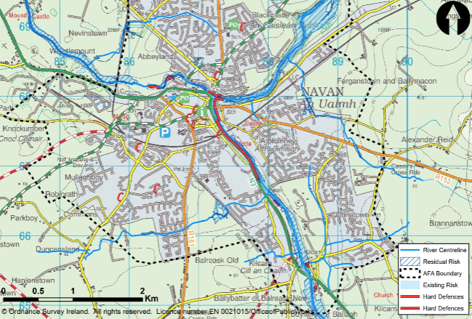  FRMP for Navan
Trim | No viable option identified.  No measures found with a benefit-cost ratio greater than 0.5, and so no further assessment was carred out. The low benefit-cost ratio is due to the relatively low risk to properties during the 1% AEP fluvial flood event in Trim, resulting in a small benefit value. However, Trim could benefit from the implementation of the Boyne Flood Forecasting and Warning System.
Mornington | It is proposed to maintain the existing Mornington Flood relief scheme and to progress the development of a further Flood Relief Scheme for Mornington to augment the existing Scheme  The proposed further measure for Mornington that may be implemented after project-level assessment and planning or Exhibition and confirmation might include physical works, such as a series of hard defences (flood embankments and walls). These works would complement the existing flood scheme already completed in Mornington. The hard defences would protect to the 1% AEP fluvial flood event and to the 0.5% AEP coastal flood event, with an average height of 1.04m and a total length of approximately 530m.  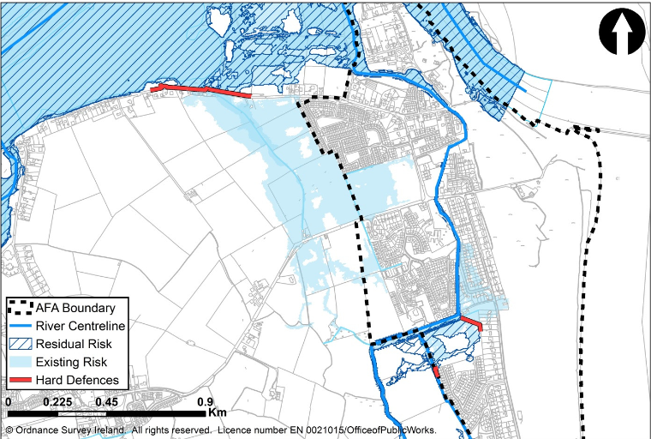  FRMP for Mornington

Development Management and Flood Risk
In order to guide both applicants and relevant council staff through the process of planning for and mitigating flood risk, the key features of a range of development scenarios have been identified (relating the flood zone, development vulnerability and presence or absence of defences). For each scenario, a number of considerations relating to the suitability of the development are summarised below.
It should be noted that this section of the SFRA begins from the point that all land zoned for development has passed the Justification Test for Development Plans, and therefore passes Part 1 of the Justification Test for Development Management. In addition to the general recommendations in the following sections, Section 5 should be reviewed for specific recommendations for individual settlements, including details of the application of the Justification Test.
In order to determine the appropriate design standards for a development it may be necessary to undertake a site specific flood risk assessment. This may be a qualitative appraisal of risks, including drainage design. Alternatively, the findings of the CFRAM, FEM FRAM, or other detailed study, may be drawn upon to inform finished floor levels. In other circumstances a detailed modelling study and flood risk assessment may need to be undertaken. Further details of each of these scenarios, including considerations for the flood risk assessment are provided in the following sections.

Requirements for a Flood Risk Assessment
As specified under INF POL 20, assessment of flood risk is required in support of any planning application where flood risk may be an issue and this may include sites in Flood Zone C where a watercourse or field drain exists nearby. The level of detail will vary depending on the risks identified and the proposed land use. As a minimum, all proposed development, including that in Flood Zone C, must consider the impact of surface water flood risks on drainage design, this is specified in INF POL 16. In addition, flood risk from sources other than fluvial and tidal should be reviewed.
For sites within Flood Zone A or B, a site specific "Stage 2 - Initial FRA" will be required, and may need to be developed into a "Stage 3 - Detailed FRA". The extents of Flood Zone A and B are delineated through this SFRA. However, future studies may refine the extents (either to reduce or enlarge them) so a comprehensive review of available data should be undertaken once a FRA has been triggered.
Within the FRA the impacts of climate change and residual risk (including culvert/structure blockage) should be considered and remodelled where necessary, using an appropriate level of detail, in the design of finished floor levels. Further information on the required content of the FRA is provided in the Planning System and Flood Risk Management Guidelines.
Any proposal that is considered acceptable in principle shall demonstrate the use of the sequential approach in terms of the site layout and design and, in satisfying the Justification Test (where required), the proposal will demonstrate that appropriate mitigation and management measures are put in place.

Drainage impact assessment
Under INF POL 16 all proposed development, whether in Flood Zone A, B or C, must consider the impact of surface water flood risks on drainage design as specified by the surface water management policies in the Greater Dublin Strategic Drainage Study (GDSDS) and this will be considered in the planning process. This may be in the form of a section within the flood risk assessment (for sites in Flood Zone A or B) or part of a surface water management plan.
Areas vulnerable to ponding are indicated on the OPW's PFRA mapping. Particular attention should be given to development in low-lying areas which may act as natural ponds for collection of runoff.
The drainage design should ensure no increase in flood risk to the site, or the downstream catchment. Where possible, and particularly in areas of new development, floor levels should at a minimum be 300mm above adjacent roads and hard standing areas to reduce the consequences of any localised flooding. Where this is not possible, an alternative design appropriate to the location may be prepared.
In addition, for larger sites (i.e. multiple dwellings or commercial units) master planning should ensure that existing flow routes are maintained, through the use of green infrastructure.

Development proposals in Flood Zone C
Where a site is within Flood Zone C, but adjoining or in close proximity to Flood Zone A or B there could be a risk of flooding associated with factors such as future scenarios (climate change) or in the event of failure of a defence, blocking of a bridge or culvert. Risk from sources other than fluvial and coastal must also be addressed for all development in Flood Zone C. As a minimum in such a scenario, a flood risk assessment should be undertaken which will screen out possible indirect sources of flood risk and where they cannot be screened out it should present mitigation measures. The most likely mitigation measure will involve setting finished floor levels to a height that is above the 1 in 100 year fluvial or 1 in 200 year tidal flood level, with an allowance for climate change and freeboard, or to ensure a step up from road level to prevent surface water ingress. Design elements such as channel maintenance or trash screens may also be required. Evacuation routes in the event of inundation of surrounding land should also be detailed.
The impacts of climate change should be considered for all proposed developments. A development which is currently in Flood Zone C may be shown to be at risk when 0.5m is added to the extreme (1 in 200 year) tide. Details of the approach to incorporating climate change impacts into the assessment and design are provided in Section 4.10.

Applications for Developments in Flood Zone A or B

Minor Developments
Section 5.28 of the Planning Guidelines on Flood Risk Management identifies certain types of development as being 'minor works' and therefore exempt from the Justification Test. Such development relates to works associated with existing developments, such as extensions, renovations and rebuilding of the existing development, small scale infill and changes of use.
Despite the ‘Sequential Approach’ and ‘Justification Test’ not applying, as they relate to existing buildings, an assessment of the risks of flooding should accompany such applications. This must demonstrate that the development would not increase flood risks, by introducing significant numbers of additional people into the flood plain and/or putting additional pressure on emergency services or existing flood management infrastructure. The development must not have adverse impacts or impede access to a watercourse, floodplain or flood protection and management facilities. Where possible, the design of built elements in these applications should demonstrate principles of flood resilient design (See ‘The Planning System and Flood Risk Management Guidelines for Planning Authorities Technical Appendices, 2009', Section 4 - Designing for Residual Flood Risk).
Generally, the approach to deal with flood protection would involve raising the ground floor levels above the level of extreme river levels. If this leads to floor levels being much higher than adjacent streets it could create a hostile streetscape for pedestrians. This would cause problems for infill development sites if floor levels were required to be significantly higher than those of neighbouring properties. In this regard, it has been recognised that some flexibility could be allowed, in limited circumstances, on a site by site basis, for commercial and business developments. In these cases, the detailed design of the development should reflect the vulnerability of the site in terms of materials, fixtures and fittings and internal layout. For high risk areas, less vulnerable uses are encouraged at ground floor levels. A site specific FRA will inform appropriate uses and detailed design and layout.
It should be noted that for residential buildings within Flood Zone A or B, bedroom accommodation is more appropriate at upper floor levels.
For commercial operations, business continuity must be considered, and steps taken to ensure operability during and recovery after a flood event for both residential and commercial developments. Emergency access must be considered as in many cases flood resilience will not be easily achieved in the existing built environment.
The requirement for providing compensatory storage for minor developments has been reviewed and can generally be relaxed, even where finished floor levels have been raised. This is because the development concerns land which has previously been developed and would already have limited capacity to mitigate flooding. However, a commentary to this effect must be substantiated in the site specific FRA.

Highly vulnerable development in Flood Zone A or B
Development which is highly vulnerable to flooding, as defined in The Planning System and Flood Risk Management, includes (but is not limited to) dwelling houses, hospitals, emergency services and caravan parks.

New development
It is not appropriate for new, highly vulnerable development to be located on greenfield land in Flood Zones A or B, particularly outside the core of a settlement and where there are no flood defences. Such proposals do not pass the Justification Test. Instead, a less vulnerable use should be considered.
For extant permissions in Flood Zone A/B if the site remains unconstructed and the planning application lapses, any future planning applications on the site should be subject to an appropriately detailed FRA specific to the new site layout and it may be found that the site cannot be developed as planned. As part of any future variation to the Development Plan or the preparation of a Local Area Plan (as applicable to the relevant settlement) lands with no extant permission should be considered in line with the sequential approach and Justification Test for Plan Making.

Existing developed areas
The Planning Circular (PL02/2014) states that "notwithstanding the need for future development to avoid areas at risk of flooding, it is recognised that the existing urban structure of the country contains many well established cities and urban centres which will continue to be at risk of flooding. In addition, development plans have identified various strategically important urban centres … whose continued consolidation, growth, development or generation, including for residential use, is being encouraged to bring about compact and sustainable growth.”
Minor/small scale infill housing, extensions or changes of use is discussed in Section 4.8.1 and, subject to site specific flood risk assessment, can generally be considered appropriate.
In cases where development has been justified, the outline requirements for a flood risk assessment and flood management measures have been detailed in this SFRA in both the following sections and the settlement review in Section 5. Of prime importance is the requirement to manage risk to the development site and not to increase flood risk elsewhere. This should give due consideration to safe evacuation routes and access for emergency services during a flood event.

Less vulnerable development in Flood Zone A or B
Less vulnerable development includes retail, leisure, warehousing, technology, enterprise and buildings used for agriculture and forestry a comprehensive categorisation of land uses and vulnerability is provided in Table 5-1 on Page 35.
The design and assessment of less vulnerable development should generally begin with 1% AEP fluvial or 0.5% tidal events as standard, with climate change and a suitable freeboard included in the setting of finished floor levels. The site specific FRA should ensure that the risks are defined, understood, and accepted. Operability and emergency response should also be clearly defined. In a limited number of cases this may allow construction as low as the 1% AEP level to be adopted, provided the risks of climate change are included in the development through adaptable designs or resilience measures.

Key points for FRAs for all types of development
- Finished floor levels to be set above the 1% AEP fluvial (0.5% AEP tide) level, with an allowance for climate change plus a freeboard of at least 300mm. The freeboard allowance should be assessed, and the choice justified.
- Flow paths through the site and areas of surface water storage should be managed to maintain their function and without causing increased flood risk elsewhere
- Compensatory storage is to be provided to balance floodplain loss as a result of raising ground levels within Flood Zone A. The storage should be provided within the flood cell and on a level for level basis up to the 1% level.
- In a defended site, compensatory storage is not required, but the impact of removing the net reduction in floodplain storage should be assessed, and any impacts to existing development mitigated for the 0.1% event or a breach of these defences.
- A site is considered to be defended if the standard of protection is equal or beyond the 1% AEP (within which a freeboard of at least 300mm is included) The FFL of the proposed development needs to take into account the impacts of climate change and other residual risks, including the 0.1% event, unless this has also been incorporated into the defence design. This may be assessed through breach analysis, overtopping analysis or projection of levels from the channel inland.
- For less vulnerable development, it may be that a finished floor level as low as the 1% AEP level could be adopted, provided the risks of climate change are included in the development through adaptable designs or resilience measures. This approach should reflect emergency planning and business continuity to be provided within the development. It may reflect the design life of the development, the proposed use, the vulnerability of items to be kept in the premises, the occupants and users, emergency plan and inclusion of flood resilience and recovery measures.

Incorporating Climate Change into Development Design
The Flood Zones are determined based on readily available information and their purpose is to be used as a tool to avoid inappropriate development in areas of flood risk. Where development is proposed within an area of potential flood risk (Flood Zone A or B), a flood risk assessment of appropriate scale will be required and this assessment must take into account climate change and associated impacts. Under the National CFRAM programme, the detailed modelling and assessment stage of each study will include climate change effects. For the eastern area of County Meath, detailed modelling, with consideration of climate change, has been completed under the FEM FRAMS pilot CFRAM study, within the plan this applies to Duleek, Gormanston, Julianstown, Kentstown, Stamullen, Ashbourne, Dunshaughlin and Ratoath. Climate change data has not yet been provided from the CFRAM deliverables, but will be issued in the future.
Consideration of climate change is particularly important where flood alleviation measures are proposed as the design standard of the proposal may reduce significantly in future years due to increased rainfall, river flows and sea levels. As recommended by the planning guidelines, a precautionary approach should be adopted.
Climate change may result in increased flood extents and therefore caution should be taken when zoning lands in transitional areas. In general, Flood Zone B, which represents the 0.1% AEP extent, can be taken as an indication of the extent of the 1% AEP flood event with climate change. In steep valleys an increase in water level will relate to a very small increase in extent, however in flatter low-lying basins a small increase in water level can result in a significant increase in flood extent.
For most development, including residential, nursing homes, shops and offices, the medium-range future scenario (20% increase in flows and / or 0.5m increase in sea level) is an appropriate consideration. This should be applied in all areas that are at risk of flooding (i.e. within Flood Zone A and B) and should be considered for sites which are in Flood Zone C but are adjacent to Flood Zone A or B. This is because land which is currently not at risk may become vulnerable to flooding when climate change is taken into account.
Where the risk associated with inundation of a development is low and the design life of the development is short (typically less than 30 years) the allowance provided for climate change may be less than the 20% / 0.5m level. However, the reasoning and impacts of such an approach should be provided in the site specific FRA.
Conversely, there may be development which requires a higher-level response to climate change. This could include major facilities which are extremely difficult to relocate, such as hospitals, Seveso sites or power stations, and those which represent a high-economic and long term investment within the scale of development of the specific settlement. In such situations it would be reasonable to expect the high-end future scenario (30% increase in flow or 1m in sea level) to be used as the design standard. In the case of coastal locations, and as climate projections are further developed, it may be prudent to demonstrate adaptability to even higher sea levels.
Further consideration to the potential future impacts of climate change will be given for each settlement within Section 5.

Flood Mitigation Measures at Site Design
For any development proposal in an area at moderate or high risk of flooding that is considered acceptable in principle, it must be demonstrated that appropriate mitigation measures can be put in place and that residual risks can be managed to acceptable levels. It is anticipated that this will impact very few developments and should be predominantly limited to areas of existing development.
To ensure that adequate measures are put in place to deal with residual risks, proposals should demonstrate the use of flood-resistant construction measures that are aimed at preventing water from entering a building and that mitigate the damage floodwater causes to buildings. Alternatively, designs for flood resilient construction may be adopted where it can be demonstrated that entry of floodwater into buildings is preferable to limit damage caused by floodwater and allow relatively quick recovery.
Various mitigation measures are outlined below and further detail on flood resilience and flood resistance are included in the Technical Appendices of the Planning Guidelines, The Planning System and Flood Risk Management.
It should be emphasised that measures such as those highlighted below should only be considered once it has been deemed 'appropriate' to allow development in a given location and it will predominantly be relevant to existing developed areas as all other undeveloped sites in Flood Zone A have been re-zoned to a less vulnerable land use (unless subject to an extant permission). The Planning Guidelines do not advocate an approach of engineering solutions in order to justify the development which would otherwise be inappropriate.

Site Layout and Design
To address flood risk in the design of new development, a risk based approach should be adopted to locate more vulnerable land use to higher ground while water compatible development i.e. car parking, recreational space can be located in higher flood risk areas. This should be the preferred approach for sites with extant permissions where the permission expires, is subject to an extension of duration application or a new application is lodged.
The site layout should identify and protect land required for current and future flood risk management. Waterside areas or areas along known flow routes can be used for recreation, amenity and environmental purposes to allow preservation of flow routes and flood storage, while at the same time providing valuable social and environmental benefits.

Ground levels, floor levels and building use
Modifying ground levels to raise land above the design flood level is a very effective way of reducing flood risk to the particular site in question. However, in most areas of fluvial flood risk, conveyance or flood storage would be reduced locally and could have an adverse effect on flood risk off site. There are a number of criteria which must all be met before this is considered a valid approach:
- Development at the site must have been justified through this SFRA based on the existing (unmodified) ground levels.
- The FRA should establish the function provided by the floodplain. Where conveyance is a prime function then a hydraulic model will be required to show the impact of its alteration.
- Compensatory storage should be provided on a level for level basis to balance the total area that will be lost through infilling where the floodplain provides static storage.
- The provision of the compensatory storage should be in close proximity to the area that storage is being lost from (i.e. within the same flood cell).
- The land proposed to provide the compensatory storage area must be within the ownership / control of the developer.
- The land being given over to storage must be land which does not flood in the 1% AEP event (i.e. Flood Zone B or C).
- The compensatory storage area should be constructed before land is raised to facilitate development.
In some sites it is possible that ground levels can be re-landscaped to provide a sufficiently large development footprint. However, it is likely that in other potential development locations there is insufficient land available to fully compensate for the loss of floodplain. In such cases it will be necessary to reconsider the layout or reduce the scale of development, or propose an alternative and less vulnerable type of development. In other cases, it is possible that the lack of availability of suitable areas of compensatory storage mean the target site cannot be developed and should remain open space.
Raising finished floor levels within a development is an effective way of avoiding damage to the interior of buildings (i.e. furniture and fittings) in times of flood.
Alternatively, assigning a water compatible use (i.e. garage / car parking) or less vulnerable use to the ground floor level, along with suitable flood resilient construction, is an effective way of raising vulnerable living space above design flood levels. It can however have an impact on the streetscape. Safe access and egress is a critical consideration in allocating ground floor uses.
Depending on the scale of residual risk, resilient and resistance measures may be an appropriate response but this will mostly apply to less vulnerable development.

Raised Defences
Construction of raised defences (i.e. flood walls and embankments) traditionally has been the response to flood risk. However, this is not a preferred option on an ad-hoc basis where the defences to protect the development are not part of a strategically led flood relief scheme. Where a defence scheme is proposed as the means of providing flood defence, the impact of the scheme on flood risk up and downstream must be assessed and appropriate compensatory storage must be provided.

Settlement Zoning Review
The purpose of land use zoning objectives is to indicate to property owners and members of the public the types of development the Planning Authority considers most appropriate in each land use category. Zoning is designed to reduce conflicting uses within areas, to protect resources and, in association with phasing, to ensure that land suitable for development is used to the best advantage of the community as a whole.
This section of the SFRA will:
- Consider the land use zoning objectives utilised within County Meath as a whole and assess their potential vulnerability to flooding.
- Based on the associated vulnerability of the particular use, a clarification on the requirement of the application of the Justification Test is provided.
- The consideration of the specific land use zoning objectives and flood risk will be presented for the settlements. Comment will be provided on the use of the sequential approach and Justification Test. Conclusions will be drawn on how flood risk is proposed to be managed in the settlement.

Land Use Zoning Objectives
The zoning objectives can be related to the vulnerability classifications in the 'Planning System and Flood Risk Management'; highly vulnerable, less vulnerable and water compatible. As discussed in Section 2, the preference for the allocation of zoning objectives within areas at potential risk of flooding is that of avoidance (the sequential approach). Where avoidance or substitution of land use is not possible the specific vulnerability of the land use, coupled with the Flood Zone in which it lies, guides the need for application of the Justification Test. This is set out in detail within Table 5-1 below.
Table 5-1 Land Zoning Objectives and Vulnerabilities
Objective/Use | Vulnerability* | Justification Test Required
A1 - Existing Residential | High | For development in Flood Zone A or B
A2 - New Residential | High | For development in Flood Zones A or B
B1 – Commercial Town or Village Centre | High / Less | For highly vulnerable development in Flood Zone A or B  For less vulnerable development in Flood Zone A
B2 - Retail Warehouse Park | Less | For development in Flood Zone A
C1 - Mixed Use | High / Less | For highly vulnerable development in Flood Zone A or B  For less vulnerable development in Flood Zone A
D1 - Tourism | High / Less / Water Compatible | For highly vulnerable development in Flood Zone A or B  For less vulnerable development in Flood Zone A  Or appropriate - if water compatible
E1 – Strategic Employment Zone (High Technology) | High / Less | For highly vulnerable development in Flood Zone A or B  For less vulnerable development in Flood Zone A
E2 - General Enterprise & Employment | High / Less | For highly vulnerable development in Flood Zone A or B  For less vulnerable development in Flood Zone A
E3 - Warehousing & Distribution | High / Less | For highly vulnerable development in Flood Zone A or B  For less vulnerable development in Flood Zone A
E1/E2 - Strategic Employment Zones (High Technology Uses)/ General Enterprise & Employment | High / Less | For highly vulnerable development in Flood Zone A or B  For less vulnerable development in Flood Zone A
E1/E3 - Strategic Employment Zones (High Technology Uses)/ Warehousing & Distribution | High / Less | For highly vulnerable development in Flood Zone A or B  For less vulnerable development in Flood Zone A
E2/E3 - General Enterprise & Employment/ Warehousing & Distribution | High / Less | For highly vulnerable development in Flood Zone A or B  For less vulnerable development in Flood Zone A
F1 - Open Space | Water Compatible | Development is generally appropriate
F1/D1 – Open Space/ Tourism | High / Less / Water Compatible | For highly vulnerable development in Flood Zone A or B  For less vulnerable development in Flood Zone A  Or appropriate - if water compatible
G1 - Community Infrastructure | High / Less | For highly vulnerable development in Flood Zone A or B  For less vulnerable development in Flood Zone A
H1 - High Amenity | Less / Water Compatible | For less vulnerable development in Flood Zone A or appropriate - if water compatible
R1 - Rail Corridor | Less | n/a
TI - Transport | High /Less | For highly vulnerable development in Flood Zone A or B  For less vulnerable development in Flood Zone A
TU - Transport & Utilities | Less | For development in Flood Zone A
RA - Rural Area | High / Less / Water Compatible | For highly vulnerable development in Flood Zone A or B  For less vulnerable development in Flood Zone A  Or appropriate - if water compatible
* Land Use Vulnerability is expressed in relation to Table 3.1 (p25) of the Planning System and Flood Risk Management Guidelines for Planning Authorities. Some Zoning Objectives include a mix of different vulnerabilities of land use and are therefore presented as such in the table above.

It is important to note that Table 5-1 is provided as a general guide and the specific development types within the zoning objective must be considered individually, and with reference to Table 3-1 of the 'Planning System and Flood Risk Management'.
Whilst the Justification Test has been applied to land use zoning objectives in determining their applicability, there is some degree of variance in the vulnerability of the land uses under certain objectives in Table 5-1. For example the many zonings can include for high or less vulnerable development. This results in a varying requirement for the application of the Justification Test and potential suitability of the development. Where such conditions exist the zoning objectives include a clarification of the suitability of land use vulnerability within individual land zonings.

The following sections review the land use zoning objectives for each settlement within the plan and provide a comprehensive summary of flood risk and justification where necessary.

Ashbourne
Hierarchy |  | SELF-SUSTAINING GROWTH TOWN
Area for Further Assessment under CFRAM programme? |  | Ashbourne Flood Relief Scheme 2016
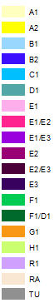
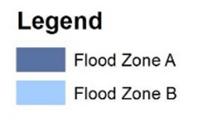
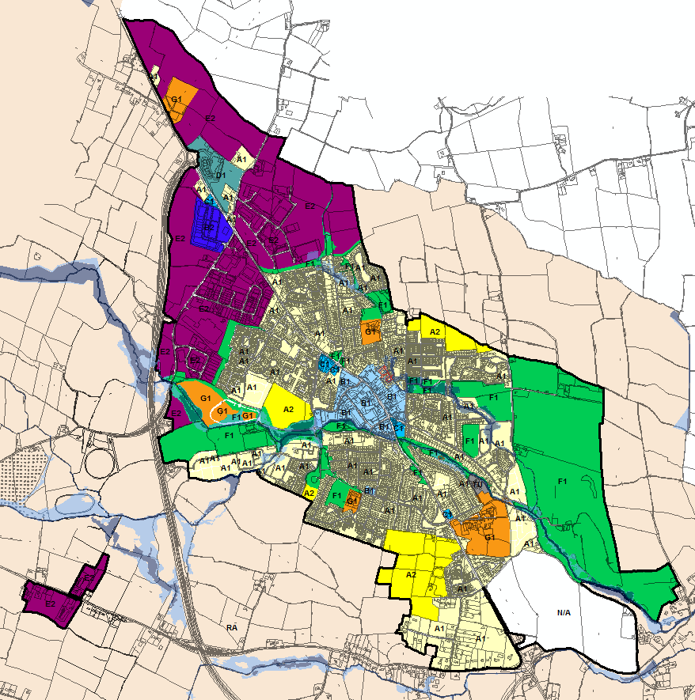
© Ordnance Survey Ireland & Government of Ireland, Meath 2019/31/CCMA
The Flood Zone mapping has been produced in accordance with the Planning Guidelines and therefore ignores the impact of flood protection structures. Areas protected by flood defences still carry a residual risk of flooding due to overtopping or breach, there may also be no guarantee of maintenance in perpetuity. Areas that benefit from defences are annotated separately. Flood Zone A – Fluvial: 1 in 100 year or 1% AEP, Tidal: 1 in 200 year or 0.5% AEP. Flood Zone B – 1 in 1000 year or 0.1% AEP.

Flood Zone Data | Ashbourne Flood Relief Scheme and JBA site visit.
Historic Flooding | Historic flooding events occurred in August 1986 and November 2002. Gauge data for the events are available.
Comment:
The Broadmeadow River approaches Ashbourne from the south west and then joins a small tributary downstream of the GAA pitches before passing through the urban core in an easterly direction. Another tributary approaches from the north and then flows parallel with the Broadmeadow before its confluence in the east of the settlement.

All watercourses pose flood risk to the settlement and this is represented by the Ashbourne Flood Relief Scheme Pre-Scheme flood extents which indicate a significant amount of exiting residential development at potential flood risk. The scheme will not be complete until the end of 2020 and until then the pre-scheme outlines remain the best estimate.

Some E2 land is subject to a small amount of overtopping flow along the boundary with the M2. The E2 land is typically less vulnerable to flooding and under any planning application a swale should be introduced to direct any potential flow around the site and back into the watercourse.

Within areas of existing development at potential risk of flooding, proposals for extensions and minor works should be considered under Section 5.28 of the Planning System and Flood Risk Management Guidelines and with due regard to the policies within Chapter 6 of the MCDP 2020-2026. Particular attention should be paid to the potential impact of the future flood relief scheme and future residual risk. Any other highly vulnerable or less vulnerable land uses covered by Flood Zone A and B should employ the sequential approach when considering the site layout and an appropriately detailed FRA must be completed.

Residual risk from culvert blockage is significant for the many culverts within the settlement and inspection and maintenance would help to reduce risk.

Climate Change | FEM FRAMS climate change scenario modelling suggests that the settlement is highly sensitive to the impacts of climate change.
Conclusion | Areas of E2 which contain a flow pathway (Flood Zone B) should manage this on a site-specific basis at Development Management stage. The Ashbourne Flood Relief scheme will be completed at the end of 2020 and the scheme will offer protection to a significant amount of existing development. Manage flood risk and development in line with the policies of the MCDP. Development should be subject to an appropriately detailed FRA at development management stage. This will ensure that FFLs and ground levels are set appropriately and that the risk of surface water flooding is managed. Maintenance and monitoring of culverts and flood defence assets as well as a flood warning system is recommended.

Athboy
Hierarchy |  | TOWN
Area for Further Assessment under CFRAM programme? |  | Yes - Flood Mapping available, flood relief scheme not recommended.
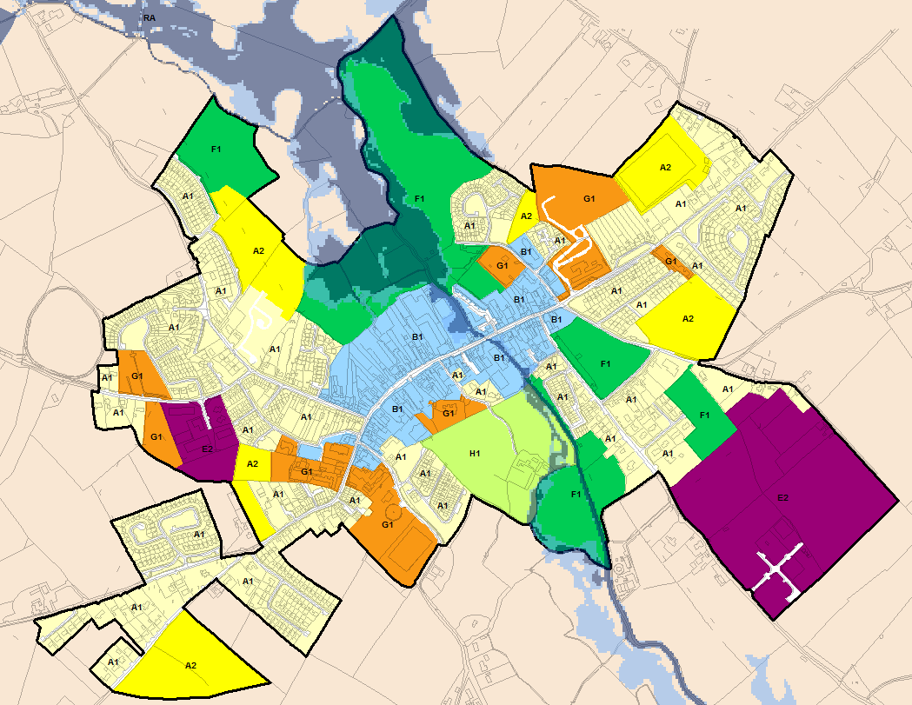
© Ordnance Survey Ireland & Government of Ireland, Meath 2019/31/CCMA
The Flood Zone mapping has been produced in accordance with the Planning Guidelines and therefore ignores the impact of flood protection structures. Areas protected by flood defences still carry a residual risk of flooding due to overtopping or breach, there may also be no guarantee of maintenance in perpetuity. Areas that benefit from defences are annotated separately. Flood Zone A – Fluvial: 1 in 100 year or 1% AEP, Tidal: 1 in 200 year or 0.5% AEP. Flood Zone B – 1 in 1000 year or 0.1% AEP.

Flood Zone Data | CFRAM mapping verified on site by JBA.
Historic Flooding | Minor surface water issue on N51, flooding noted in Castletown (outside settlement boundary) Aug 2008. Athboy River subject to OPW arterial drainage scheme and FRR notes channel capacity may be as high as 1% AEP (1 in 100 years).
Comment:
The final CFRAM flood mapping has now been incorporated. The management plan confirms that the risk in Athboy is minimal and a formal flood relief scheme will not be progressed here.

The Athboy River runs through the centre of the settlement and development has established on both sides of the watercourse. Existing development (B1) within the core town centre is at potential risk of flooding and in line with the policies of the MCDP, any extensions/change of use/reconstruction should be subject to an appropriately detailed FRA.

The area to the north of Upper Bridge Street/Main Street is referred to as the backland area and is intended to facilitate the orderly expansion of the town centre through the B1 zoning. The area contains a commercial building construction business and the at risk land is used for storage. Any redevelopment within Flood Zones A or B could have negative impacts on flood risk elsewhere, both through obstructing flow paths and reducing floodplain capacity. However, given that a significant percentage of the site is within Flood Zone C, it is anticipated that sustainable flood risk mitigation measures could be designed to allow development of the wider subject site, as necessary. This must be undertaken through an appropriately detailed Flood Risk Assessment, which would form part of the planning application. The FRA should consider the Sequential Approach within the subject site which would involve allocating water compatible development within Flood Zones A and some/all of Zone B. Where necessary, compensatory storage should be provided. Further details on compensatory storage are provided in Appendix B of the Planning System and Flood Risk Management. Buildings should be sited at an appropriate FFL, which should be above the 1 in 100 year flood level, with an allowance for freeboard and climate change.

With regard to all development within Athboy; particular consideration should be given to the management of surface water (INF POL 16).

Other land use objectives at potential risk include open space and high amenity (F1 and H1), these are generally appropriate and any less vulnerable development within H1 should be directed to Flood Zone C in preference. The waste water treatment plant is potentially at risk of flooding.

Climate Change | CFRAM mapping deliverables do not include climate change impacts, however an initial appraisal suggests that lands upstream of the town centre are sensitive to increases in flow and therefore climate change.
Conclusion | Manage flood risk and development in line with approved policies and objectives.  Development proposals within the backlands must consider the sequential approach and allocate water compatible development within Flood Zones A and some/all of Zone B where possible. Planning applications in this area must be accompanied by an appropriately detailed FRA, setting out the above approach that clearly assesses flood risks, management measures and demonstrates compliance with the Planning Guidelines.

Baile Gibb
Hierarchy |  | VILLAGE
Area for Further Assessment under CFRAM programme? |  | No
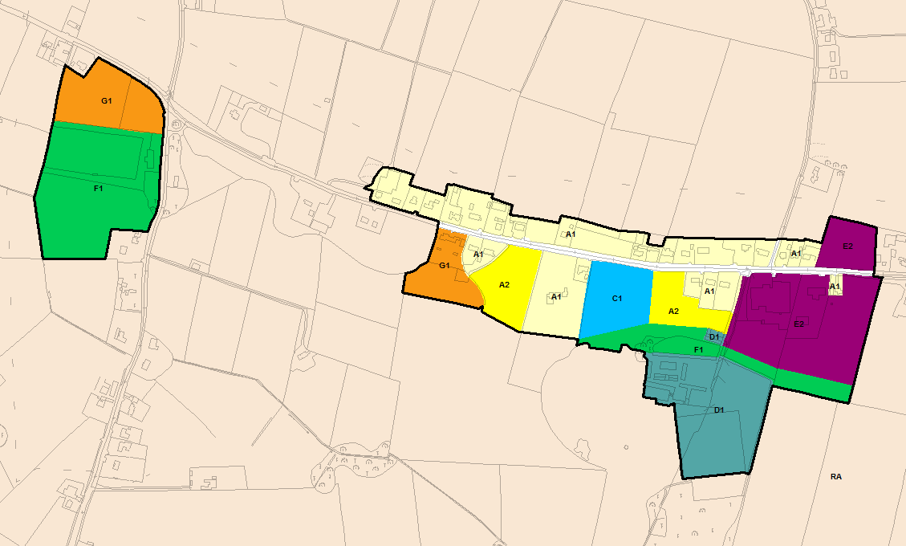
© Ordnance Survey Ireland & Government of Ireland, Meath 2019/31/CCMA
The Flood Zone mapping has been produced in accordance with the Planning Guidelines and therefore ignores the impact of flood protection structures. Areas protected by flood defences still carry a residual risk of flooding due to overtopping or breach, there may also be no guarantee of maintenance in perpetuity. Areas that benefit from defences are annotated separately. Flood Zone A – Fluvial: 1 in 100 year or 1% AEP, Tidal: 1 in 200 year or 0.5% AEP. Flood Zone B – 1 in 1000 year or 0.1% AEP.

Flood Zone Data | n/a
Historic Flooding | No historic records of flooding were found.
Comment | No fluvial flood risk identified and no flood history.
Climate Change | No fluvial impacts, potential increase in runoff.
Conclusion | Manage flood risk and development in line with approved policies and objectives.

Ballivor
Hierarchy |  | VILLAGE
Area for Further Assessment under CFRAM programme? |  | Yes - Flood Mapping available, flood relief scheme not recommended.
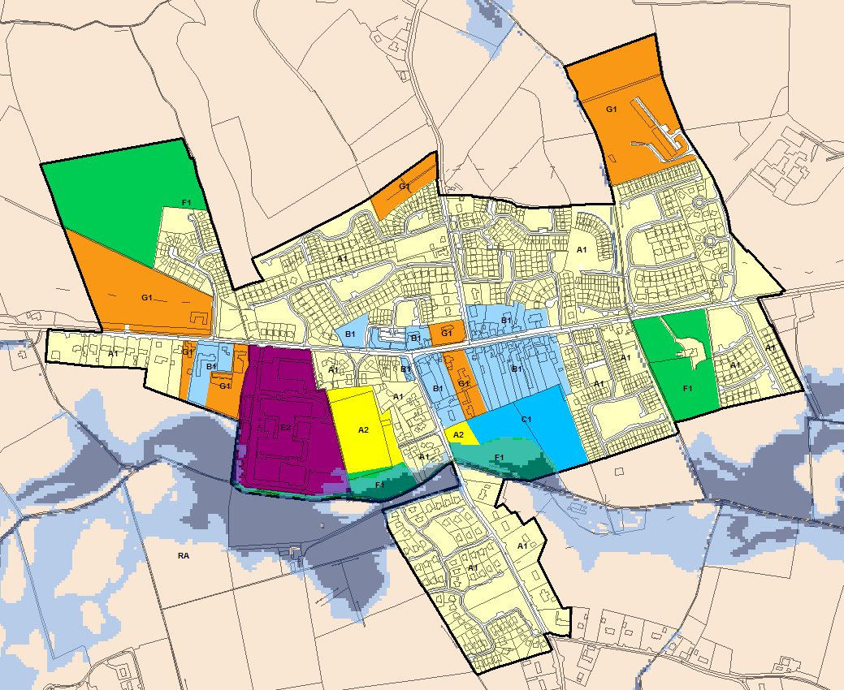
© Ordnance Survey Ireland & Government of Ireland, Meath 2019/31/CCMA
The Flood Zone mapping has been produced in accordance with the Planning Guidelines and therefore ignores the impact of flood protection structures. Areas protected by flood defences still carry a residual risk of flooding due to overtopping or breach, there may also be no guarantee of maintenance in perpetuity. Areas that benefit from defences are annotated separately. Flood Zone A – Fluvial: 1 in 100 year or 1% AEP, Tidal: 1 in 200 year or 0.5% AEP. Flood Zone B – 1 in 1000 year or 0.1% AEP.

Flood Zone Data | CFRAM mapping verified on site by JBA.
Historic Flooding | No flooding within urban area but a record of flooding occurred to the southeast in Clonycavan after prolonged rainfall in the Boyne Catchment.
Comment:
The final CFRAM flood mapping has now been incorporated. The management plan confirms that the risk in Ballivor is minimal and a formal flood relief scheme will not be progressed here.

There are two watercourses that flow through Ballivor, the main watercourse flows from east to west south of the R156. The second and more minor watercourse flows in from the north. Fluvial flooding is predicted from the river flowing east west as it passes though predominantly undeveloped land. Land use zonings have been adjusted in line with the sequential approach.

Any new development or extensions to existing development that is situated on lands adjacent to any of the watercourses should, in line with the policies of the MCDP, still be subject to an appropriately detailed FRA. During the FRA the residual risk of culvert/bridge blockage must be investigated with respect to the potential impacts on flood levels/extents.

Climate Change | CFRAM mapping deliverables do not include climate change impacts, however an initial appraisal suggests that the watercourse flowing east west through the settlement is sensitive to increases in flow and therefore climate change.
Conclusion | Manage flood risk and development in line with approved policies and objectives under Chapter 6 of the MCDP 2020-2026.

Bettystown/ Laytown/ Mornington East/ Donacarney/ Mornington
Hierarchy |  | SELF-SUSTAINING TOWN
Area for Further Assessment under CFRAM programme? |  | FEM FRAMS published 2011CFRAMS 2017
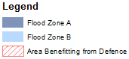
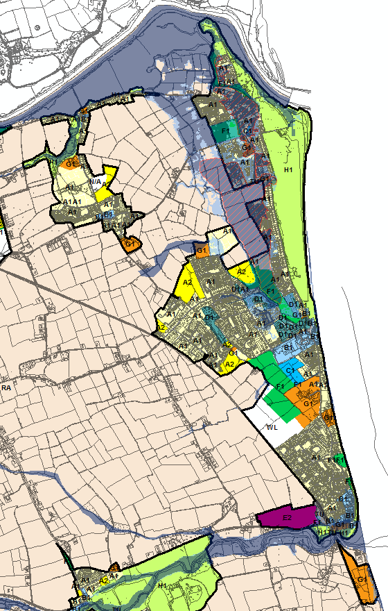
© Ordnance Survey Ireland & Government of Ireland, Meath 2019/31/CCMA
The Flood Zone mapping has been produced in accordance with the Planning Guidelines and therefore ignores the impact of flood protection structures. Areas protected by flood defences still carry a residual risk of flooding due to overtopping or breach, there may also be no guarantee of maintenance in perpetuity. Areas that benefit from defences are annotated separately. Flood Zone A – Fluvial: 1 in 100 year or 1% AEP, Tidal: 1 in 200 year or 0.5% AEP. Flood Zone B – 1 in 1000 year or 0.1% AEP.

Flood Zone Data | FEM FRAMS, CFRAMS OPW PFRA, site specific flood study and JBA site visit.
Historic Flooding | Northlands Estate Oct 2011 & Sept 2012, Mouth of the Nanny River (recurring), Alvera heights (surface water), tidal flooding Mornington East 2000 & 2002.
Comment:
Flood risk is principally focussed in Bettystown and Mornington East. The Northlands Estate Scheme and the Mornington District Surface Water and Flood Protection Scheme protect a significant amount of property from the impacts of coastal/fluvial flooding, but residual risk remains. The outflanking of the Mornington East defences has prompted a review of the FEMFRAMS mapping and an additional scheme has approved funding (<€1m) to address the issues of undefended risk in Mornington East. However, at present there is no timescale and risk is assessed as undefended.

Donacarney and Mornington are at low risk and land use zoning objectives are appropriate. Laytown is impacted by the River Nanny Estuary but the risk is low due to the application of the sequential approach. E2 lands near to the estuary will need a suitably detailed FRA in compliance with INF POL 14-29.

G1 lands in Bettystown are at potential flood risk, however the confidence in the PFRA mapping at this point is low, the outlines are conservative and the land use is water compatible use – Donacarney Celts FC.

All new residential zoning (A2) is located within Flood Zone C and is being subject to detailed FRA at development management stage in accordance with MCDP policy, this must continue under the 2019 MCDP. However, there is significant existing development at undefended risk within Mornington East. Even when the forthcoming scheme is completed the amount of new development should be restricted due to the level of residual risk, this is the same for all defended lands. The Justification Test still applies for all lands in Zone A/B and it is not generally appropriate to construct large amounts of new housing in defended areas. Extensions, re-builds and infill development is at the discretion of MCC and must be subject to adequately detailed FRA.

North south and east west distributor roads were previously proposed for Bettystown. River crossings were included for the Brookside stream. Any future planning applications for the spine road must be subject to an appropriately detailed FRA at development management stage to demonstrate that the application fully adheres to the Planning System and Flood Risk Management Guidelines, including the Justification Test. Section 50 consent will also be required from the OPW to ensure the appropriate design of culverts.

Climate Change | There is a significant potential impact from climate change (sea level rise) as a result of the location. The flood relief scheme should have been developed to be adaptable to these impacts.
Conclusion | Manage flood risk and development in line with approved policies and objectives.

Carlanstown
Hierarchy |  | VILLAGE
Area for Further Assessment under CFRAM programme? |  | No
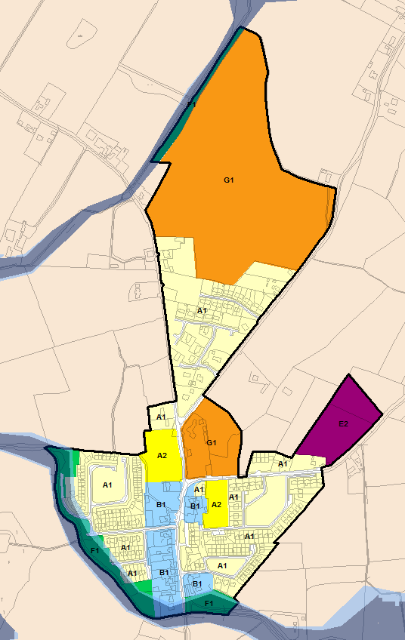
© Ordnance Survey Ireland & Government of Ireland, Meath 2019/31/CCMA
The Flood Zone mapping has been produced in accordance with the Planning Guidelines and therefore ignores the impact of flood protection structures. Areas protected by flood defences still carry a residual risk of flooding due to overtopping or breach, there may also be no guarantee of maintenance in perpetuity. Areas that benefit from defences are annotated separately. Flood Zone A – Fluvial: 1 in 100 year or 1% AEP, Tidal: 1 in 200 year or 0.5% AEP. Flood Zone B – 1 in 1000 year or 0.1% AEP.

Flood Zone Data | PFRA and JBA site visit.
Historic Flooding | No historic records of flooding were found.
Comment:
The Moynalty River flows along the south west boundary of the settlement, potentially impacting some existing residential zoning (A1) and open space (F1) as well as a small proportion of the E2 lands. A tributary of the Moynalty impacts the fringe of the undeveloped Community Infrastructure (G1).

Existing residential development (A1) should be managed in line with the policies (INF POL 14-29) of the MCDP.

New development under the proposed G1 land use zoning bordering the tributary of the Moynalty River is appropriate as long as risk is assessed and managed by an FRA in accordance with policies of the MCDP.

Climate Change | A review of the PFRA Flood Zone A and B outlines suggests that there is only a marginal increase in fluvial flood extent for an increase in severity - low impact from climate change in this settlement. Potential increase in runoff from pluvial events.
Conclusion | Manage flood risk and development in line with approved policies and objectives, apply sequential approach within G1 lands at potential risk of flooding to avoid development within Flood Zone A & B.

Carnaross
Hierarchy |  | VILLAGE
Area for Further Assessment under CFRAM programme? |  | No
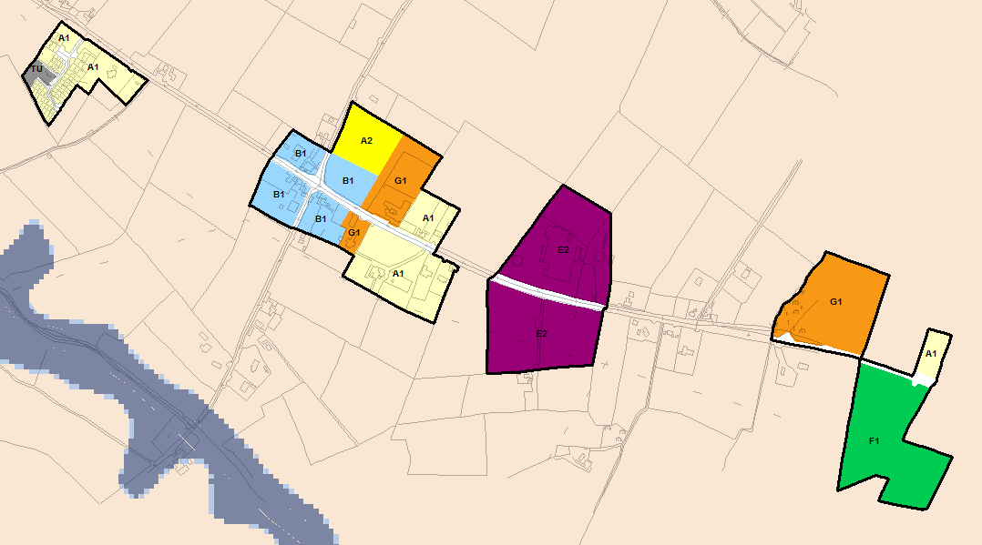
© Ordnance Survey Ireland & Government of Ireland, Meath 2019/31/CCMA
The Flood Zone mapping has been produced in accordance with the Planning Guidelines and therefore ignores the impact of flood protection structures. Areas protected by flood defences still carry a residual risk of flooding due to overtopping or breach, there may also be no guarantee of maintenance in perpetuity. Areas that benefit from defences are annotated separately. Flood Zone A – Fluvial: 1 in 100 year or 1% AEP, Tidal: 1 in 200 year or 0.5% AEP. Flood Zone B – 1 in 1000 year or 0.1% AEP.

Flood Zone Data | n/a
Historic Flooding | None recorded
Comment | No fluvial flood risk identified and no flood history.
Climate Change | No fluvial impacts, potential increase in runoff.
Conclusion | Manage flood risk and development in line with approved policies and objectives.

Clonard
Hierarchy |  | VILLAGE
Area for Further Assessment under CFRAM programme? |  | No
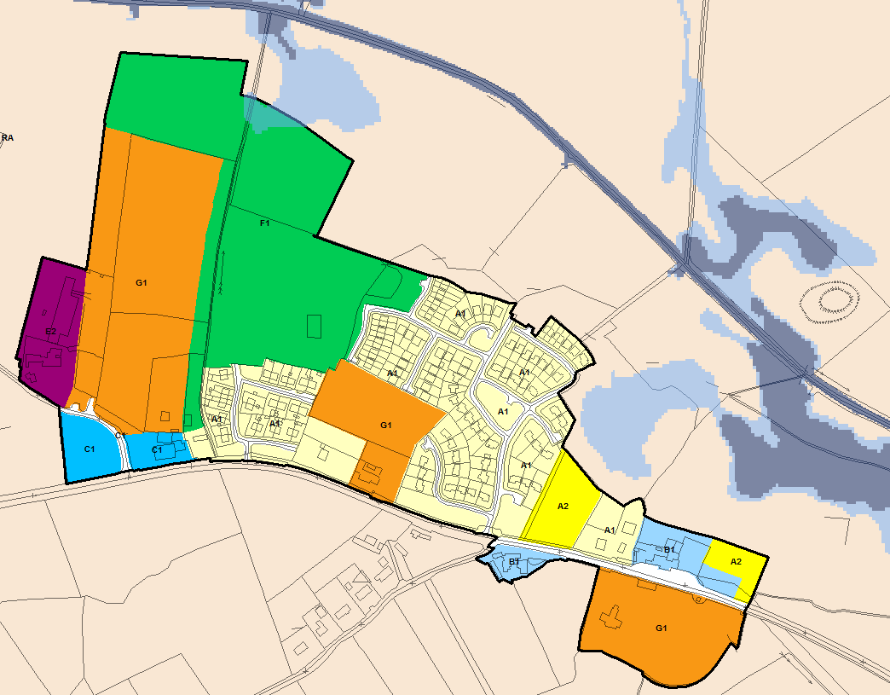
© Ordnance Survey Ireland & Government of Ireland, Meath 2019/31/CCMA
The Flood Zone mapping has been produced in accordance with the Planning Guidelines and therefore ignores the impact of flood protection structures. Areas protected by flood defences still carry a residual risk of flooding due to overtopping or breach, there may also be no guarantee of maintenance in perpetuity. Areas that benefit from defences are annotated separately. Flood Zone A – Fluvial: 1 in 100 year or 1% AEP, Tidal: 1 in 200 year or 0.5% AEP. Flood Zone B – 1 in 1000 year or 0.1% AEP.

Flood Zone Data | Detailed flood mapping study.
Historic Flooding | No historic records of flooding were found.
Comment:
The Kilwarden River has been subject to a detailed flood mapping study that has reduced the extent of the floodplain compared to previous iterations of the MCDP. The reduction in risk is as a result of more accurate representation of channel capacity resulting from the OPW Arterial Drainage Scheme that was implemented on the river.

Open Space (F1) lands are within Flood Zone B and the zoning objectives are consistent with the level of flood risk.

Existing residential development (A1) should be managed in line with the policies (INF POL 14-19) of the MCDP.
Climate Change | Model outlines indicate minor impact from future climate change.
Conclusion | Manage existing flood risk and development in line with approved policies and objectives.

Crossakeel
Hierarchy |  | VILLAGE
Area for Further Assessment under CFRAM programme? |  | No
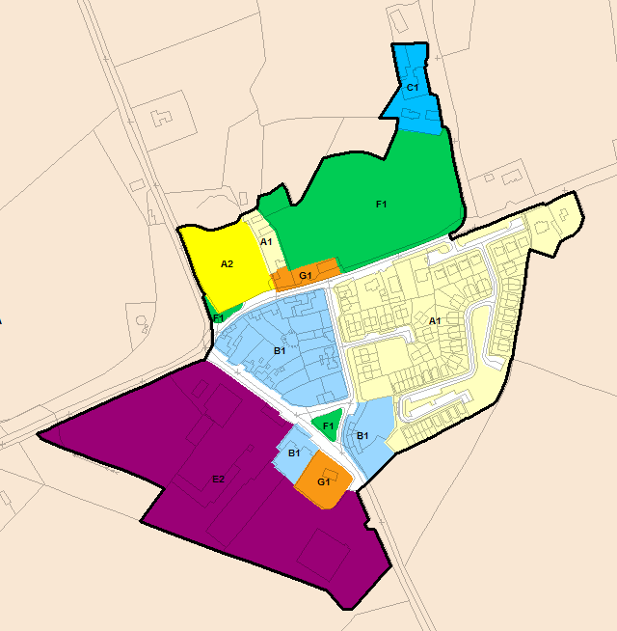
© Ordnance Survey Ireland & Government of Ireland, Meath 2019/31/CCMA
The Flood Zone mapping has been produced in accordance with the Planning Guidelines and therefore ignores the impact of flood protection structures. Areas protected by flood defences still carry a residual risk of flooding due to overtopping or breach, there may also be no guarantee of maintenance in perpetuity. Areas that benefit from defences are annotated separately. Flood Zone A – Fluvial: 1 in 100 year or 1% AEP, Tidal: 1 in 200 year or 0.5% AEP. Flood Zone B – 1 in 1000 year or 0.1% AEP.

Flood Zone Data | n/a
Historic Flooding | No historic records of flooding were found.
Comment | No fluvial flood risk identified and no flood history.
Climate Change | No fluvial impacts, potential increase in runoff.
Conclusion | Manage flood risk and development in line with approved policies and objectives.

Donore
Hierarchy |  | VILLAGE
Area for Further Assessment under CFRAM programme? |  | No
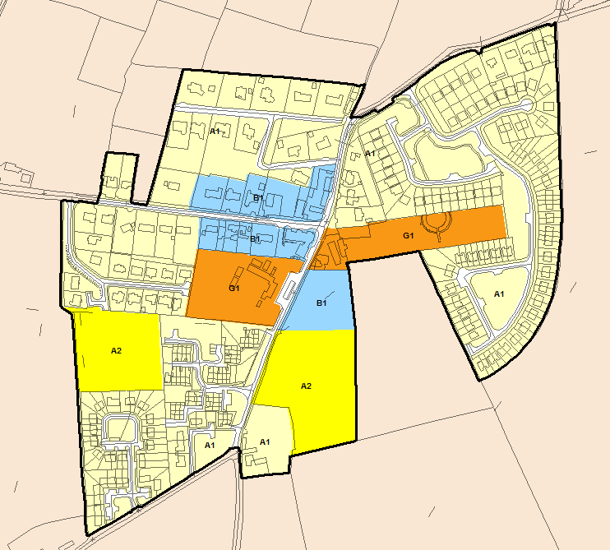
© Ordnance Survey Ireland & Government of Ireland, Meath 2019/31/CCMA
The Flood Zone mapping has been produced in accordance with the Planning Guidelines and therefore ignores the impact of flood protection structures. Areas protected by flood defences still carry a residual risk of flooding due to overtopping or breach, there may also be no guarantee of maintenance in perpetuity. Areas that benefit from defences are annotated separately. Flood Zone A – Fluvial: 1 in 100 year or 1% AEP, Tidal: 1 in 200 year or 0.5% AEP. Flood Zone B – 1 in 1000 year or 0.1% AEP.

Flood Zone Data | n/a
Historic Flooding | No historic records of flooding were found.
Comment | None recorded
Climate Change | No fluvial flood risk identified and no flood history.
Conclusion | No fluvial impacts, potential increase in runoff.

Drumconrath
Hierarchy |  | VILLAGE
Area for Further Assessment under CFRAM programme? |  | No
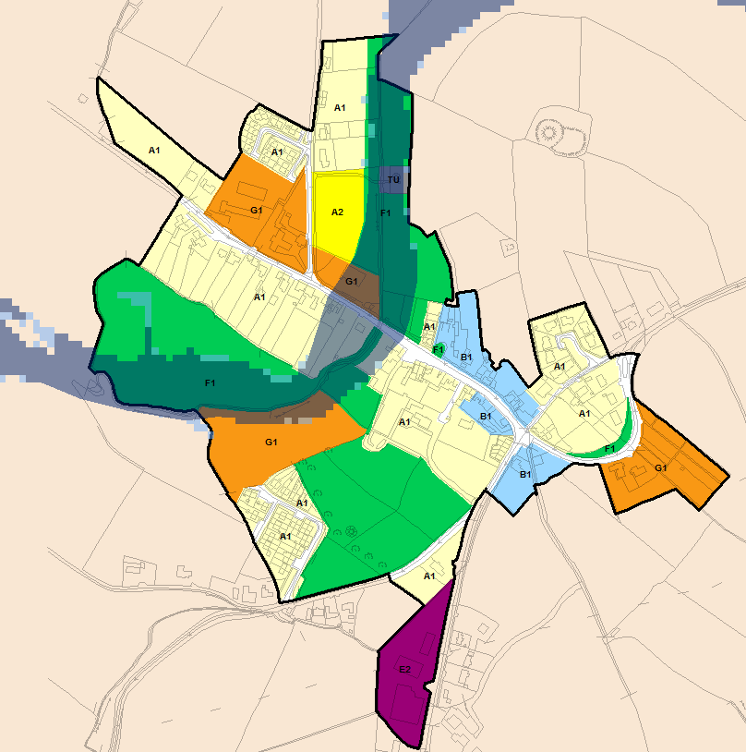
© Ordnance Survey Ireland & Government of Ireland, Meath 2019/31/CCMA
The Flood Zone mapping has been produced in accordance with the Planning Guidelines and therefore ignores the impact of flood protection structures. Areas protected by flood defences still carry a residual risk of flooding due to overtopping or breach, there may also be no guarantee of maintenance in perpetuity. Areas that benefit from defences are annotated separately. Flood Zone A – Fluvial: 1 in 100 year or 1% AEP, Tidal: 1 in 200 year or 0.5% AEP. Flood Zone B – 1 in 1000 year or 0.1% AEP.

Flood Zone Data | JFLOW and validation from historic flooding plus JBA site visit.
Historic Flooding | Flooding reported in 1993, 2008 and most recently 2011 when four private houses and a community centre flooded.
Comment:
Development is restricted by the river and the natural topography of the land. Flooding of properties in 2011 highlighted flood risk in this area which extends to existing residential (A1) and Community Infrastructure (G1). New residential zoning is located outside of Flood Zone A & B and any undeveloped land use in these areas is zoned F1.

Within areas of existing development, proposals for extensions and minor works should be considered under Section 5.28 of the Planning System and Flood Risk Management Guidelines and with due regard to INF POL 14-29 of the MCDP. Maintenance of the watercourse and culvert is recommended to lower the risk of blockage and flooding relating to surcharging flows. Pedestrian walkways are appropriate within Flood Zone A/B but will require an appropriately detailed FRA at planning stage and should generally not increase ground level within these zones.

Climate Change | Marginal increase in fluvial impact; risk is predominantly linked to the culvert which has a limited capacity.
Conclusion | Manage flood risk and development in line with approved policies and objectives, apply sequential approach within existing zoned development lands at potential risk of flooding.

Duleek
Hierarchy |  | TOWN
Area for Further Assessment under CFRAM programme? |  | FEM FRAMS published 2011
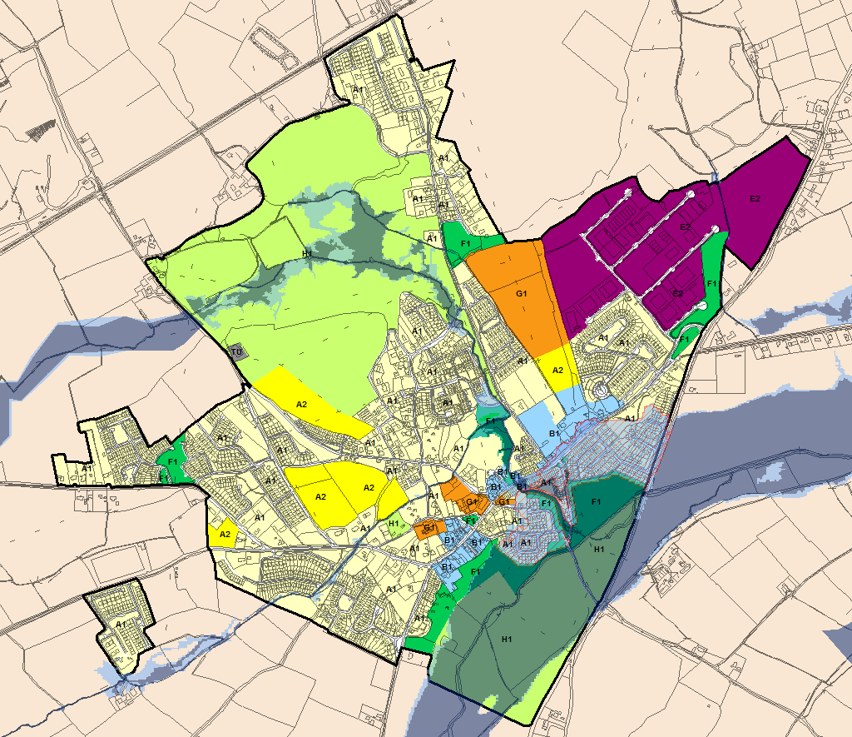
© Ordnance Survey Ireland & Government of Ireland, Meath 2019/31/CCMA
The Flood Zone mapping has been produced in accordance with the Planning Guidelines and therefore ignores the impact of flood protection structures. Areas protected by flood defences still carry a residual risk of flooding due to overtopping or breach, there may also be no guarantee of maintenance in perpetuity. Areas that benefit from defences are annotated separately. Flood Zone A – Fluvial: 1 in 100 year or 1% AEP, Tidal: 1 in 200 year or 0.5% AEP. Flood Zone B – 1 in 1000 year or 0.1% AEP.

Flood Zone Data | FEM FRAMS and OPW PFRA
Historic Flooding | Flooding event recorded in October 1993 from the River Nanny. Flood relief scheme carried out.
Comment:
Duleek is at significant risk from the River Nanny and existing development is now protected by the Duleek Flood Relief Scheme. The River Nanny is joined by a watercourse that approaches from the north and flows into the Nanny in the centre of the settlement. Development behind the River Nanny flood defences should be limited to extensions and changes of use or redevelopment of existing sites. No new undeveloped lands are zoned behind the flood defences (other than for water compatible land uses). To the north of the settlement, undeveloped H1 land is at risk of flooding. H1 is water compatible land use.

Within areas of existing development, proposals for extensions and minor works should be considered under Section 5.28 of the Planning System and Flood Risk Management Guidelines and with due regard to INF POL 14-29 of the MCDP and an appropriately detailed FRA must be submitted at development management stage.

Climate Change | A review of the FEM FRAMS climate change outlines suggests that there is a marginal increase in fluvial flood extent through the core of the settlement. Climate change impacts should be reviewed in the future to ensure the Duleek Flood Relief Scheme is providing adequate protection.
Conclusion | Manage flood risk and development in line with approved policies and objectives, ensure appropriately detailed FRA is provided for any new or existing zoned development lands at potential risk of flooding. The option for increasing protection to properties in Duleek shall be monitored and reviewed in the next cycle of the CFRAM process. The responsibility for this shall be with the OPW.

Dunboyne/ Clonee/ Pace
Hierarchy |  | SELF-SUSTAINING GROWTH TOWN
Area for Further Assessment under CFRAM programme? |  | No - the area was subject to a flood relief scheme (Tolka Flood Study) and was not included within the CFRAM. Flood maps for the River Tolka and Castle Stream have now been updated (2019) to CFRAM standard.
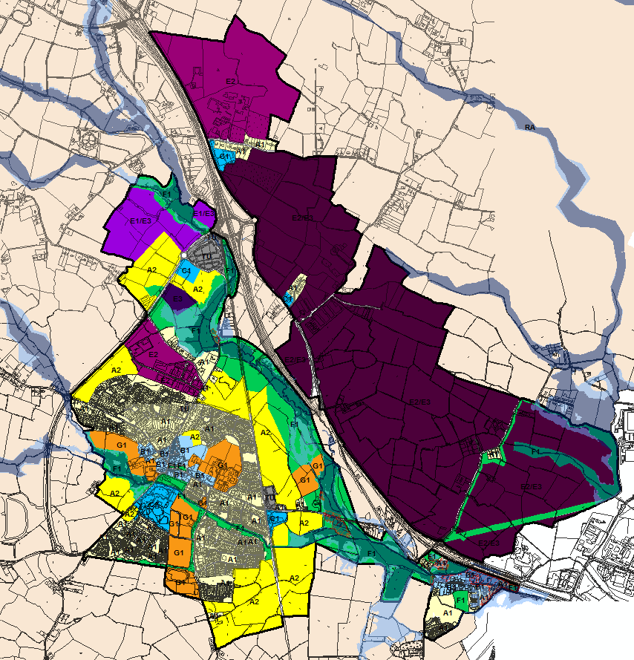
© Ordnance Survey Ireland & Government of Ireland, Meath 2019/31/CCMA
The Flood Zone mapping has been produced in accordance with the Planning Guidelines and therefore ignores the impact of flood protection structures. Areas protected by flood defences still carry a residual risk of flooding due to overtopping or breach, there may also be no guarantee of maintenance in perpetuity. Areas that benefit from defences are annotated separately. Flood Zone A – Fluvial: 1 in 100 year or 1% AEP, Tidal: 1 in 200 year or 0.5% AEP. Flood Zone B – 1 in 1000 year or 0.1% AEP.

Flood Zone Data | Tolka Flood Study, Eastern CFRAM Flood Risk Review (PFRA), JFlow and JBA site visit.
Historic Flooding | Historic Flooding from the River Tolka in November 2000 and November 2002.
Comment:
Dunboyne, Clonee and Pace are located in the south east corner of County Meath, at the confluence of the Tolka River and a tributary that flows through Dunboyne itself, the Castle Stream. The Tolka and its tributaries are a source of significant flood risk in the area.

The Tolka flood study was commissioned by Dublin City Council in association with Fingal County Council, Meath County Council and the Office of Public Works (OPW) in 2002. The recommendations for the flood relief scheme have now been constructed and protect a significant area in and around the Dunboyne, Clonee, and Pace settlements. The standard of protection offered by the scheme is stated by OPW as the 1% AEP (1 in 100 year) based on design flows calculated in 2002. The flood mapping for Dunboyne was updated in 2019 with an update to CFRAM standard with a re-assessment of the hydrology and inclusion of the 0.1% AEP.

When zoning land, consideration must be given to the undefended scenario (as stated in the Planning System and Flood Risk Management Guidelines). As such, development behind the flood defences will be subject to the Justification Test and this should largely limit development activity to building extensions and changes of use or redevelopment of existing sites.

Within areas of existing development, proposals for extensions and minor works should be considered under Section 5.28 of the Planning System and Flood Risk Management Guidelines and with due regard to INF POL 14-29 of the MCDP. Any highly vulnerable or less vulnerable land uses covered by Flood Zone A and B should employ the sequential approach when considering the site layout and an appropriately detailed FRA must be completed.

There is a small overlap of Flood Zone B to the periphery of E3 lands southwest of the railway station, and also E1/E3 lands to the north west of the station. This land use represents warehousing and distribution and high technology warehousing/distribution and is generally less vulnerable to the impacts of flooding. Risk should be assessed at development management stage and the recommendations in Section 4.8 of this report should apply.

A distributor road objective is in place that seeks to cross the River Tolka tributary in between the settlements of Dunboyne and Clonee. In this case the Justification Test has been applied and passed (see Appendix A.1). A site specific FRA will be required to manage the risk and to demonstrate there will be no impact on adjacent lands. OPW Section 50 consent for all watercourse crossings will be required. Proposed distributor roads are identified by transport objectives for lands in Gunnocks and Pace, however, alignments are not yet confirmed. During the environmental assessment stage of the road scheme, the Justification Test will need to be applied if alignments intersect with Flood Zone A/B. FRA will be required to manage the risk and to demonstrate there will be no impact on adjacent lands. OPW Section 50 consent for all watercourse crossings will be required.

The maintenance of the flood relief scheme is the responsibility of Meath County Council and is important to maintain the standard of protection through Dunboyne, Clonee and Pace.

Climate Change | The River Tolka and Castle Stream are sensitive to increases in flow and therefore climate change.
Conclusion | Manage flood risk and development in line with the policies (INF POL 14-29) of the MCDP including guidance provided in Sections 4.4 to 4.11 of this SFRA. All development should be subject to an appropriately detailed FRA at development management stage. This will ensure that FFLs and ground levels are set appropriately and that the risk of surface water flooding is correctly managed. Ensure that distributor roads have appropriate site specific FRA and OPW Section 50 consent.

Dunshaughlin
Hierarchy |  | SELF-SUSTAINING GROWTH TOWN
Area for Further Assessment under CFRAM programme? |  | FEM FRAMS published 2011
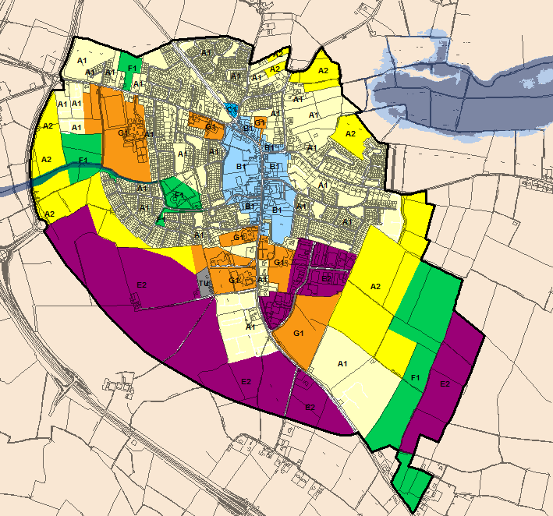
© Ordnance Survey Ireland & Government of Ireland, Meath 2019/31/CCMA
The Flood Zone mapping has been produced in accordance with the Planning Guidelines and therefore ignores the impact of flood protection structures. Areas protected by flood defences still carry a residual risk of flooding due to overtopping or breach, there may also be no guarantee of maintenance in perpetuity. Areas that benefit from defences are annotated separately. Flood Zone A – Fluvial: 1 in 100 year or 1% AEP, Tidal: 1 in 200 year or 0.5% AEP. Flood Zone B – 1 in 1000 year or 0.1% AEP.

Flood Zone Data | FEM FRAMS, OPW PFRA and JBA site visit.
Historic Flooding | Flooding event occurred in November 2000 from a tributary to the River Boyne.
Comment
There is limited predicted fluvial flood risk in Dunshaughlin and land use zoning is generally appropriate. Fluvial flooding from the Broadmeadow River mainly affects agricultural lands to the north east of the settlement. A minor watercourse drains in a westerly direction adjacent to the GAA pitches and exerts a small risk of flooding to surrounding lands.

Given the indicative pluvial flood risk highlighted by the PFRA, any proposed development within Dunshaughlin should consider the management of surface water (INF POL 14-17).

Other land use objectives at potential risk include Open Space and Community Infrastructure and (F1 & G1), these are generally appropriate and any less vulnerable development within the GAA site (G1) should be directed to Flood Zone C in preference, the margin of Flood Zone A/B is very minor and will not restrict any future development.
Pedestrian walkways may require FRA during planning application stage but the Justification Text is not required. The management of surface water flood risk and suitable site specific FRA is required for all sites in line with INF POL 14-29 of the MCDP, further guidance is provided in Sections 4.4 to 4.11 of this SFRA.

Climate Change | FEM FRAMS Climate change modelling suggests a moderate increase in flood extent for the area of ponding to the east of the settlement.
Conclusion | Manage flood risk and development in line with approved policies and objectives. Consider the management of surface water flood risk carefully, apply INF POL 14-17 from the MCDP to ensure any new development or redevelopment appropriately manages the risk of surface water flooding.

Enfield
Hierarchy |  | SELF-SUSTAINING TOWN
Area for Further Assessment under CFRAM programme? |  | No
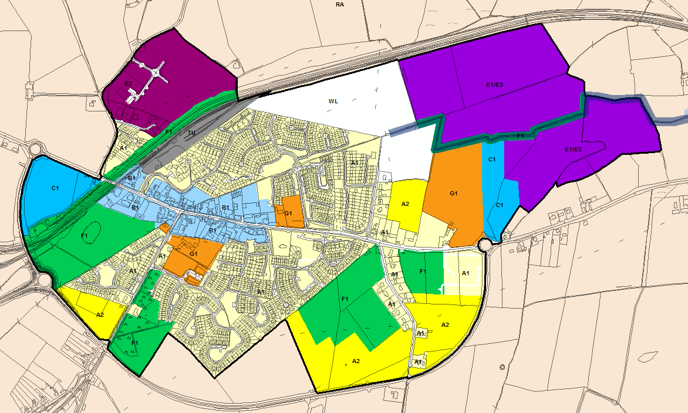
© Ordnance Survey Ireland & Government of Ireland, Meath 2019/31/CCMA
The Flood Zone mapping has been produced in accordance with the Planning Guidelines and therefore ignores the impact of flood protection structures. Areas protected by flood defences still carry a residual risk of flooding due to overtopping or breach, there may also be no guarantee of maintenance in perpetuity. Areas that benefit from defences are annotated separately. Flood Zone A – Fluvial: 1 in 100 year or 1% AEP, Tidal: 1 in 200 year or 0.5% AEP. Flood Zone B – 1 in 1000 year or 0.1% AEP.

Flood Zone Data | JBA estimated Flood Zone.
Historic Flooding | Flooding after heavy rainfall recurs.
Comment:
Risk is generally low. Lands zoned E1/E2 in the east of the settlement are adjacent to a field drain, they are located within Flood Zone C but must be subject to site specific FRA and consideration of INF POL 14-29 of the MCDP. Further guidance on the approach to development management and FRA is provided in Sections 4.4 to 4.11.

Given the indicative pluvial/surface water flood risk highlighted by the PFRA, any proposed development within Enfield should consider the appropriate management of surface water (INF POL 14-17).

Climate Change | Moderate sensitivity to Climate Change.
Conclusion | Limited predicted impacts from fluvial flooding, some indicative surface water risk predicted. Site specific FRA and consideration of INF POL 14-29 of the MCDP should accompany planning applications in E1/E3 lands in the east of the settlement. Given the indicative pluvial/surface water flood risk highlighted by the PFRA, any proposed development within Enfield should consider the appropriate management of surface water (INF POL 14-17).

Gormanston
Hierarchy |  | VILLAGE
Area for Further Assessment under CFRAM programme? |  | FEM FRAMS published 2011
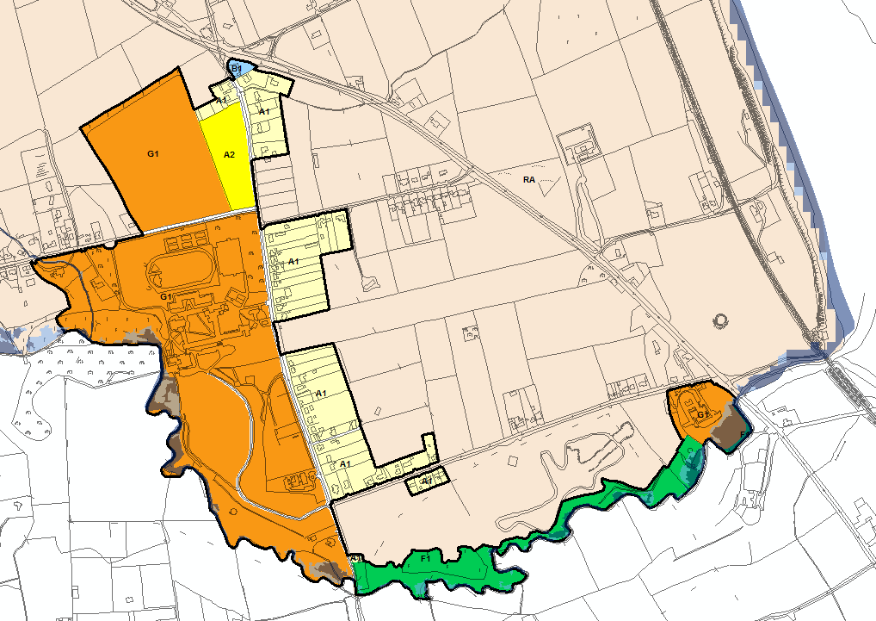
© Ordnance Survey Ireland & Government of Ireland, Meath 2019/31/CCMA
The Flood Zone mapping has been produced in accordance with the Planning Guidelines and therefore ignores the impact of flood protection structures. Areas protected by flood defences still carry a residual risk of flooding due to overtopping or breach, there may also be no guarantee of maintenance in perpetuity. Areas that benefit from defences are annotated separately. Flood Zone A – Fluvial: 1 in 100 year or 1% AEP, Tidal: 1 in 200 year or 0.5% AEP. Flood Zone B – 1 in 1000 year or 0.1% AEP.

Flood Zone Data | FEM FRAMS - note the Flood Extents are only shown for lands within the Meath county boundary.
Historic Flooding | History of recurring flood event at Martin's Road. Cause of flooding sites as flat land with no drainage and therefore liable to flooding after prolonged rainfall.
Comment:
The southern boundary of the settlement is created by the Delvin River, which has been assessed as part of the FEM FRAMS. Flood risk from the Delvin is limited to open spaces within existing development sites and also F1 zoning.

G1 can include for a range of land use vulnerabilities from water compatible through to highly vulnerable. As the existing sites under G1 zoning are at potential risk of flooding in some isolated areas, these pockets of flooding should be avoided. Development elsewhere is appropriate.

A flood forecasting and warning system was recommended for the Delvin River by the FEM FRAMS. In Gormanston there are no properties at direct risk but the measure would assist people who intend to access flooded areas.

Climate Change | A review of the FEM FRAMS climate change outlines suggests that there is a negligible increase in fluvial flood extent on the River Delvin.
Conclusion | Manage flood risk and development in line with approved policies and objectives, avoidance of development within Flood Zone A or B.

Julianstown
Hierarchy |  | VILLAGE
Area for Further Assessment under CFRAM programme? |  | FEM FRAMS published 2011
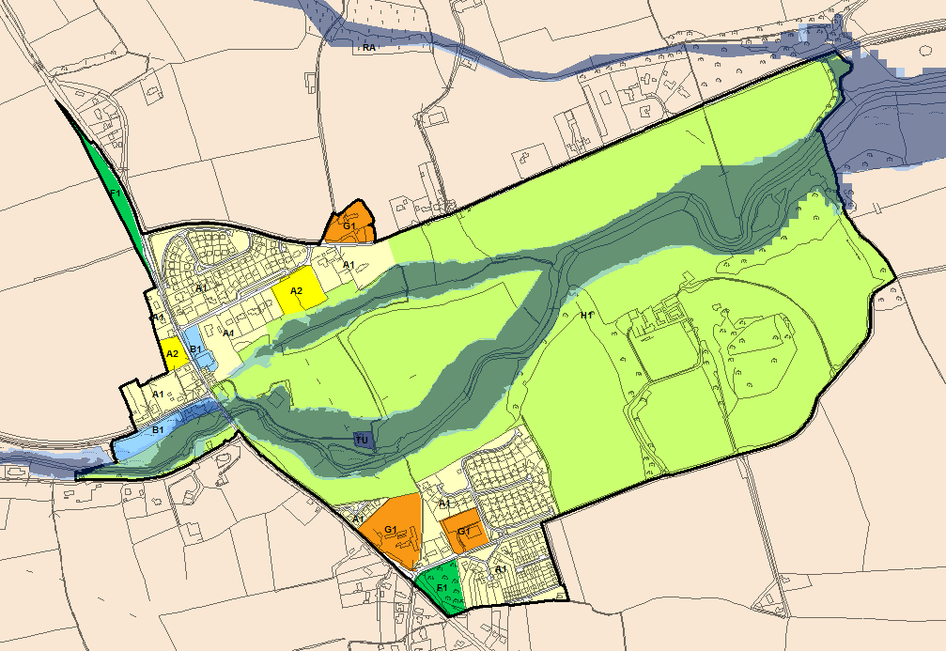
© Ordnance Survey Ireland & Government of Ireland, Meath 2019/31/CCMA
The Flood Zone mapping has been produced in accordance with the Planning Guidelines and therefore ignores the impact of flood protection structures. Areas protected by flood defences still carry a residual risk of flooding due to overtopping or breach, there may also be no guarantee of maintenance in perpetuity. Areas that benefit from defences are annotated separately. Flood Zone A – Fluvial: 1 in 100 year or 1% AEP, Tidal: 1 in 200 year or 0.5% AEP. Flood Zone B – 1 in 1000 year or 0.1% AEP.

Flood Zone Data | FEM FRAMS and JBA site visit.
Historic Flooding | Reports of recurring flooding in the reach between Julianstown and Beaumont. Flood waters from the River Nanny over onto floodplain 2-3 times per year.
Comment:
The River Nanny flows through Julianstown but the majority of existing development is situated at levels far above that of the floodplain. The exception to this is the now unoccupied Old Mill Hotel which is within the B1 zoning at the junction of the R132 and R150. Since the development is existing it cannot be rezoned as water compatible use. Any future planning applications on this site must be subject to an appropriately detailed FRA at development management stage. Section 4 provides further guidance on development management recommendations.

Pedestrian walkways are generally appropriate within Flood Zone A/B but will require an appropriately detailed FRA at planning stage (for any further extensions of these routes) and should generally not result in increased ground level within these zones.

A flood forecasting and warning system was recommended for the Nanny River by the FEM FRAMS as a non-structural measure designed to limit the impact of flooding for communities at risk from the Nanny River.

Climate Change | A review of the FEM FRAMS climate change outlines suggests that there is a negligible increase in fluvial flood extent on the River Nanny.
Conclusion | Manage flood risk and development in line with approved policies and objectives, A site specific FRA will be required for any redevelopment of the Old Mill Hotel site (B1 zoning). A flood forecasting and warning system was recommended for the Nanny River by the FEM FRAMS.

Kells
Hierarchy |  | SELF-SUSTAINING GROWTH TOWN
Area for Further Assessment under CFRAM programme? |  | No
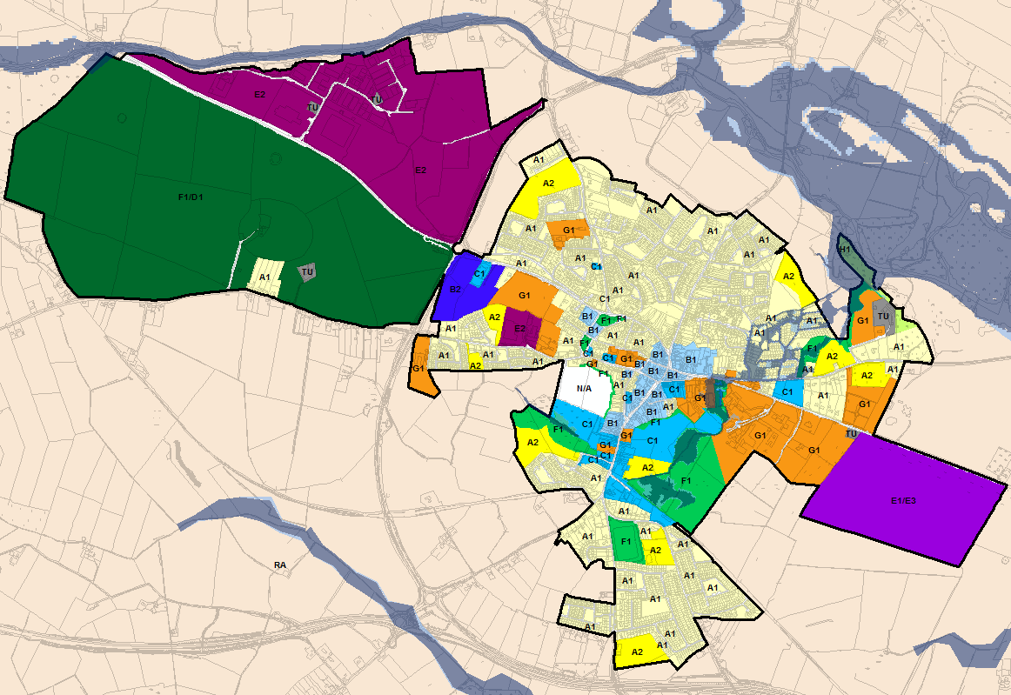
© Ordnance Survey Ireland & Government of Ireland, Meath 2019/31/CCMA
The Flood Zone mapping has been produced in accordance with the Planning Guidelines and therefore ignores the impact of flood protection structures. Areas protected by flood defences still carry a residual risk of flooding due to overtopping or breach, there may also be no guarantee of maintenance in perpetuity. Areas that benefit from defences are annotated separately. Flood Zone A – Fluvial: 1 in 100 year or 1% AEP, Tidal: 1 in 200 year or 0.5% AEP. Flood Zone B – 1 in 1000 year or 0.1% AEP.

Flood Zone Data | Detailed Flood Mapping Study for Newrath Stream, PFRA and JFlow for other watercourses.
Historic Flooding | Significant flood history, the 1000mm culvert that narrows to 650mm to rear of swimming pool is the largest single contributing factor to flood risk. The trash screen at the inlet is at high risk of blockage. There have been a number of previous incidents of blockages and resulting scouring/damage to the culvert in the vicinity of Murphy's Service Station, and the Service Station itself flooded previously due to a localised blockage at that location.
Comment:
Flood risk from the undersized culvert at the swimming pool impacts existing residential housing estates of Grand Priory and Headfort as a result of overland flow paths from the Newrath Stream. Only development that does not increase exposure to flood risk should be permitted within Flood Zone A/B, such as small extensions (Section 5.28 of the Guidelines).

Redevelopment that incorporates less vulnerable land uses within Flood Zone A and B is preferable. Any future development will require a suitably detailed FRA in accordance with INF POL 14-29. In the ‘backlands’ area all undeveloped land has now been zoned as water compatible use within Flood Zone A/B, however the overland flow path resulting from the undersized culvert inlet is still of concern. A large proportion of existing development including Murphy’s Service Station and the former HSE building to the rear is within Flood Zones A and B as a result of this overland flow pathway. Any alterations/extensions/renovations to the existing buildings in this area will require an FRA that ensures appropriate consideration of flood risk.

Areas of the frontlands are also within Flood Zone A/B, however the land at risk is zoned open space. It is essential that all the frontlands and backlands development is subject to strict control of surface water discharge rates in line with INF POL 14-29, so as to avoid exacerbation of the flooding issue at the culvert inlet by the swimming pool. Flood risk from the River Blackwater to the periphery of the settlement is minor and lands are appropriately zoned.
Climate Change | There is significant climate change risk to the backlands area as a result of the undersized culvert.
Conclusion | Manage flood risk and development in line with approved policies and objectives. The significant risk to residential property could be solved if a suitable scheme for the replacement of the culvert to the rear of Murphy’s Service Station could be actioned.

Kentstown
Hierarchy |  | VILLAGE
Area for Further Assessment under CFRAM programme? |  | FEMFRAMS published 2011
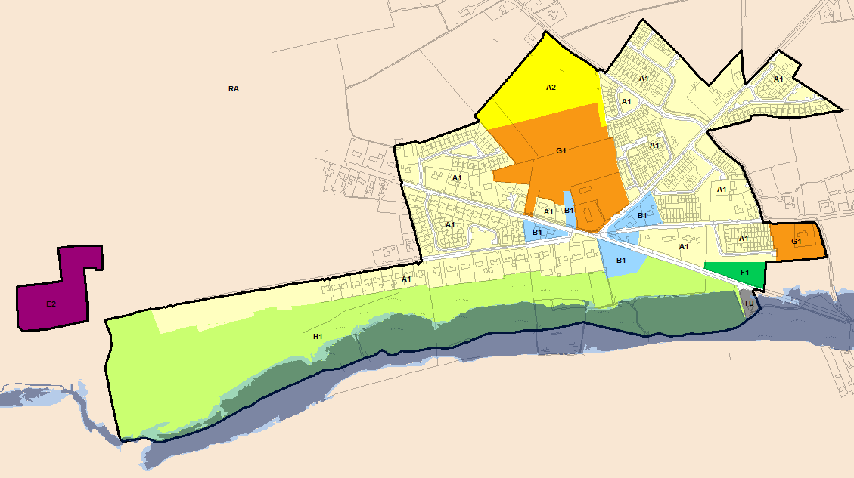
© Ordnance Survey Ireland & Government of Ireland, Meath 2019/31/CCMA
The Flood Zone mapping has been produced in accordance with the Planning Guidelines and therefore ignores the impact of flood protection structures. Areas protected by flood defences still carry a residual risk of flooding due to overtopping or breach, there may also be no guarantee of maintenance in perpetuity. Areas that benefit from defences are annotated separately. Flood Zone A – Fluvial: 1 in 100 year or 1% AEP, Tidal: 1 in 200 year or 0.5% AEP. Flood Zone B – 1 in 1000 year or 0.1% AEP.

Flood Zone Data | FEM FRAMS
Historic Flooding | Reports of historic flooding from the River Nanny (impacting roads not houses). Recurring road flooding related to minor local drainage issue.
Comment:
FEM FRAMS report notes that "The Kentstown area is exposed to fluvial flooding and the R153 road bridge overtops for the 2% AEP fluvial design event or greater. Fluvial flooding for the 10%, 1% and 0.1% AEP flood events affects agricultural lands on the left and right banks of the River Nanny."
The River Nanny restricts development to the south and lands subject to flood risk are appropriately zoned H1. The Flood Zones will not hinder future development for the majority of the settlement. A wastewater treatment/pumping station zoned TU is located adjacent to the River Nanny and has been raised/protected from the river. A site specific flood risk assessment would be required for any future development/upgrade here.

Flood risk can be managed by adopting the policies set out in the MCDP.

A flood forecasting and warning system was recommended for the Nanny River by the FEM FRAMS as a non-structural measure designed to limit the impact of flooding for communities at risk from the Nanny River.
Climate Change | A "Marginal" impact is predicted by the FEM FRAMS for both banks of the River Nanny.
Conclusion | Manage flood risk and development in line with approved policies and objectives. The FEM FRAMS recommendation for proactive maintenance of the Kentstown Bridge R153 should be followed. A flood forecasting and warning system was also recommended by the FEM FRAMS.

Kilbride
Hierarchy |  | VILLAGE
Area for Further Assessment under CFRAM programme? |  | No
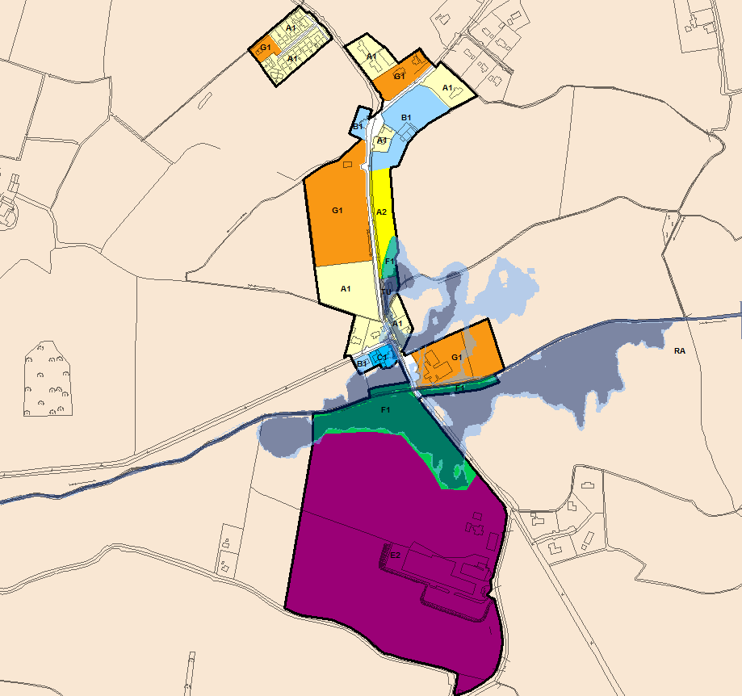
© Ordnance Survey Ireland & Government of Ireland, Meath 2019/31/CCMA
The Flood Zone mapping has been produced in accordance with the Planning Guidelines and therefore ignores the impact of flood protection structures. Areas protected by flood defences still carry a residual risk of flooding due to overtopping or breach, there may also be no guarantee of maintenance in perpetuity. Areas that benefit from defences are annotated separately. Flood Zone A – Fluvial: 1 in 100 year or 1% AEP, Tidal: 1 in 200 year or 0.5% AEP. Flood Zone B – 1 in 1000 year or 0.1% AEP.

Flood Zone Data | Detailed Flood Risk Assessment – 1D/2D modelling.
Historic Flooding | Kilbride recurring flooding after heavy rain due to blocked drains - surface water flood problem. Flooding of farmland upstream of the village.
Comment:
The Ward River flows through Kilbride and passes along the boundary of Kilbride National School. There are no historic records that suggest the River Ward has flooded the school or other properties, however there has been flooding of agricultural land upstream of the village.

Flood mapping was recently updated following a detailed flood risk assessment. The G1 school site has been raised and there is some minor overtopping of the bank at the 0.1% AEP event. Risk to existing development comes from water that comes out of bank upstream of the village, flowing through agricultural lands before becoming separated from the channel. Flow crosses the main road and ponds in land to the east of the cross roads. Existing residential development and an MCC Pumping Station are potentially impacted.

Any additional development should be managed in line with the policies (INF POL 14-29) of the MCDP. Within areas of existing development proposals for extensions and minor works should be considered under Section 5.28 of the Planning System and Flood Risk Management Guidelines and with due regard to the aforementioned policies.

Climate Change | A marginal increase in flood risk is suggested by the flood extents.
Conclusion | Manage flood risk and development in line with approved policies and objectives, application of the sequential approach and associated detailed FRA is required for any new development within Flood Zone A/B or adjacent to a field drain.

Kilcock Environs
Hierarchy |  | SELF-SUSTAINING TOWN
Area for Further Assessment under CFRAM programme? |  | Yes - Flood Mapping available, flood relief scheme recommended for review.
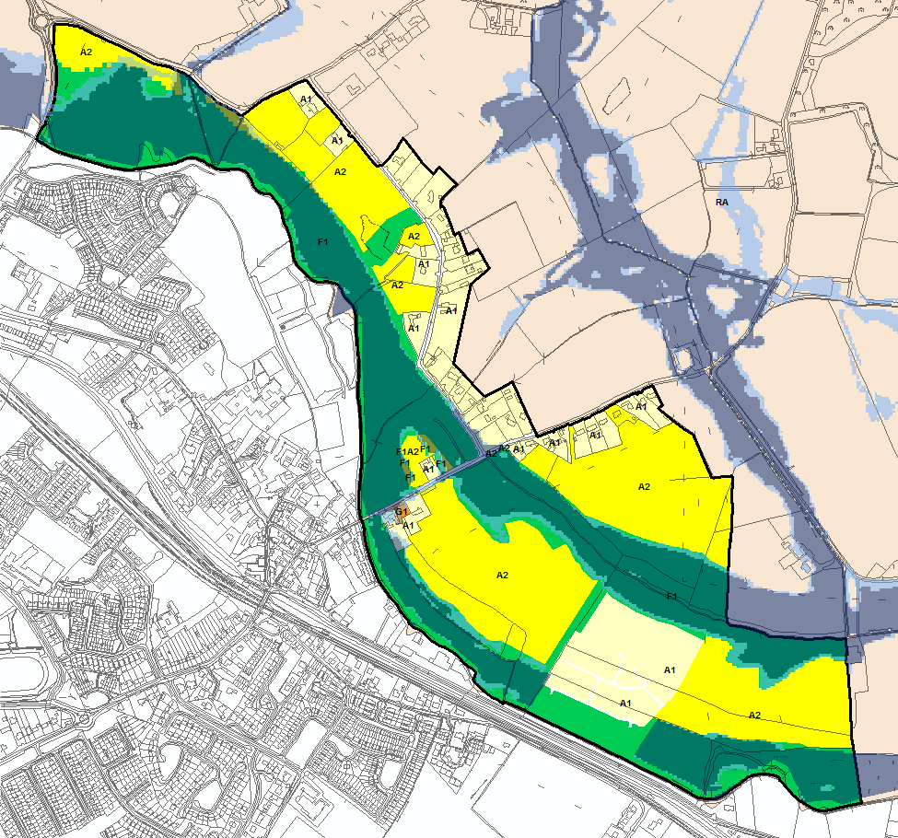
© Ordnance Survey Ireland & Government of Ireland, Meath 2019/31/CCMA
The Flood Zone mapping has been produced in accordance with the Planning Guidelines and therefore ignores the impact of flood protection structures. Areas protected by flood defences still carry a residual risk of flooding due to overtopping or breach, there may also be no guarantee of maintenance in perpetuity. Areas that benefit from defences are annotated separately. Flood Zone A – Fluvial: 1 in 100 year or 1% AEP, Tidal: 1 in 200 year or 0.5% AEP. Flood Zone B – 1 in 1000 year or 0.1% AEP.
Flood Zone Data | CFRAM mapping verified on site by JBA.
Historic Flooding | Recurring flooding from the River Rye Water is noted along with events in August 2008 and November 2000.
Comment:
Kilcock Environs is situated on the county border with Kildare and is subject to significant flood risk from the River Rye Water. A FRAM study for the area was commissioned for a consortium of private developers and the existing (undefended) flood outlines were provided to MCC and were used under the Variation 2 of the 2013-19 MCDP to represent the Flood Zones. Under Variation 3 of the 2013-19 MCDP the previous mapping was superseded by the draft CFRAM mapping, flood extents were similar, but more extensive in some areas. The finalised CFRAM mapping is now available and has been updated for the 2020-2026 MCDP, extents varied slightly compared to the draft.

The flood relief scheme designed as part of the FRAM study for the undeveloped lands was granted permission by An Bord Pleanála and has recently been constructed in County Meath, protecting some of the A1 land that formerly in Flood Zone A. The Flood Zone mapping in these raised lands has been adjusted, however for the remaining land-bank impacted by the flood relief scheme there is currently no revised Flood Zone information available. As such there has only been a minor adjustment to the Flood Zones for Kilcock Environs. There is still some A2 land that overlaps with the current version of the Flood Zones in the north west of the settlement and in the pocket north of the R125. These areas must be reconciled with an up to date version of the Flood Zones and the principles of the Planning Guidelines prior to adoption.

When zoning land, consideration should be given to the undefended scenario (as stated in the Planning System and Flood Risk Management Guidelines) and this is the overriding principle in Kilcock. Existing development has historically avoided areas at high risk of flooding from the River Rye Water.

New residential (A2) land use zoning objectives exist where the River Rye Water bifurcates into two channels. This area contains Flood Zone C which is where the A2 zoning is focussed. Whilst highly vulnerable development is appropriate within Flood Zone C, road access must be maintained in the event of flooding and roads objectives exist to ensure this is achieved. Since the proposed Local Distributor Road, extending from the R148 (Maynooth Road) to the existing R125 (Dunshaughlin Road), is crossing Flood Zone A/B the Justification Test has been applied and passed (see Appendix A.3).

Any planning permissions for A2 development must be subject to appropriately detailed FRA at development management stage and INF POL 14-29 of the MCDP. Further guidance on the approach to development management and FRA is provided in Sections 4.4 to 4.11. The FRA must include for the design of FFL/ground levels that are in excess of the 100 year flood level plus climate change and freeboard. The Local Distributor Road extending from the R148 (Maynooth Road) to the existing R125 (Dunshaughlin Road) must also undergo appropriately detailed FRA at development management stage. As the road alignment is within Flood Zone A/B adequate consideration should be given to the maintenance of floodplain storage and potential negative impacts of the road alignment on the neighbouring A2 site. Section 50 consent will be required from the OPW for any watercourse crossings.

Climate Change | A marginal increase in flood risk is expected on the River Rye Water.
Conclusion | Manage flood risk and development in line with approved policies and objectives, appropriately detailed FRA is required for any new A2 development in this settlement which must demonstrate that FFLs and ground levels are maintained above the 100yr flood level plus climate change and freeboard. The Local Distributor Road must also undergo FRA at development management stage. Final details of the Flood Zones as a result of the new flood relief scheme works is yet to be supplied, but this must be reconciled with proposed zonings and the Planning Guidelines applied prior to adoption.

Kildalkey
Hierarchy |  | VILLAGE
Area for Further Assessment under CFRAM programme? |  | No
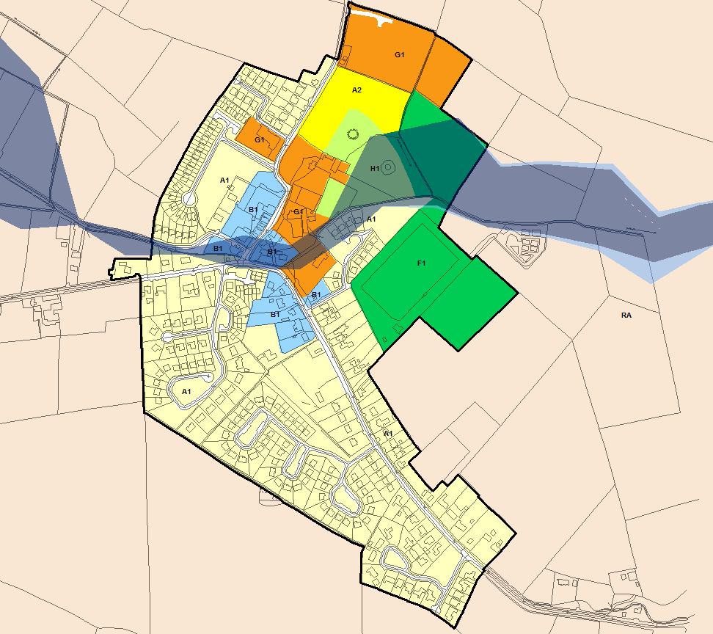
© Ordnance Survey Ireland & Government of Ireland, Meath 2019/31/CCMA
The Flood Zone mapping has been produced in accordance with the Planning Guidelines and therefore ignores the impact of flood protection structures. Areas protected by flood defences still carry a residual risk of flooding due to overtopping or breach, there may also be no guarantee of maintenance in perpetuity. Areas that benefit from defences are annotated separately. Flood Zone A – Fluvial: 1 in 100 year or 1% AEP, Tidal: 1 in 200 year or 0.5% AEP. Flood Zone B – 1 in 1000 year or 0.1% AEP.

Flood Zone Data | Eastern CFRAM Flood Risk Review (PFRA).
Historic Flooding | No historic records of flooding were found
Comment:
Flood risk in Kildalkey is related to a single watercourse with no previous history of flooding. The village centre (B1, A1 and F1) lands are at potential risk and this area contains existing development.

Existing residential development (A1 & B1) should be managed in line with the policies (INF POL 14-29) of the MCDP. Within areas of existing development proposals for extensions and minor works should be considered under Section 5.28 of the Planning System and Flood Risk Management Guidelines and with due regard to the aforementioned policies.
Climate Change | Flood outlines suggest that the site is not particularly sensitive to the impacts of climate change.
Conclusion | Manage flood risk and development in line with approved policies and objectives, application of the sequential approach and associated detailed FRA is required for any new development within Flood Zone A/B. FRA required for the A2 lands.

Kilmainhamwood
Hierarchy |  | VILLAGE
Area for Further Assessment under CFRAM programme? |  | No
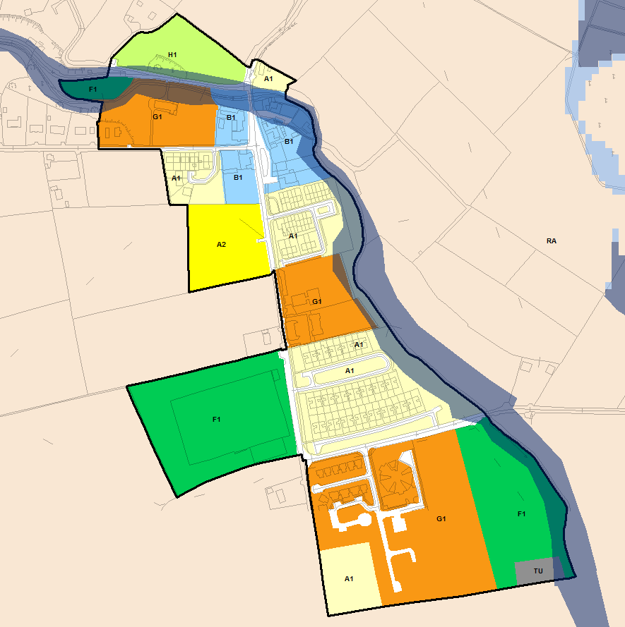
© Ordnance Survey Ireland & Government of Ireland, Meath 2019/31/CCMA
The Flood Zone mapping has been produced in accordance with the Planning Guidelines and therefore ignores the impact of flood protection structures. Areas protected by flood defences still carry a residual risk of flooding due to overtopping or breach, there may also be no guarantee of maintenance in perpetuity. Areas that benefit from defences are annotated separately. Flood Zone A – Fluvial: 1 in 100 year or 1% AEP, Tidal: 1 in 200 year or 0.5% AEP. Flood Zone B – 1 in 1000 year or 0.1% AEP.

Flood Zone Data | North West Neagh-Bann CFRAM Flood Risk Review (PFRA) and JBA site visit.
Historic Flooding | Four residential properties recently flooded and remedial work (dredging) has been carried out on the watercourse by OPW. Local pluvial flooding noted near to football pitch.
Comment:
Development is constrained to the north and east by the Kilmainham River and to the west by elevated ground. The extent of land use zonings shown to be within areas at potential flood risk are all on existing developed sites and no new development is proposed within Flood Zone A or B.

Risk to existing residential, commercial centre and community infrastructure development (A1, B1 & G1) should be managed in line with the policies (INF POL 14-29) of the MCDP. Within areas of existing development, proposals for extensions and minor works should be considered under Section 5.28 of the Planning System and Flood Risk Management Guidelines and with due regard to INF POL 14-29 of the MCDP. Maintenance of the watercourse (as already undertaken by OPW) is recommended to lower the risk of flooding. Pedestrian walkways within Flood Zone A or B are appropriate and will require an appropriately detailed FRA at planning stage and should generally not result in an increase in ground level within these zones.
Climate Change | A review of the PFRA Flood Zone A and B outlines suggests that there is only a marginal increase in fluvial flood extent for an increase in severity. Potential increase in runoff from pluvial events but overall low climate change impact.
Conclusion | Manage flood risk and development in line with approved policies and objectives, apply sequential approach within existing zoned development lands at potential risk of flooding.

Kilmessan
Hierarchy |  | VILLAGE
Area for Further Assessment under CFRAM programme? |  | No
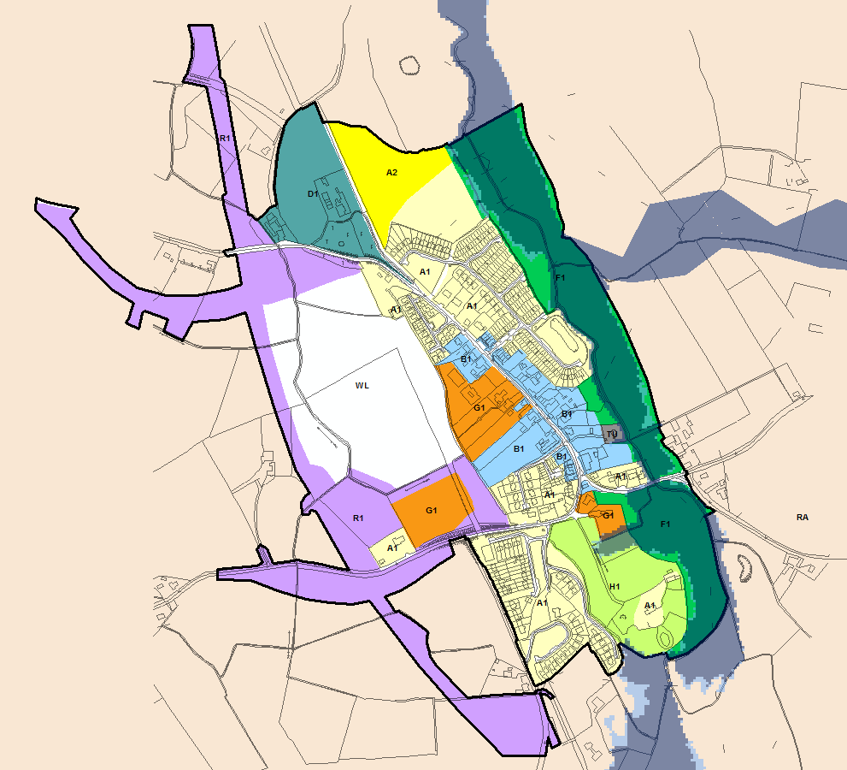
© Ordnance Survey Ireland & Government of Ireland, Meath 2019/31/CCMA
The Flood Zone mapping has been produced in accordance with the Planning Guidelines and therefore ignores the impact of flood protection structures. Areas protected by flood defences still carry a residual risk of flooding due to overtopping or breach, there may also be no guarantee of maintenance in perpetuity. Areas that benefit from defences are annotated separately. Flood Zone A – Fluvial: 1 in 100 year or 1% AEP, Tidal: 1 in 200 year or 0.5% AEP. Flood Zone B – 1 in 1000 year or 0.1% AEP.

Flood Zone Data | JFlow, Eastern CFRAM Flood Risk Review (PFRA) & and JBA site visit.
Historic Flooding | Reports of recurring flood event from a stream to the north. Record states this occurs annually. Flood event in 2008 affected 1 property.
Comment:
The River Skane flows through Kilmessan and the Flood Zone extent mapping has been re-modelled using revised flow estimates and improved DTM. There is a clearly defined floodplain associated with the river and existing development through Kilmessan has historically avoided high risk areas.

The principal of risk avoidance has been applied when considering undeveloped land use zoning objectives and areas within Flood Zone A and B are under H1 or F1 zoning to ensure water compatible uses are maintained.

Kilmessan Bridge represents the largest risk to existing property as a result of the potential for structure blockage and residual flood risk from increased flood levels. An active maintenance programme on the watercourse would provide a suitable risk management measure.

Climate Change | JFLOW Flood Zone A and B outlines suggest that there is only a marginal increase in fluvial flood extent through the core of the village. The area most sensitive to the impacts of climate change is the area upstream of Kilmessan Bridge.
Conclusion | Manage flood risk and development in line with approved policies and objectives. Active maintenance of the river at Kilmessan Bridge is recommended to reduce the probability of structure blockage.

Longwood
Hierarchy |  | VILLAGE
Area for Further Assessment under CFRAM programme? |  | Yes - Flood Mapping available, flood relief scheme not recommended.
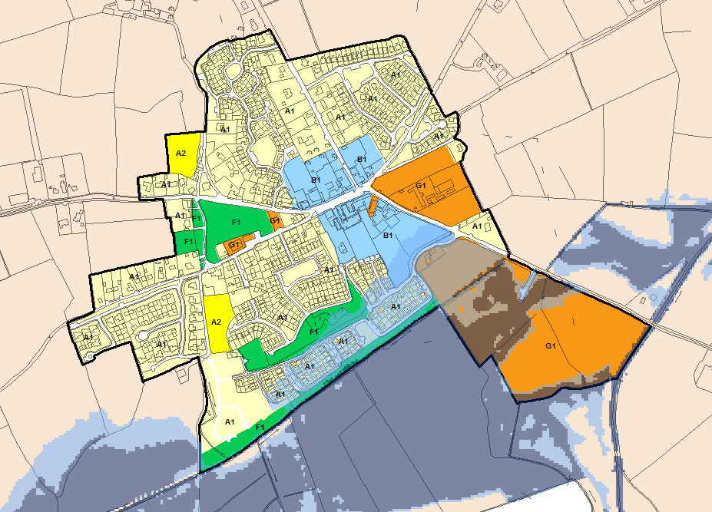
© Ordnance Survey Ireland & Government of Ireland, Meath 2019/31/CCMA
The Flood Zone mapping has been produced in accordance with the Planning Guidelines and therefore ignores the impact of flood protection structures. Areas protected by flood defences still carry a residual risk of flooding due to overtopping or breach, there may also be no guarantee of maintenance in perpetuity. Areas that benefit from defences are annotated separately. Flood Zone A – Fluvial: 1 in 100 year or 1% AEP, Tidal: 1 in 200 year or 0.5% AEP. Flood Zone B – 1 in 1000 year or 0.1% AEP.

Flood Zone Data | CFRAM mapping verified on site by JBA.
Historic Flooding | No history of flooding with the urban area of Longwood but a record of flooding recurring in the Moyvalley.
Comment:
The River Blackwater flows adjacent to the eastern border of the settlement, A large field drain extends along the southern border of the settlement and flows into the River Blackwater passing through the G1 lands. The CFRAM mapping impacts significant additional lands some developed and some undeveloped, the CFRAM management plan did not recommend a flood relief scheme as there are not significant properties within Flood Zone A.

Any new development or extensions within the G1 or B1 lands should be subject to an appropriately detailed FRA at development management stage to ensure that the FFL is set appropriately and the site can manage any potential risk. During any FRA the residual risk of culvert/bridge blockage must also be investigated with respect to the potential impacts on flood levels/extents. Assessments should be in line with INF POL 14-29 of the MCDP and further guidance on the approach to development management and FRA is provided in Sections 4.4 to 4.11.

The potential for structure blockage and residual flood risk from increased flood levels should be managed by the appropriate maintenance of the large field drain that runs through the G1 lands. Previous flooding in the area has resulted from the operation of a sluice on this watercourse. The revised flood outlines provided by the CFRAM mapping suggests that this process should be a high priority given the highly vulnerable development in the locality.

Climate Change | CFRAM mapping deliverables do not include climate change impacts, however an initial appraisal suggests that there is a high level of sensitivity to increases in flow and therefore climate change.
Conclusion | The CFRAM mapping presents significant increase in fluvial risk through the lands in the south of the settlement adjacent to the field drain and River Blackwater. The impacts are on existing developed lands. Prior to any future adjustment to the existing land use zonings the management of flood risk falls to the development management stage and INF POL 14-29 of the MCDP. Otherwise, manage flood risk and development in line with approved policies and objectives. Monitor the impacts of climate change at the next development plan review.

Maynooth Environs
Hierarchy |  | KEY TOWN
Area for Further Assessment under CFRAM programme? |  | Yes - Flood Mapping available, flood relief scheme not recommended.
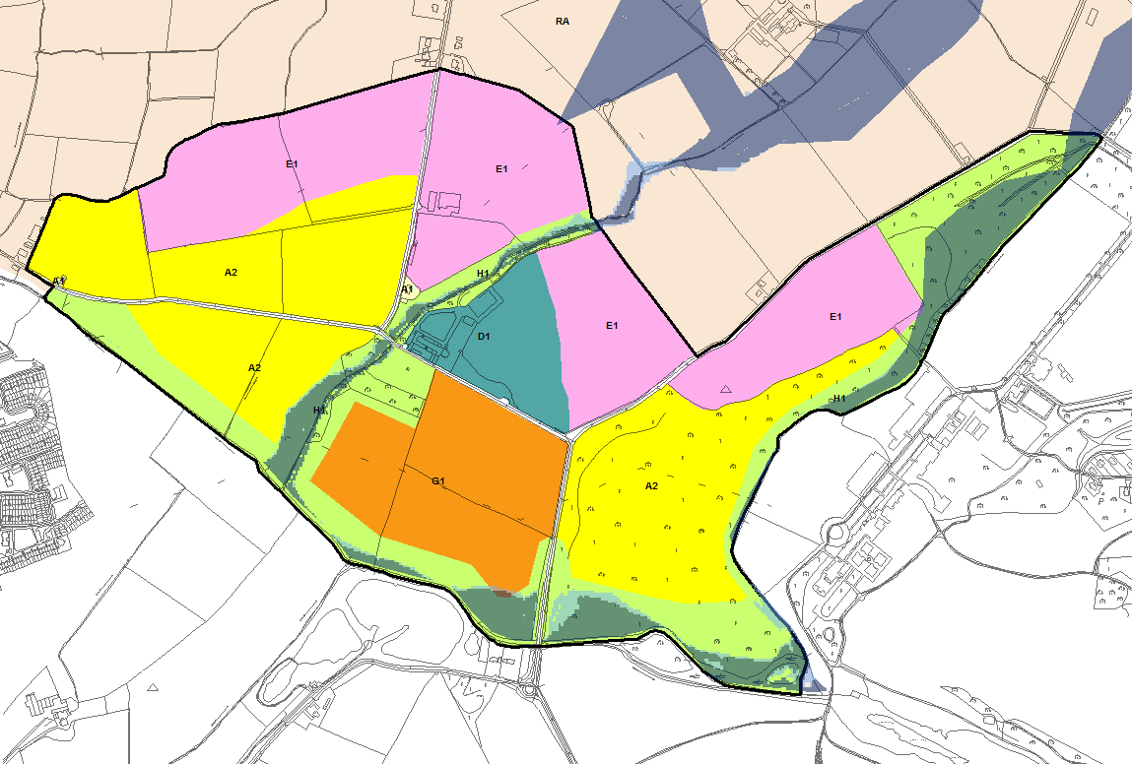
© Ordnance Survey Ireland & Government of Ireland, Meath 2019/31/CCMA
The Flood Zone mapping has been produced in accordance with the Planning Guidelines and therefore ignores the impact of flood protection structures. Areas protected by flood defences still carry a residual risk of flooding due to overtopping or breach, there may also be no guarantee of maintenance in perpetuity. Areas that benefit from defences are annotated separately. Flood Zone A – Fluvial: 1 in 100 year or 1% AEP, Tidal: 1 in 200 year or 0.5% AEP. Flood Zone B – 1 in 1000 year or 0.1% AEP.

Flood Zone Data | CFRAM mapping verified on site by JBA.
Historic Flooding | A record of a flood event in November 2000 is noted. The source is the floodwater is the River Rye Water.
Comment:
The River Rye Water flows adjacent to the southern and eastern border of the settlement, and a further tributary flows through the settlement from a north easterly direction. The CFRAM management plan confirms that there is an additional measure for Maynooth, however this is in Kildare and does not impact County Meath. The floodplain of both watercourses is appropriately zoned as F1 or H1. Existing development has largely avoided areas of high flood risk.

A distributor road objective is in place that seeks to cross the tributary of the River Rye Water, in this case the Justification Test has been applied and passed (see Appendix A.4). A site specific FRA will be required to manage the risk and to demonstrate there will be no impact on adjacent lands. OPW Section 50 consent for all watercourse crossings will be required.
Climate Change | CFRAM mapping deliverables do not include climate change impacts, however an initial appraisal suggests that there is a low level of sensitivity to increases in flow and therefore climate change.
Conclusion | Manage flood risk and development in line with approved policies and objectives. Ensure that the distributor road has appropriate site specific FRA and OPW Section 50 consent.

Moynalty
Hierarchy |  | VILLAGE
Area for Further Assessment under CFRAM programme? |  | No
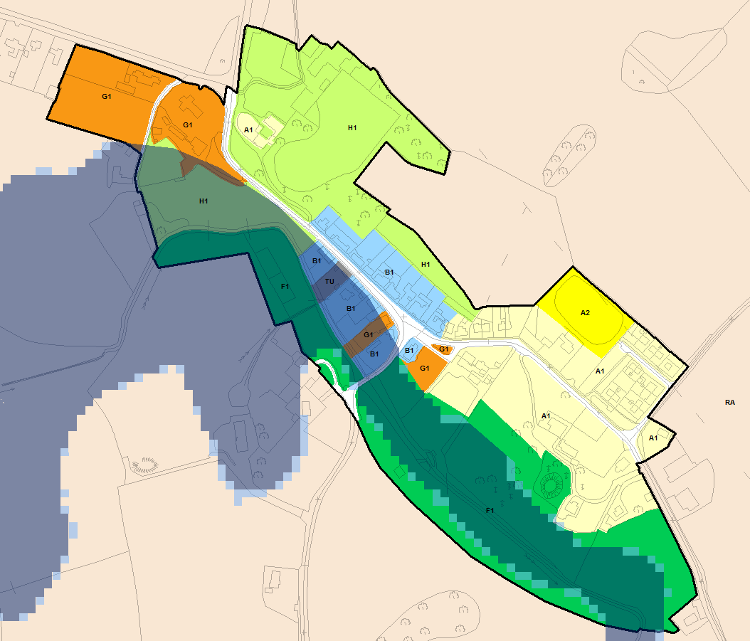
© Ordnance Survey Ireland & Government of Ireland, Meath 2019/31/CCMA
The Flood Zone mapping has been produced in accordance with the Planning Guidelines and therefore ignores the impact of flood protection structures. Areas protected by flood defences still carry a residual risk of flooding due to overtopping or breach, there may also be no guarantee of maintenance in perpetuity. Areas that benefit from defences are annotated separately. Flood Zone A – Fluvial: 1 in 100 year or 1% AEP, Tidal: 1 in 200 year or 0.5% AEP. Flood Zone B – 1 in 1000 year or 0.1% AEP.

Flood Zone Data | JFLOW modified based on JBA site visit.
Historic Flooding | Historic flooding from the Moynalty River is noted in 2009 and recurring.
Comment:
The Moynalty River restricts new development in the south and west of the settlement and all undeveloped lands at risk of flooding are zoned in a water compatible manner. Existing development in the core of the village (B1 & G1) should be managed in line with the policies (INF POL 14-29) of the MCDP. Within areas of existing development, proposals for extensions and minor works should be considered under Section 5.28 of the Planning System and Flood Risk Management Guidelines and with due regard to the aforementioned policies. It is unlikely that any development would be appropriate that interferes with conveyance of flood flows. Pedestrian walkways within Flood Zone A or B will require an appropriately detailed FRA at planning stage and should generally not result in an increase in ground level within these zones.
Climate Change | JFLOW Flood Zone A and B outlines suggest that there is only a marginal increase in fluvial flood extent for an increase in severity. Potential increase in runoff from pluvial events but overall low climate change impact is anticipated.
Conclusion | Manage flood risk and development in line with approved policies and objectives; apply sequential approach within existing zoned development lands at potential risk of flooding.

Navan
Hierarchy |  | KEY TOWN
Area for Further Assessment under CFRAM programme? |  | Yes - Flood Mapping available, flood relief scheme is pending project-level assessment. It is not listed on the 118 OPW schemes emanating from the CFRAM.
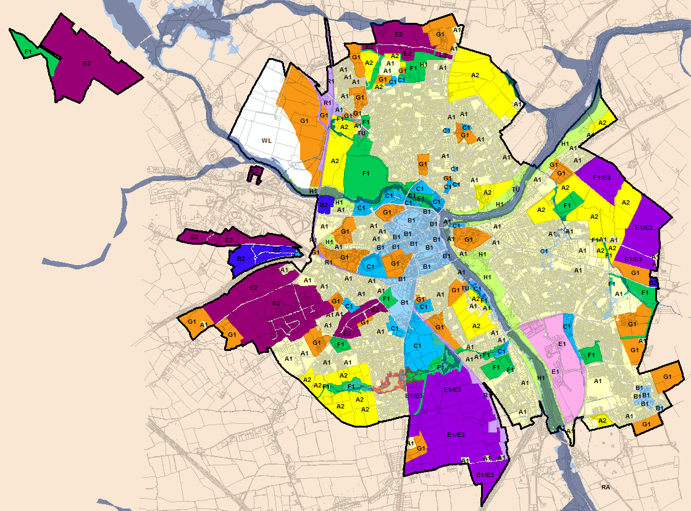
© Ordnance Survey Ireland & Government of Ireland, Meath 2019/31/CCMA
The Flood Zone mapping has been produced in accordance with the Planning Guidelines and therefore ignores the impact of flood protection structures. Areas protected by flood defences still carry a residual risk of flooding due to overtopping or breach, there may also be no guarantee of maintenance in perpetuity. Areas that benefit from defences are annotated separately. Flood Zone A – Fluvial: 1 in 100 year or 1% AEP, Tidal: 1 in 200 year or 0.5% AEP. Flood Zone B – 1 in 1000 year or 0.1% AEP.

Flood Zone Data | CFRAM, PFRA, and JBA site visit.
Historic Flooding | Significant flood history in Navan from Swan River & Rivers Boyne/Blackwater. Significant events in 2013, 2009, 2008, 2002, 2000.
Comment:
Areas of existing residential development (A1) and town centre lands (B1) are at potential risk of flooding. Flood history supports Flood Zone mapping on Academy Street and Bridge Street as well as flooding from the River Swan in Balreask and Kilcarn housing estates. Balreask Manor and Canterbrook estates are now protected up to a 1 in 100 year standard. In line with the policies (INF POL 14-29) of the MCDP, any extensions/change of use/reconstruction should be subject to an appropriately detailed FRA.

All new residential zoning objectives (A2) follow the sequential approach and preferentially avoid areas within Flood Zone A or B. In all cases, risk can be managed by an appropriately detailed FRA at development management stage (in line with INF POL 14-29 of the MCDP).

There is significant existing C1 and B2 development adjacent to the Rivers Boyne and Blackwater some of which is located within Flood Zone A/B and risk should be managed in line with the policies (INF POL 14-29) of the MCDP. Any extensions/change of use/reconstruction should be subject to an appropriately detailed FRA.

Areas of C1 & E1 development within Flood Zone A or B are located off Metges Road (Priory Stream). Flood extents are now mapped by the CFRAM modelling, and are not significantly out of bank, it is recommended that open space is maintained adjacent to the watercourses within Flood Zone A/B in accordance with INF POL 14-29 (INF POL 22 in particular). An appropriately detailed FRA will be required to demonstrate that any planning application(s) are employing this approach. There is also A2 zoned land in this area and the CFRAM mapping confirms minor flood risk Flood Zone A/B is retained within the channel. Any planning applications on the A2 sites adjoining the local watercourses should be subject to appropriately detailed FRA in line with INF POL 14-29 of the MCDP.

Some existing E2 lands to the north of the settlement (Kilsaran) have a small overlap with Flood Zone A, as generated from PFRA mapping. Any potential future development should seek to address the risk in more detail in line with INF POL 14-29.

The protection of the designated route of the extension of the Clonsilla to Parkway rail line to Navan is catered for by zoning objective R1 “To provide for a strategic rail corridor and associated physical infrastructure.” The zoning has a single purpose use which is to protect the designated route from development which would otherwise compromise its future delivery. As such, the Justification Test and more detailed FRA of the corridor is not required. At such a time as the scheme is formally progressed then the detailed design should be subject to further investigation in line with the Planning System and Flood Risk Management Guidelines. For the most part the route alignment seeks to utilise an existing de-commissioned railway line and many of the river crossings are already in place. Any new crossings will also need to obtain OPW Section 50 consent. To the west of this zoning some G1 lands are within Flood Zone A/B. Flood Zone A is retained within the channel, Flood Zone B impacts some lands and adequate provision for the management of flood risk should be provided at development management stage through the application of INF POL 14-29.

Proposed road objectives could potentially intersect Flood Zones A/B. The indicative sites will require further assessment once the routes are confirmed and intersections with Flood Zone A/B have been identified, in line with the INF POL 14-29 of the MCDP. OPW Section 50 consent for all watercourse crossings will be required prior to construction.
Climate Change | Moderate to high risk presented, particularly on smaller watercourses where culverts are exerting an influence on upstream flood levels.
Conclusion | Flood risk is manageable by application of Policies 14-29 of the MCDP. Undeveloped zoned land applies the sequential approach and preferentially avoids risk. Some existing land is at risk but a potential flood relief scheme has not been guaranteed by OPW after the formal promotion of 118 schemes from the CFRAM process. Any potential link roads crossing Flood Zone A/B should be subject to FRA and Section 50 consent.

Nobber
Hierarchy |  | VILLAGE
Area for Further Assessment under CFRAM programme? |  | No
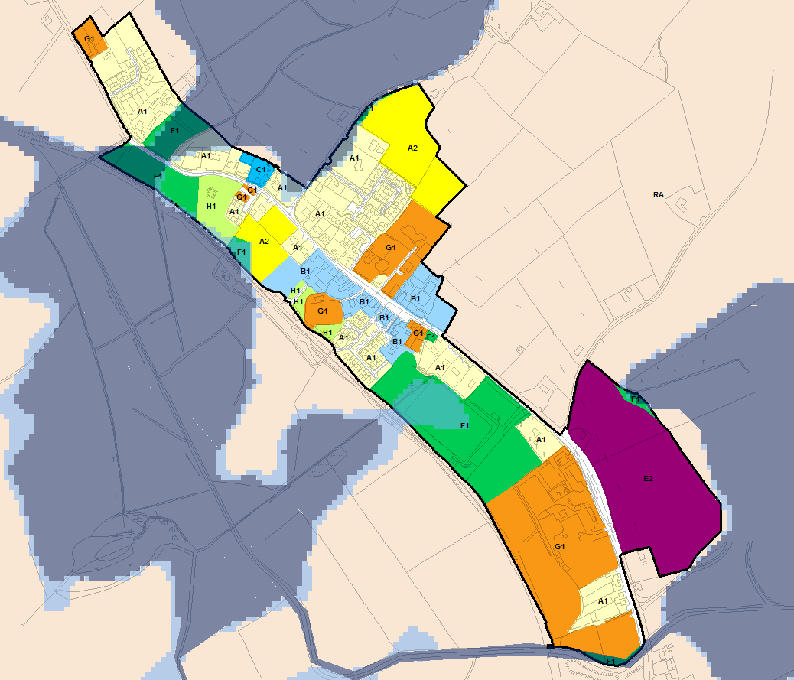
© Ordnance Survey Ireland & Government of Ireland, Meath 2019/31/CCMA
The Flood Zone mapping has been produced in accordance with the Planning Guidelines and therefore ignores the impact of flood protection structures. Areas protected by flood defences still carry a residual risk of flooding due to overtopping or breach, there may also be no guarantee of maintenance in perpetuity. Areas that benefit from defences are annotated separately. Flood Zone A – Fluvial: 1 in 100 year or 1% AEP, Tidal: 1 in 200 year or 0.5% AEP. Flood Zone B – 1 in 1000 year or 0.1% AEP.

Flood Zone Data | JFLOW, PFRA, and JBA site visit.
Historic Flooding | The River Dee is noted as causing flooding as well as the tributary entering the River Dee from the north east.
Comment:
Development in Nobber is generally constrained by the natural (drumlin dominated) topography and development on lower lying land is also restricted by potential flooding. The extent of Flood Zones A and B are limited to water compatible or existing residential (F1, H1 & A1) land uses.
Development within the settlement should be managed in line with the policies (INF POL 14-29) of the MCDP. Within areas of existing development, proposals for extensions and minor works should be considered under Section 5.28 of the Planning System and Flood Risk Management Guidelines and with due regard to the aforementioned policies. Pedestrian walkways within Flood Zone A or B will require an appropriately detailed FRA at planning stage and should generally not result in increased ground level within these zones.

Climate Change | A review of the PFRA & JFLOW Flood Zone A and B outlines suggests that there is some sensitivity to climate change, most likely to be occur where Flood Zone B is significantly greater than Zone A - south west of village core in F1 zoning. Potential increase in runoff from pluvial events but overall low climate change impact.
Conclusion | Manage flood risk and development in line with approved policies and objectives. The E2 lands must promote open space/water compatible use within Flood Zone A/B.

Oldcastle
Hierarchy |  | TOWN
Area for Further Assessment under CFRAM programme? |  | No
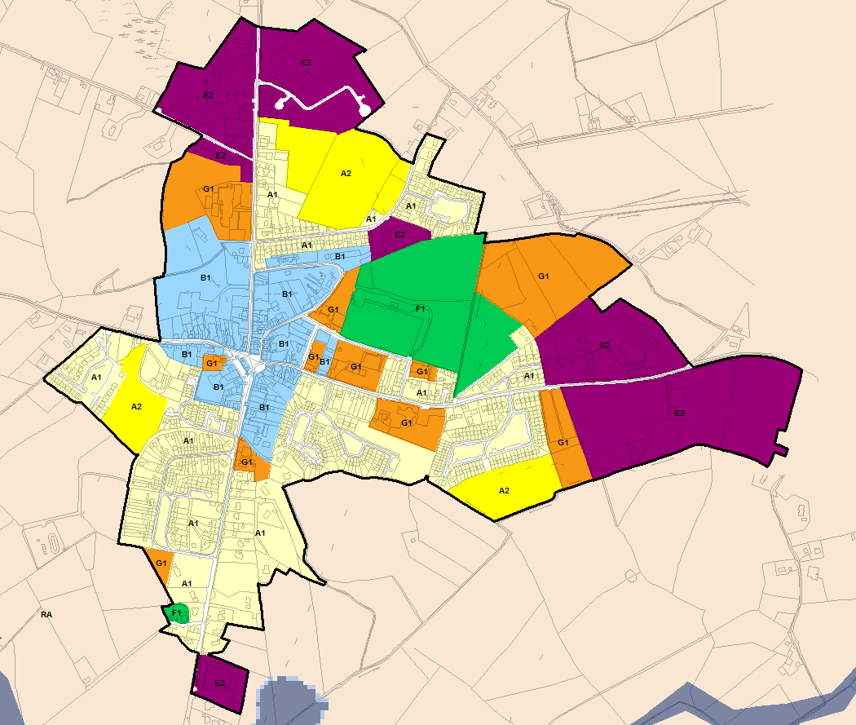
© Ordnance Survey Ireland & Government of Ireland, Meath 2019/31/CCMA
The Flood Zone mapping has been produced in accordance with the Planning Guidelines and therefore ignores the impact of flood protection structures. Areas protected by flood defences still carry a residual risk of flooding due to overtopping or breach, there may also be no guarantee of maintenance in perpetuity. Areas that benefit from defences are annotated separately. Flood Zone A – Fluvial: 1 in 100 year or 1% AEP, Tidal: 1 in 200 year or 0.5% AEP. Flood Zone B – 1 in 1000 year or 0.1% AEP.

Flood Zone Data | n/a
Historic Flooding | Recurring surface water flooding on Store Road.
Comment:
No fluvial risk identified. OPW benefitting lands mapping indicates some coverage within previously developed general enterprise & employment (E2) zoned land and new residential (A2) in the north west fringe of the settlement. This is not verified by flood history or recent PFRA or JFLOW mapping.

Development within the settlement should be managed in line with the policies (INF POL 14-29) of the MCDP and this will ensure adequate consideration of risk at development management stage.

Climate Change | Limited or no fluvial impacts, potential increase in runoff could exacerbate existing surface water flooding.
Conclusion | Manage flood risk and development in line with approved policies and objectives.

Rathcairn
Hierarchy |  | VILLAGE
Area for Further Assessment under CFRAM programme? |  | No
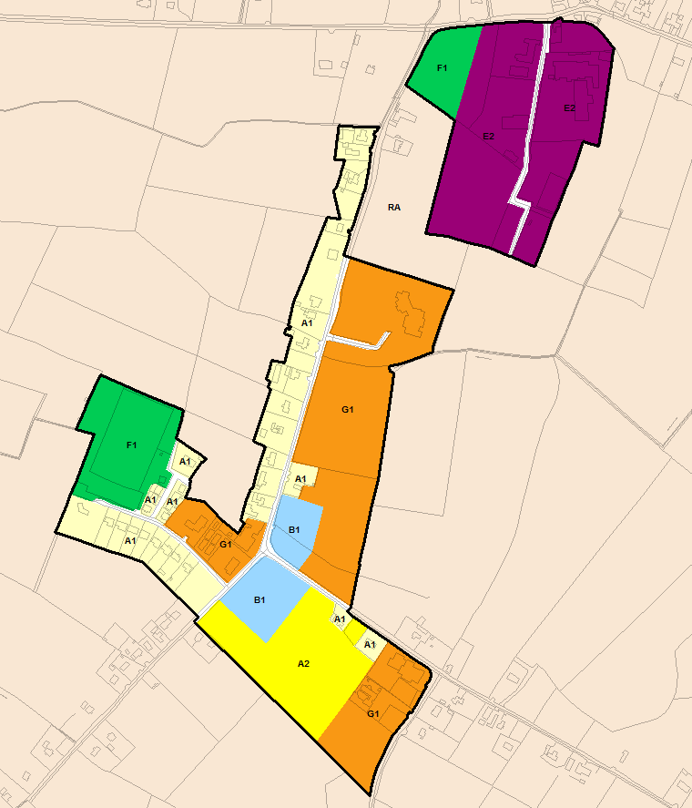
© Ordnance Survey Ireland & Government of Ireland, Meath 2019/31/CCMA
The Flood Zone mapping has been produced in accordance with the Planning Guidelines and therefore ignores the impact of flood protection structures. Areas protected by flood defences still carry a residual risk of flooding due to overtopping or breach, there may also be no guarantee of maintenance in perpetuity. Areas that benefit from defences are annotated separately. Flood Zone A – Fluvial: 1 in 100 year or 1% AEP, Tidal: 1 in 200 year or 0.5% AEP. Flood Zone B – 1 in 1000 year or 0.1% AEP.

Flood Zone Data | n/a
Historic Flooding | No historic records of flooding were found.
Comment:
No fluvial risk identified. OPW benefitting lands mapping indicates some coverage within previously developed general enterprise & employment (E2) zoned land in the north eastern pocket of the settlement. This is not verified by flood history or recent PFRA or JFLOW mapping. Development within the settlement should be managed in line with the policies (INF POL 14-29) of the MCDP and this will ensure adequate consideration of risk at development management stage.

Climate Change | No fluvial impacts, potential increase in runoff.
Conclusion | Manage flood risk and development in line with approved policies and objectives.

Rathmolyon
Hierarchy |  | VILLAGE
Area for Further Assessment under CFRAM programme? |  | No
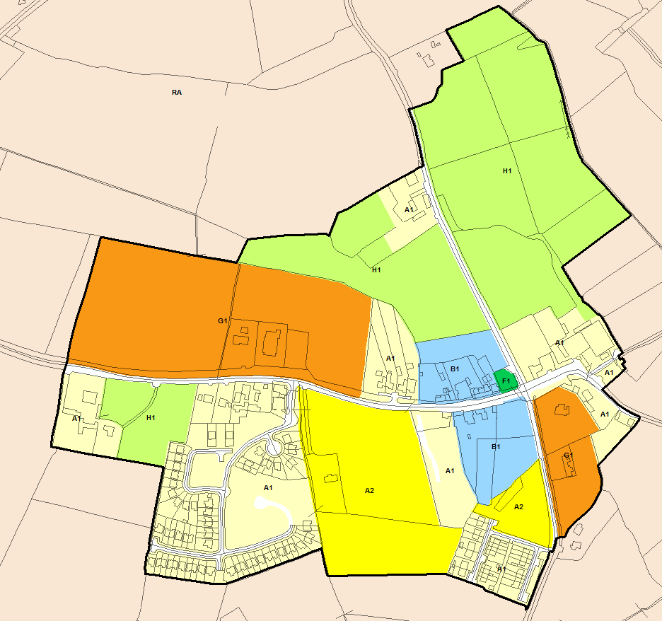
© Ordnance Survey Ireland & Government of Ireland, Meath 2019/31/CCMA
The Flood Zone mapping has been produced in accordance with the Planning Guidelines and therefore ignores the impact of flood protection structures. Areas protected by flood defences still carry a residual risk of flooding due to overtopping or breach, there may also be no guarantee of maintenance in perpetuity. Areas that benefit from defences are annotated separately. Flood Zone A – Fluvial: 1 in 100 year or 1% AEP, Tidal: 1 in 200 year or 0.5% AEP. Flood Zone B – 1 in 1000 year or 0.1% AEP.
Flood Zone Data | n/a
Historic Flooding | Recurring flood event on the R156 road to Cherryvalley.
Comment | None recorded
Climate Change | No fluvial impacts, potential increase in runoff.
Conclusion | Manage flood risk and development in line with approved policies and objectives.

Ratoath
Hierarchy |  | SELF-SUSTAINING TOWN
Area for Further Assessment under CFRAM programme? |  | FEM FRAMS published 2011
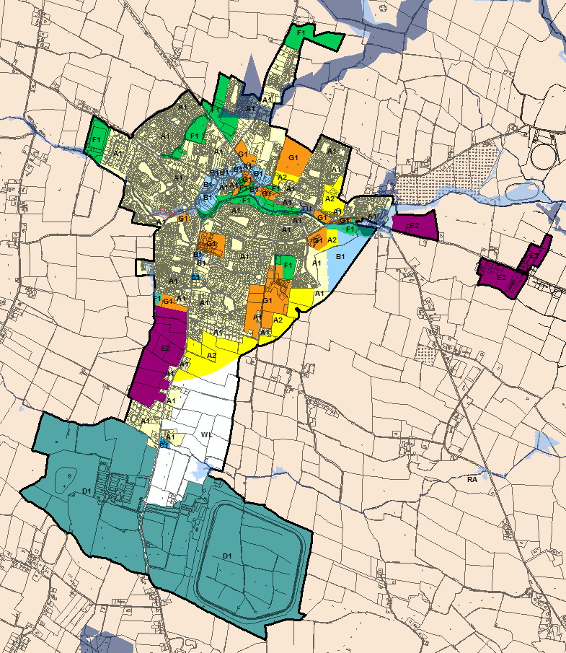
© Ordnance Survey Ireland & Government of Ireland, Meath 2019/31/CCMA
The Flood Zone mapping has been produced in accordance with the Planning Guidelines and therefore ignores the impact of flood protection structures. Areas protected by flood defences still carry a residual risk of flooding due to overtopping or breach, there may also be no guarantee of maintenance in perpetuity. Areas that benefit from defences are annotated separately. Flood Zone A – Fluvial: 1 in 100 year or 1% AEP, Tidal: 1 in 200 year or 0.5% AEP. Flood Zone B – 1 in 1000 year or 0.1% AEP.

Flood Zone Data | FEM FRAMS, OPW PFRA and JBA site visit.
Historic Flooding | No historic records of flooding were found.
Comment:
Ratoath is exposed to fluvial flooding from the Broadmeadow River. Flood Zone A mainly affects agricultural lands and a small number of properties on the eastern side of Ratoath in the Moulden Bridge Area. Defences in the Somerville Estate in Ratoath provide protection up to the 1% AEP event (Flood Zone A). For return periods above this standard of protection the area is still at risk (Flood Zone B is unchanged).

The flood extents impact on existing development for Residential (A1), Open Space (F1), Community Infrastructure (G1). Transport & Utilities (TU) and Town Centre (B1) lands. Risk to existing A1, B1, TU and G1 development should be managed in line with the policies (INF POL 14-29) of the MCDP. Within areas of existing development, proposals for extensions and minor works should be considered under Section 5.28 of the Planning System and Flood Risk Management Guidelines and with due regard to the aforementioned policies.

Potential risk to new development to east of town for, G1 and B1. Any new development under the proposed G1 land use zoning bordering the Broadmeadow River should be subject to appropriately detailed FRA at the development management stage in line with the MCDP policies.

Risk to development in the defended area of Somerville estate should be managed in line with the current policies and objectives. Any development is likely to be limited by the Justification Test to extensions and residual risk should be considered under the associated FRA.

Significant lands to the south of Ratoath (Fairyhouse and Tattersalls) are zoned for tourism (D1) and incorporate equine uses. A small watercourse passes alongside the northern boundary of the site and does not significantly impact the zoned land. Flood risk should be managed by the application of the sequential approach and appropriately detailed FRA at development management stage, as required.

The FEM FRAMS highlighted possible risk from conveyance/blockage from the R125 bridge and a culvert on the tributary of the Broadmeadow River. Any FRAs undertaken in this area at development management stage should include consideration of the residual flood risk related to blockage.

FEM FRAMS mitigation options identified the improvement of channel conveyance by replacing a bridge on the Broadmeadow River at the R125 Ashbourne Road and replacing a culvert on a tributary of the Broadmeadow River. However, the benefit cost ratio was not greater than 1 and unless additional analysis can increase this value above 1 then a scheme will not be progressed. The bridge on the Broadmeadow River at the R125 Ashbourne Road has now been upgraded. Proactive maintenance of the existing flood defence in Ratoath was recommended and this is not subject to further review.

Pedestrian walkways may require FRA during planning application stage but the Justification Text is not required.

Climate Change | The impact of Climate change on increased river flows results in a large increase in flood risk in Ratoath, particularly around the R125 bridge.
Conclusion | Manage flood risk and development in line with approved policies and objectives. At development management stage any FRAs should include consideration of culvert blockage when assessing risk and recommending design details. Pedestrian walkways may require FRA during planning application stage but the Justification Text is not required.

Slane
Hierarchy |  | VILLAGE
Area for Further Assessment under CFRAM programme? |  | Yes - Flood Mapping available, flood relief scheme not recommended.
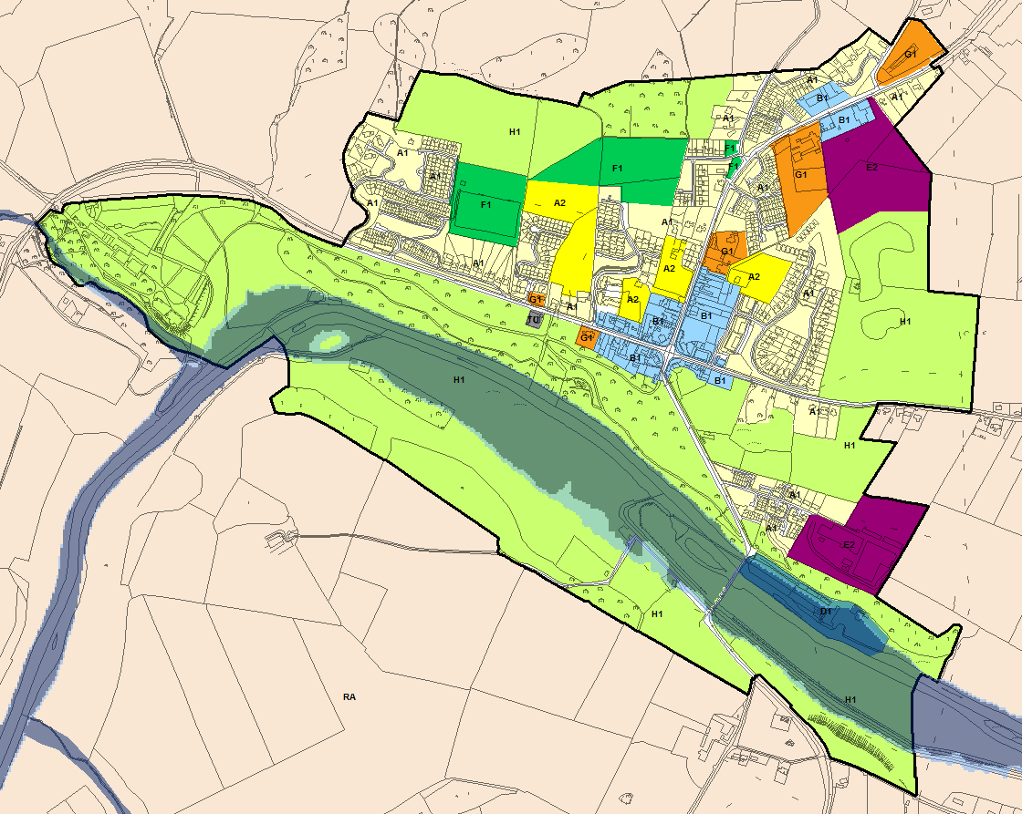
© Ordnance Survey Ireland & Government of Ireland, Meath 2019/31/CCMA
The Flood Zone mapping has been produced in accordance with the Planning Guidelines and therefore ignores the impact of flood protection structures. Areas protected by flood defences still carry a residual risk of flooding due to overtopping or breach, there may also be no guarantee of maintenance in perpetuity. Areas that benefit from defences are annotated separately. Flood Zone A – Fluvial: 1 in 100 year or 1% AEP, Tidal: 1 in 200 year or 0.5% AEP. Flood Zone B – 1 in 1000 year or 0.1% AEP.

Flood Zone Data | CFRAM mapping verified on site by JBA.
Historic Flooding | History of flood events in February 1990, November 2000 and November 2002. There are recurring flood events at St. Patrick's terrace due to inadequate drainage.
Comment:
Slane is situated adjacent to the River Boyne. The grounds of Slane Castle are located adjacent to the watercourse and the H1 land use zoning is appropriate. The mill situated at the eastern extent of the settlement is zoned D1 and any extensions or new development within the zoning should be subject to an appropriately detailed FRA at development management stage.

Climate Change | CFRAM mapping deliverables do not include climate change impacts, however an initial appraisal suggests that water levels are not subject to significant variation between Flood Zone A and B. The sensitivity to climate change is expected to be low.
Conclusion | Manage flood risk and development in line with approved policies and objectives.

Southern Environs of Drogheda
Hierarchy |  | REGIONAL GROWTH TOWN
Area for Further Assessment under CFRAM programme? |  | Yes - Flood Mapping available, flood relief scheme recommended. The scheme protects areas within County Louth only.
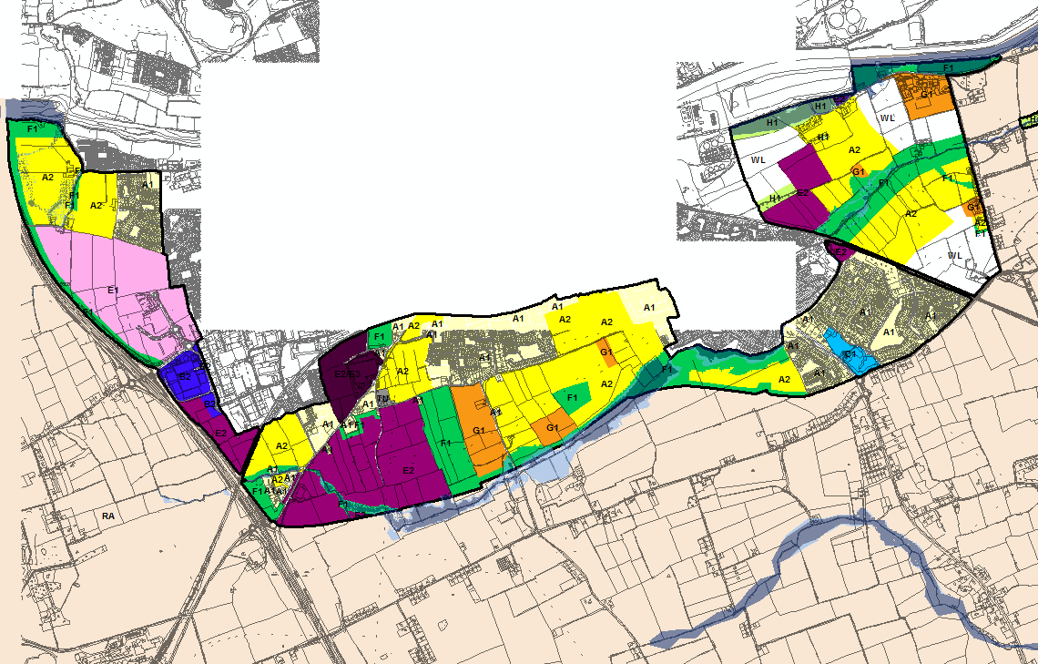
© Ordnance Survey Ireland & Government of Ireland, Meath 2019/31/CCMA
The Flood Zone mapping has been produced in accordance with the Planning Guidelines and therefore ignores the impact of flood protection structures. Areas protected by flood defences still carry a residual risk of flooding due to overtopping or breach, there may also be no guarantee of maintenance in perpetuity. Areas that benefit from defences are annotated separately. Flood Zone A – Fluvial: 1 in 100 year or 1% AEP, Tidal: 1 in 200 year or 0.5% AEP. Flood Zone B – 1 in 1000 year or 0.1% AEP.

Flood Zone Data | CFRAM mapping verified on site by JBA.
Historic Flooding | History of recurring flooding at Elmwood/McEoys road, the R152, the Dublin Road and at Colp West.
Comment:
The final CFRAM flood mapping has now been incorporated. The management plan confirms that the risk from the River Boyne and Stagrennan River is significant and a flood relief scheme is viable, the scheme protects areas within County Louth only. The tidal River Boyne presents fluvial and tidal flood risk.

There is some conflict between Flood Zone A/B in A2 zoned land to the west and E2 zoned land to the east. The opportunity to manage land use zonings will only become available as part of the preparation of the Joint Urban Area Plan for Drogheda by Meath and Louth County Councils. It is likely that the flood risk in the A2 lands is overestimated and a review of this should be undertaken when the land use zonings are considered.

Until the new plan is in place flood risk should be managed at development management stage in line with policies INF POL 14-29 of the MCDP.

Climate Change | The Flood Zone mapping suggests a negligible increase in flood extent for the majority of the settlement. Areas close to the River Boyne will be subject to the more severe effects of sea level rise and these areas should be monitored in future development plans.
Conclusion | Manage flood risk and development in line with the policies (INF POL 14-29) of the MCDP. Development should be subject to an appropriately detailed FRA at development management stage. This will ensure that FFLs and ground levels are set appropriately and that the risk of surface water flooding is correctly managed.  Review of land use zonings is required under the Joint Spatial Plan.

Stamullen
Hierarchy |  | SELF-SUSTAINING TOWN
Area for Further Assessment under CFRAM programme? |  | FEM FRAMS published 2011
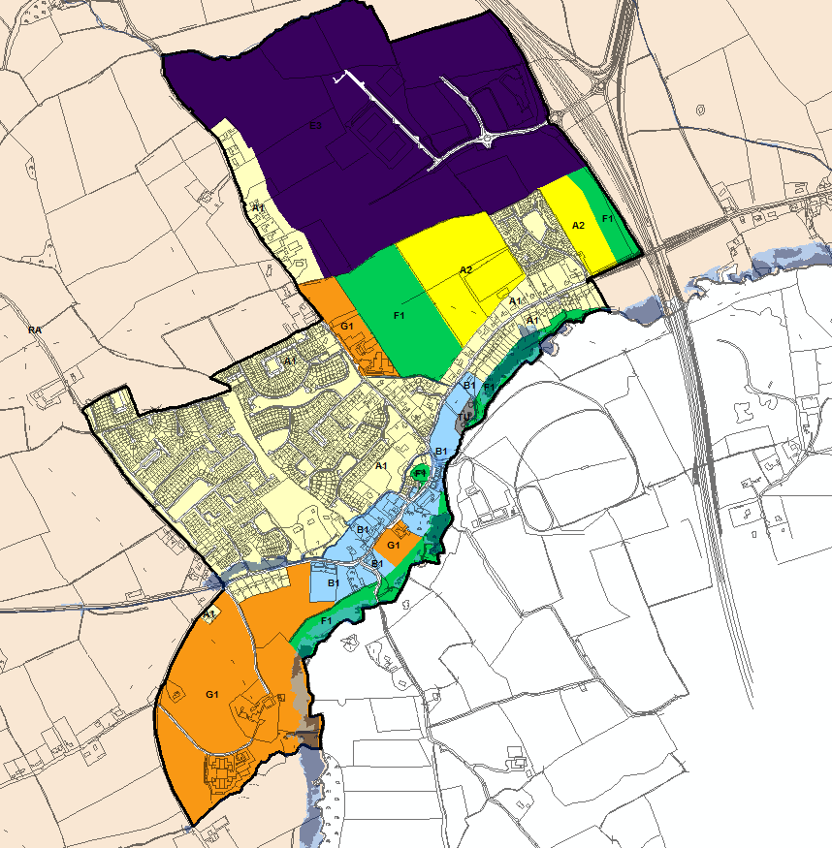
© Ordnance Survey Ireland & Government of Ireland, Meath 2019/31/CCMA
The Flood Zone mapping has been produced in accordance with the Planning Guidelines and therefore ignores the impact of flood protection structures. Areas protected by flood defences still carry a residual risk of flooding due to overtopping or breach, there may also be no guarantee of maintenance in perpetuity. Areas that benefit from defences are annotated separately. Flood Zone A – Fluvial: 1 in 100 year or 1% AEP, Tidal: 1 in 200 year or 0.5% AEP. Flood Zone B – 1 in 1000 year or 0.1% AEP.

Flood Zone Data | FEM FRAMS
Historic Flooding | The River Delvin is recorded as overflowing its banks 2-3 times per year after heavy rain. A local road is also liable to flooding.
Comment:
Flood Zones A and B mainly affect farmland on the left and right banks of the channel south of Main Street. A recreational area in the Mountain View/Elvana Housing Estates is also at risk of flooding. The impact is therefore confined to Existing Residential (A1) although no actual dwellings appear to be within Flood Zone A or B. Community Infrastructure (G1) and Open Space (F1) are also within Flood Zone A/B.

Risks to existing residential development (A1) should be managed in line with the policies (INF POL 14-29) of the MCDP. Within areas of existing development proposals for extensions and minor works should be considered under Section 5.28 of the Planning System and Flood Risk Management Guidelines and with due regard to INF POL 14-29of the MCDP 2020-2026.

Any new development under the proposed G1 land use zoning bordering the River Delvin should be subject to appropriately detailed FRA at the development management stage in line with the MCDP policies.

FEM FRAMS recommendations include proactive maintenance of the channel and the setup of a flood forecasting and warning system for the River Devlin. The FEM FRAMS management plan highlights three culverts in Stamullen that could result in potential flooding if a blockage occurs.

Climate Change | There are marginal increases in MRFS fluvial flood extents in this area. The areas affected are mainly agricultural lands on both banks of the Delvin River.
Conclusion | Manage flood risk and development in line with approved policies and objectives. At development management stage any FRAs should include consideration of culvert blockage when assessing risk and recommending design details. Flood forecasting and warning system was recommended by the FEM FRAMS.

Summerhill
Hierarchy |  | VILLAGE
Area for Further Assessment under CFRAM programme? |  | No
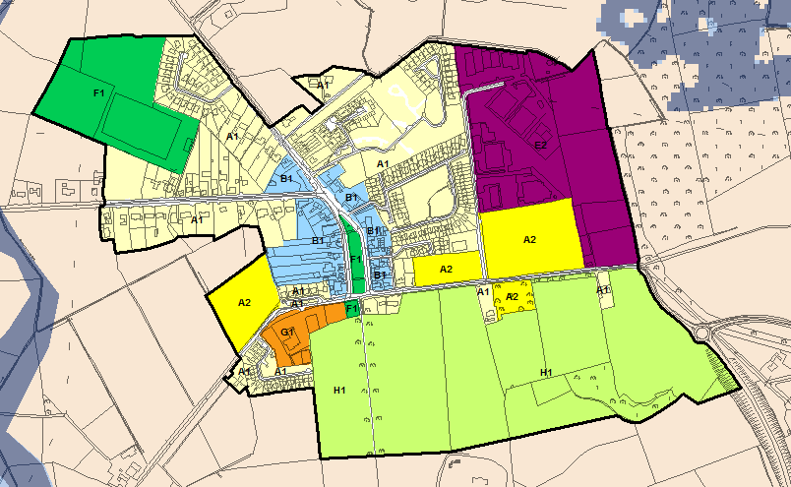
© Ordnance Survey Ireland & Government of Ireland, Meath 2019/31/CCMA
The Flood Zone mapping has been produced in accordance with the Planning Guidelines and therefore ignores the impact of flood protection structures. Areas protected by flood defences still carry a residual risk of flooding due to overtopping or breach, there may also be no guarantee of maintenance in perpetuity. Areas that benefit from defences are annotated separately. Flood Zone A – Fluvial: 1 in 100 year or 1% AEP, Tidal: 1 in 200 year or 0.5% AEP. Flood Zone B – 1 in 1000 year or 0.1% AEP.
Flood Zone Data | n/a and verified by JBA site visit.
Historic Flooding | Reports of a flooding event in August 2008. The source is this event was the River Moynalvy which is outside the settlement boundary.
Comment | The settlement is at low risk of flooding.
Climate Change | No fluvial flood risk identified and no flood history.
Conclusion | Manage flood risk and development in line with approved policies and objectives.

Trim
Hierarchy |  | SELF-SUSTAINING TOWN
Area for Further Assessment under CFRAM programme? |  | Yes - Flood Mapping available, flood relief scheme not economically viable. Future reliance on a Flood Warning Scheme and preparedness is favoured.
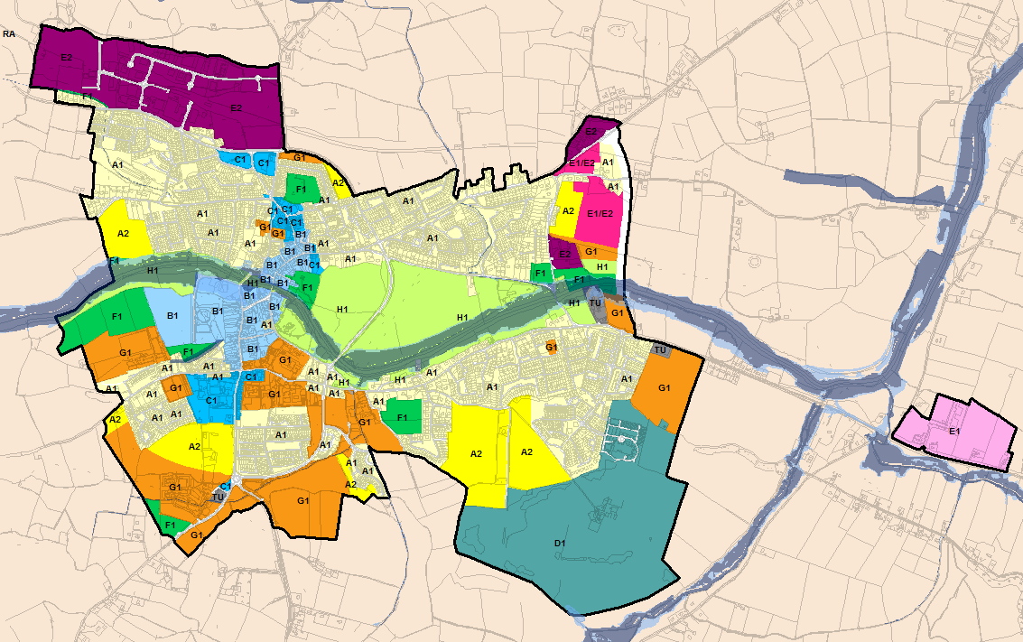
© Ordnance Survey Ireland & Government of Ireland, Meath 2019/31/CCMA
The Flood Zone mapping has been produced in accordance with the Planning Guidelines and therefore ignores the impact of flood protection structures. Areas protected by flood defences still carry a residual risk of flooding due to overtopping or breach, there may also be no guarantee of maintenance in perpetuity. Areas that benefit from defences are annotated separately. Flood Zone A – Fluvial: 1 in 100 year or 1% AEP, Tidal: 1 in 200 year or 0.5% AEP. Flood Zone B – 1 in 1000 year or 0.1% AEP.

Flood Zone Data | CFRAM, JBA site visit.
Historic Flooding | The main source of flooding in the town in the past has been the River Boyne, there are significant and recurring flood events from this river dating back to 1905. On the Clonfane Stream, since works were completed to the culvert under the road in the Bloomfield area there have been no flood events.
Comment:
All undeveloped residential zoned land (A2) has applied the sequential approach and is located within Flood Zone C.

B1 lands to the north of the OPW offices are within Flood Zone A/B (adjacent to the River Boyne) are now significantly developed and were previously subject to the Justification Test. Any further development of the land would require an FRA in accordance with INF POL 14-29 of the MCDP. The FRA should consider the Sequential Approach within the subject site and would typically involve allocating open space/car parking within Flood Zones A and some/all of Zone B. Whilst re-profiling of land within this area may be acceptable, land filling without provision of compensatory storage would not be permissible. Further details on compensatory storage are provided in Appendix B of the Planning System and Flood Risk Management. Buildings should be sited at an appropriate FFL, which should be above the 1 in 100 year flood level, with an allowance for freeboard and climate change.

Any FRA for town centre sites (redevelopment or extension/refurbishment) within Flood Zone A/B must include adequate consideration of the impacts of flooding, climate change and emergency management/evacuation procedures. The future Flood Warning System, when available, will provide great benefit in this regard and should be coupled with an emergency plan to proactively manage flood events.

Indicative distributor road alignments have the potential to traverse Flood Zone A/B. River crossings are included for the Knightsbrook River, Knightsbridge Stream, River Boyne and Butterly Stream. Meath County Council have proposed that a review of the current requirement for the distributor road network will be completed and this will include environmental considerations, under which the route configuration will be assessed with regard to the Planning System and Flood Risk Management Guidelines.

Climate Change | Moderate sensitivity to climate change impacts, most significantly from River Boyne.
Conclusion | Manage flood risk and development in line with approved policies and objectives. Development proposals for undeveloped B1 lands must consider the sequential approach and allocate water compatible development within Flood Zones A and some/all of Zone B where possible. Whilst re-profiling of land within this area may be acceptable, land filling without provision of compensatory storage would not be permissible.  Planning applications within this area and for any redevelopment/extensions/change of use within the town centre lands within Flood Zone A/B must be accompanied by an appropriately detailed FRA, setting out the above approach that clearly assesses flood risks, mitigation measures and demonstrates compliance with the Planning Guidelines particularly in regard to access and egress.

Appendices

Justification Test
ALL TEXT PROVIDED BY MEATH COUNTY COUNCIL, OTHER THAN PART 3 OF THE JUSTIFICATION TEST WHICH IS BY JBA. NOTE THAT THE RESPONSES BELOW WERE MADE AS PART OF PREVIOUS ITERATIONS OF THE COUNTY DEVELOPMENT PLAN, PRIOR TO THE PUBLICATION OF THE NEW NPF & RSES.

Dunboyne - Proposed Local Distributor Road linking the Rooske Road to the Station Road / Clonee Road across the Dunboyne to Clonsilla Rail Line
Issue – The proposed Local Distributor Road traverses lands identified on the flood risk mapping as being located within Flood Zones A & B south of Station Road / Clonee Road noting that there are existing flood defences in place at this location.

JUSTIFICATION TEST

1. Urban settlement is targeted for growth – Yes.
National Spatial Strategy 2002 – 2020
Dunboyne is categorised as a town with a population of 1,500 – 5,000 persons, positioned on a National Transport Corridor (Motorway and Rail Connection to Dublin). The population of Dunboyne now exceeds 5,000 population which was the next category of urban centre identified in the NSS.
Regional Planning Guidelines for the Greater Dublin Area 2010 – 2022.
Dunboyne is listed as a Large Growth Town II in the settlement hierarchy within the Metropolitan Area of the Greater Dublin Area. Such centres are identified as strong active growth towns, economically vibrant with high quality transport links to larger towns/city. The spatial dimension to the Strategy supports the growth of the polycentric gateway and primary economic growth towns linked by multi-modal corridors and focused on identified Core Economic Areas. Dunboyne is identified as a ‘Secondary Economic Growth Town’ along with Ashbourne. Dunboyne is also identified as a Level 3 Sub County Town in the Retail Hierarchy of the GDA but intended to develop gradually to a Level 2 Centre over a 20 year period.

2. The zoning or designation of the lands for the particular use or development type is required to achieve the proper planning and sustainable development of the urban settlement and, in particular:
The proposed Local Distributor Road is an integral part of the proposed Dunboyne Eastern Distributor Road which will connect the Rooske Road to the Clonee Road to the former Navan Road and ultimately to connect to the Dunboyne bypass. Vehicular bridges will be required to pass over the railway line to accommodate the major distributor road at two separate locations. The existing zoned lands, which are contained in Flood Zone C, generally to the east of the rail line, are identified to accommodate the majority of the required additional residential growth which is allocated to Dunboyne under the Core Strategy of the County Development Plan. The development of these lands are subject to the provision of the associated infrastructure, including in particular the Eastern Distributor Road.
This is provided for in the existing Dunboyne Clonee Pace Local Area Plan by MOV POL 9 which seeks
To facilitate the development of the Dunboyne Eastern Distributor Road in conjunction with the development of the A4 lands to the east and south of the railway line in Dunboyne, to include arrangements for the delivery of a rail overpass at the south and north these lands.

i. Essential to facilitate regeneration and / or expansion of the centre of the urban settlement - Yes.
This project is a key part of the future development of the plan area. Development cannot take place without the necessary infrastructure. This piece of infrastructure will enable the primary area identified to accommodate additional residential land to expand sequentially from the town centre in a logical and coherent manner and which also adjoins the existing educational campus. The proposed route will enable the consolidation of the urban area; improve connectivity between the key centres to access local services, community infrastructure and recreational facilities.

ii. Comprises significant previously developed and / or underutilised lands - Yes.
This route will pass through under-utilised land in flood zone C which is identified primarily for residential development and has been prioritised for release in the evaluation of residentially zoned lands which inform this variation.

iii. Is within or adjoining the core of an established or designated urban settlement - not relevant.
The Flood Risk Management Guidelines defines the ‘core’ area of an urban settlement as “The core area of a city, town or village which acts as a centre for a broad range of employment, retail, community, residential and transport functions”.
It is questionable as to the relevance of this criterion to the consideration of a Distributor Roadway such as proposed. The overall Eastern Distributor Road has been identified as a strategic transport objective to be delivered in tandem with residential, local shopping, commercial, education and community facilities.

iv. Will be essential in achieving compact and sustainable urban growth - Yes.
Developing the overall Eastern Distributor Road is essential to facilitating compact and sustainable urban growth of the LAP area within which a range of land uses may be accommodated to benefit the existing and proposed residential, working and visiting communities.
The Eastern Distributor Road will enable:-
- Growth of Dunboyne to logically take place eastwards maximising the ability of the town to develop as a rail based settlement;
- Unlocking lands for future residential development sequentially from Dunboyne town centre;
Improve connectivity from north to south Dunboyne and reduce the extent of unnecessary through traffic within the historic central core of Dunboyne by linking the existing Rooske Road to the Dunboyne bypass which serves the M3 northbound along with the Maynooth and Summerhill roads.

v. There are no suitable alternative lands for the particular use or development type, in areas at lower risk of flooding within or adjoining the core of the urban settlement - Yes.
The proposed development will better connect the eastern and southern areas of Dunboyne and also Clonee with the wider roads infrastructure in the area, improving access between existing residential areas to town centre functions, to educational facilities, to Dunboyne Train Station and to recreational areas. The lands identified primarily for development which will be served by the proposed Local Distributor Road are within Flood Zone C. The proposed roadway traverses Flood Zones A and B. There is no alternative alignment which could avoid having to traverse Flood Zones A and B.

Justification Test has advanced past Step 2 for Development Plans (Box 4.1 refers of the OPW Guidelines).

3. A flood risk assessment to the appropriate standard of detail has been carried out as part of the SEA as part of the development plan preparation process.
Part 3 of the Test requires that an adequately detailed FRA has been completed for the site to indicate that it can be developed for such use. Transport routes routinely cross watercourses and in this case the route consideration has minimised environmental impact and the strategic requirement for the alignment is clearly demonstrated by the Justification Test. The management of flood risk is achievable through the application of appropriate culvert/structure design in line with OPW Section 50 considerations. Risk from the Castle Stream is significant and the management of flood risk will need to be carefully considered. However, an appropriate design will adequately mitigate the potential impacts of flooding and ensure there are no significant adverse impacts elsewhere.
Any future planning applications for the distributor road must be subject to an appropriately detailed FRA at development management stage to demonstrate that the application fully adheres to the Planning System and Flood Risk Management Guidelines. Section 50 consent will also be required from the OPW to ensure the appropriate design of culverts.
Justification Test has advanced past Step 3 for Development Plans and must adhere to the recommendations from the Part 3 assessment.

Drogheda Southern Environs - The provision of a road link between the M1 Motorway and R132 (Old N1) which is referred to as the Southern Access Road
Issue – The proposed Local Distributor Road traverses lands identified on the flood risk mapping as being located within Flood Zones A & B.

JUSTIFICATION TEST

1. Urban settlement is targeted for growth – Yes.
National Spatial Strategy 2002 – 2020
Drogheda is designated as a Primary Development Centre in the Greater Dublin Area (GDA) under the NSS and therefore its close relationship with GDA has been recognised. The NSS states that Primary Development Centres should be aware of their relationship with the Metropolitan area. Notwithstanding this, they should be able to support and strengthen their own catchments and neighbouring regions. A population figure of 40,000 is recommended for self-sustaining growth in these Primary Development Centres. The NSS also recognises and supports the role of the Dublin- Belfast Corridor of which Drogheda forms part.
Regional Planning Guidelines for the Greater Dublin Area 2010 – 2022.
The Drogheda Environs are located within the Hinterland Area of the Greater Dublin Area as defined in the Guidelines. Within this area, the Guidelines state that large towns should absorb most of the new population growth and will continue to act as major service centres for adjoining towns and the surrounding rural area.
Drogheda is also identified as a Large Growth Town I and a Primary Economic Growth Centre in the Regional Planning Guidelines for the Greater Dublin Area. Large Growth Towns should accommodate significant new investment in transport, in economic and commercial activity and in housing. The Large Growth Towns I in Meath (Drogheda and Navan) are noted as being economically active towns supporting the surrounding area and located on multi modal corridors.
The Guidelines state that Primary Economic Growth Towns, such as Drogheda, should be promoted as anchors for regional enterprise. These centres are also important in delivering balanced regional development by serving their urban and rural hinterland areas and should be prioritised for economic development and investment to redress the imbalance of residential development and jobs and emergence of dormitory areas.

2. The zoning or designation of the lands for the particular use or development type is required to achieve the proper planning and sustainable development of the urban settlement and, in particular:
The M1 to R132 Link Road will form an important component of the development of the Southern Environs. It is expected that the construction of this road will be developer driven with the first section from Junction 8 on the M1 to the Beamore Road being progressed during the life of this County Development Plan.
The proposed Local Distributor Road was also identified in as a key objective of the Greater Drogheda Planning Strategy jointly prepared by Meath County Council, Louth County Council and Drogheda Borough Council. This Planning Strategy was a key consideration in the preparation of the resultant preferred land use strategy which is contained in the Drogheda Southern Environs Local Area Plan.

i. Essential to facilitate regeneration and / or expansion of the centre of the urban settlement - Yes.
This project is a key part of the future development of the overall Drogheda area as outlined above. Development cannot take place without the necessary infrastructure being provided. The Southern Access Road has been identified in high level plans for the past decade. The development of this roadway, would over time open up the Bryanstown lands identified for release as residential phase II, enable the wider movement patterns to be managed onto the national road network at the M1 and thus allowing the existing road infrastructure in the town to be served by public transport modes. It is therefore considered essential to the orderly expansion of the core of Drogheda.

ii. Comprises significant previously developed and / or underutilised lands - Yes.
This route will serve lands identified for employment, recreational and community use over the life of this plan and serve lands identified for residential development post 2019. All of the subject lands identified with a land use zoning objective that can accommodate vulnerable land uses are within flood zone C.

iii. Is within or adjoining the core of an established or designated urban settlement - not relevant.
The Flood Risk Management Guidelines defines the ‘core’ area of an urban settlement as “The core area of a city, town or village which acts as a centre for a broad range of employment, retail, community, residential and transport functions”.
It is questionable as to the relevance of this criterion to the consideration of a Distributor Roadway such as proposed.

iv. Will be essential in achieving compact and sustainable urban growth - Yes.
Developing the Southern Access Road is essential to facilitating compact and sustainable urban growth of the LAP area within which a range of land uses may be accommodated to benefit the existing and proposed residential, working and visiting communities. The Greater Drogheda Planning strategy identified the Northern Environs (Louth County Council) and Southern Environs (Meath County Council) as the preferred areas to expand their residential function in the medium to longer term.

v. There are no suitable alternative lands for the particular use or development type, in areas at lower risk of flooding within or adjoining the core of the urban settlement - Yes.

Justification Test has advanced past Step 2 for Development Plans (Box 4.1 refers of the OPW Guidelines).

3. A flood risk assessment to the appropriate standard of detail has been carried out as part of the SEA as part of the development plan preparation process.
Part 3 of the Test requires that an adequately detailed FRA has been completed for the site to indicate that it can be developed for such use. Transport routes routinely cross watercourses and in this case the route consideration has minimised environmental impact and the strategic requirement for the alignment is clearly demonstrated by the Justification Test. The management of flood risk is achievable through the application of appropriate culvert/structure design in line with OPW Section 50 considerations. Risk from the Stameen Stream is significant and the management of flood risk will need to be carefully considered, particularly along sections of the roadway that run parallel with the watercourse. However, an appropriate design can adequately mitigate the potential impacts of flooding and ensure there are no significant adverse impacts elsewhere.
Any future planning applications for the distributor road must be subject to an appropriately detailed FRA at development management stage to demonstrate that the application fully adheres to the Planning System and Flood Risk Management Guidelines. Section 50 consent will also be required from the OPW to ensure the appropriate design of culverts.
Justification Test has advanced past Step 3 for Development Plans and must adhere to the recommendations from the Part 3 assessment.

Kilcock - The provision of a Distributor Road link extending from the R148 (Maynooth Road) to the R125 (Dunshaughlin Road) which is referred to as the Northern Orbital Road
Issue – The proposed Local Distributor Road traverses lands identified on the flood risk mapping as being located within Flood Zones A & B.
Note:
Planning permission had already been granted by Meath County Council and upheld by An Bord Pleanála for the provision of this roadway.

JUSTIFICATION TEST

1. Urban settlement is targeted for growth – Yes.
National Spatial Strategy 2002 – 2020
Kilcock did not feature on Map No. 5 which outlined the strategy for the Dublin and Mid East regions. In 2002, the population of Kilcock was 2,985 persons and has since increased to 5,533. Kilcock would now be categorised as a town with a population greater than 5,000 persons, positioned on a National Transport Corridor (Motorway and Rail Connection to Dublin).
Regional Planning Guidelines for the Greater Dublin Area 2010 – 2022.
Kilcock is identified as Moderate Sustainable Growth Town in the Dublin Metropolitan area in the RPGs. Such centres are to develop as strong edge of Metropolitan area district service centres with, high quality linkages and increased densities at nodes on public transport corridors. Kilcock and Celbridge have supporting roles in the Maynooth/Leixlip Core Economic Area. Kilcock is identified as a Level 3 Town and/or District Centres & Sub-County Town Centres in the Retail Hierarchy of the GDA.

2. The zoning or designation of the lands for the particular use or development type is required to achieve the proper planning and sustainable development of the urban settlement and, in particular:
The transport principles for Kilcock include:
- To provide an Northern Orbital Road Corridor within the development framework area and suitable linkages with the existing road network; and
- To provide robust linkages between the development framework lands and Kilcock Town and existing and future strategic transport corridors.
It is intended that the Northern Orbital Road serving the Northern environs of Kilcock will eventually connect the Maynooth Road (R148) from the east to the existing roundabout junction along the Summerhill Road (R158) to the west. It may be possible to then extend this roadway through the employment generating lands and beyond within the development framework area to the county boundary with Kildare. It is expected that the section of this roadway linking the R125 (Dunshaughlin Road) to the Maynooth Road (R148) will be delivered during the life of this plan in conjunction with primarily residential development.

i. Essential to facilitate regeneration and / or expansion of the centre of the urban settlement - Yes.
The proposed infrastructure would enable a coherent and planned approach to the future growth of Kilcock which has extended to a considerable distance to the south and away from the historic core of the town at the Square. Such growth would generally in accordance with the provisions of the Regional Planning Guidelines, and, given the proximity of the land to the town centre and the existing road interconnections serving the northern side of the town, would represent a suitable location to accommodate growth of the settlement.

ii. Comprises significant previously developed and / or underutilised lands - Yes.
It is envisaged under the Regional Planning Guidelines and the County Development Plans of Meath and Kildare that the town of Kilcock, which is situated in the Metropolitan Area, will continue to develop and expand. It is considered that these lands would be suitable to accommodate such growth. The coherent development of the subject lands is desirable and offers the prospect of properly planned neighbourhoods, well connected with the core of the settlement.

iii. Is within or adjoining the core of an established or designated urban settlement - not relevant.
The Flood Risk Management Guidelines defines the ‘core’ area of an urban settlement as “The core area of a city, town or village which acts as a centre for a broad range of employment, retail, community, residential and transport functions”.
It is questionable as to the relevance of this criterion to the consideration of a Distributor Roadway such as proposed. Nonetheless in this instance, it is considered that the proposed infrastructure is adjoining the core of Kilcock.

iv. Will be essential in achieving compact and sustainable urban growth - Yes.
Having regard to;
- The existing pattern of development of the town of Kilcock;
- The provisions of the Kilcock Local Area Plan 2009-2015, and;
- The proposed land use zoning objectives to be included in the County Development Plan as part of this Variation which identifies these residential lands for release during the life of the County Development Plan.
It is considered that the development of the subject lands which will require the Northern Orbital Road provides the opportunity to rebalance the development of the town towards the north of the Royal Canal.

v. There are no suitable alternative lands for the particular use or development type, in areas at lower risk of flooding within or adjoining the core of the urban settlement - Yes.
The proposed roadway traverses Flood Zones A and B. The lands which it will serve are generally located in Flood Zone C. There is no alternative alignment which could avoid having to traverse Flood Zones A and B.

Justification Test has advanced past Step 2 for Development Plans (Box 4.1 refers of the OPW Guidelines).

3. A flood risk assessment to the appropriate standard of detail has been carried out as part of the SEA as part of the development plan preparation process.
Part 3 of the Test requires that an adequately detailed FRA has been completed for the site to indicate that it can be developed for such use. Transport routes routinely cross watercourses and in this case the route consideration has minimised environmental impact and the strategic requirement for the alignment is clearly demonstrated by the Justification Test. The management of flood risk is achievable through the application of appropriate culvert/structure design in line with OPW Section 50 considerations. Risk from the River Rye Water is significant and the management of flood risk will need to be carefully considered. However, an appropriate design can adequately mitigate the potential impacts of flooding and ensure there are no significant adverse impacts elsewhere.
Any future planning applications for the distributor road must be subject to an appropriately detailed FRA at development management stage to demonstrate that the application fully adheres to the Planning System and Flood Risk Management Guidelines. Section 50 consent will also be required from the OPW to ensure the appropriate design of culverts.
Justification Test has advanced past Step 3 for Development Plans and must adhere to the recommendations from the Part 3 assessment.

Maynooth - The provision of a new Local Distributor Road linking the R157 (Maynooth – Dunboyne Regional Road) with the Moyglare Road to form part of the Maynooth Outer Relief Road.
Issue – The proposed Local Distributor Road traverses lands identified on the flood risk mapping as being located within Flood Zones A & B where it crosses the Lyreen watercourse.

JUSTIFICATION TEST

1. Urban settlement is targeted for growth – Yes.
National Spatial Strategy 2002 – 2020
Maynooth is categorised as a town with a population greater than 5,000 persons, positioned on a National Transport Corridor (Motorway and Rail Connection to Dublin).
Regional Planning Guidelines for the Greater Dublin Area 2010 – 2022.
Maynooth is identified as a Large Growth Town II in the settlement hierarchy within the Metropolitan Area of the Greater Dublin Area. Such towns are intended to develop as strong active growth towns, economically vibrant with high quality transport links to larger towns/city. The spatial dimension to the Strategy supports the growth of the polycentric gateway and primary economic growth towns linked by multi-modal corridors and focused on identified Core Economic Areas. Maynooth and Leixlip have been identified as a ‘Primary Economic Growth Towns’ in the Maynooth/Leixlip Core Economic Area. They have been identified on equal footing as the principal economic growth centres, with both having interconnecting sectoral strengths. The cluster also includes two additional supporting towns of Kilcock and Celbridge. Maynooth is identified as a Level 3 Town and/or District Centres & Sub-County Town Centres in the Retail Hierarchy of the GDA.

2. The zoning or designation of the lands for the particular use or development type is required to achieve the proper planning and sustainable development of the urban settlement and, in particular:
TRAN OBJ 19 of the Meath County Development Plan seeks to liaise with Kildare County Council in the identification, design, reservation and delivery of the section of the Maynooth Outer Relief Road located within the administrative area of Meath County Council. Therefore, the proposed development is already an objective of the Meath County Development Plan and the written statement and detailed objectives of Maynooth Environs must be consistent with this high level objective.
Furthermore, the proposed road link is included in the recently adopted Maynooth LAP (2013) by Kildare County Council and is partially constructed within the Moyglare Hall development. Congestion remains a significant problem in the town centre and one of the key elements of the Maynooth LAP (2013) is the provision of various objectives particularly the outer orbital road to alleviate congestion problems.
Objective TRO 2 seeks to facilitate the future construction of the following roads and in the interim protect these routes from development:
(b) Between the Moyglare Road (C) and the County Boundary (D) (only a small section of this road to the County Boundary has to be completed).

i. Essential to facilitate regeneration and / or expansion of the centre of the urban settlement - Yes.
Without the development of the Maynooth Outer Relief Road, the existing congestion levels being experienced in the town centre will exacerbate and prevent the logical expansion of the town centre unless alternatives for road based traffic can be delivered.

ii. Comprises significant previously developed and / or underutilised lands - Yes.
The road infrastructure in the vicinity of the Development Framework area requires to be upgraded given the quantum of development which is envisaged by both Kildare and Meath County Councils. Meath County Council is keen to ensure the delivery of this important piece of infrastructure for the town of Maynooth which will be facilitated by the development of the lands within the Development Framework boundary. It is also considered critical to provide greater connectivity to the proposed Education Campus on lands owned by Co. Kildare VEC at Moyglare Road, Maynooth. The Campus will consist of an all-new 1,000 pupil Second Level School serving as Maynooth Community College. This will open to first years in September 2014. Another 1,000 pupil Second Level School to replace Maynooth Post Primary School will also be in situ on the Campus.

iii. Is within or adjoining the core of an established or designated urban settlement - not relevant.
The Flood Risk Management Guidelines defines the ‘core’ area of an urban settlement as “The core area of a city, town or village which acts as a centre for a broad range of employment, retail, community, residential and transport functions”.
It is questionable as to the relevance of this criterion to the consideration of a Distributor Roadway such as proposed.

iv. Will be essential in achieving compact and sustainable urban growth - Yes.
The completion of the Maynooth Outer Relief Road is critical to the development of the lands within the framework boundary. Vehicular access to the lands within the Moygaddy area will be via the Maynooth Outer Relief Road. These measures will encourage pedestrian and cyclist usage within the development framework area.

v. There are no suitable alternative lands for the particular use or development type, in areas at lower risk of flooding within or adjoining the core of the urban settlement - Yes.
The alignment of this roadway has been identified in statutory land use plans on either side of the County boundary. It is impossible to connect the permitted roundabout at Moygaddy Gate to the existing road alignment in Moyglare Hall without traversing the Lyreen stream.

Justification Test has advanced past Step 2 for Development Plans (Box 4.1 refers of the OPW Guidelines).

3. A flood risk assessment to the appropriate standard of detail has been carried out as part of the SEA as part of the development plan preparation process.
Part 3 of the Test requires that an adequately detailed FRA has been completed for the site to indicate that it can be developed for such use. Transport routes routinely cross watercourses and in this case the route consideration has minimised environmental impact and the strategic requirement for the alignment is clearly demonstrated by the Justification Test. The management of flood risk is achievable through the application of appropriate culvert/structure design in line with OPW Section 50 considerations. Risk from the River Rye Water tributary is well contained within a narrow floodplain and an appropriate design can adequately mitigate the potential impacts of flooding and ensure there are no significant adverse impacts elsewhere.
Any future planning applications for the distributor road must be subject to an appropriately detailed FRA at development management stage to demonstrate that the application fully adheres to the Planning System and Flood Risk Management Guidelines. Section 50 consent will also be required from the OPW to ensure the appropriate design of culverts.
Justification Test has advanced past Step 3 for Development Plans and must adhere to the recommendations from the Part 3 assessment.

 |  |  |  | 
Registered Office

24 Grove Island
Corbally
Limerick
Ireland

t: +353 (0) 61 345463
e:info@jbaconsulting.com

JBA Consulting Engineers and Scientists Limited

Registration number 444752

 |  |  |  | Visit our website  www.jbaconsulting.ie

JFLOW® is a registered UK trade mark in the name of Jeremy Benn Associates Limited
Flood Estimation Handbook, Institute of Hydrology, 1999
www.opw.ie/hydro
http://www.cfram.ie/pfra/
OPW Assessment of Potential Future Scenarios, Flood Risk Management Draft Guidance, 2009
Refer to Chapter 11 of the MCDP – Development Management Standards and Land Use Zoning Objectives.
FEM FRAMS Draft Flood Risk Management Plan, http://www.cfram.ie/fem-fram-pilot-study-website/
The Planning System and Flood Risk Management Guidelines for Planning Authorities, Technical Appendices, November 2009

