Laytown, Bettystown and Mornington Beach Management Plan
Revised Draft informed by Public Consultation and NIS Process

Appendix A: Recommendations
Laytown, Bettystown & Mornington Beach Management Plan

Prepared for: Meath County Council AECOM
24

Table of Contents
- Consultation 3
- Beach Access and Provision of Public Toilets 4
- Car Parking 9
- Litter and Waste Management 15
- Signage 18
- Beach Tourism and Activities 20
- Blue Flag Status 21
- Recommendations summary 23

Background
This appendix to the Laytown, Bettystown and Mornington Beach Management Plan (BMP) covers some of the background information and consultation undertaken during the development of the BMP. The BMP will act as the main reference document for the day to day management of the beach and will be proactively and reactively updated as and when required.
The following elements are discussed in more detailed within this appendix. As per the brief, the existing issues and potential opportunities associated with the beach and the requirement to protect European sites from recreational disturbance have been compiled and are presented. The appendix is set out as follows:

- Consultation
- Beach Access and Provision of Public Toilets
- Alternative Car Parking
- Litter and Waste Management
- Signage
- Beach Tourism and Activities
- Blue Flag Status

The conflict between (constitutional) rights of access to public lands and the requirement to protect European sites from recreational disturbance may pose an enforcement challenge. Whilst the Recommendations proposed have been identified as the optimal response to mitigate adverse effects on European site integrity, the legality and feasibility of enforcing some will be subject to discussion and agreement with MCC, as proponent of the Draft Plan.
As part of their statutory role in the protection of European sites, MCC has committed to drafting new Bye-laws to support the implementation of protective measures for European sites in the Draft Plan. These Bye-laws will address(to the extent legally practicable) the threats posed to coastal habitats and wintering birds from horses, dog-walkers, car users, and other forms of recreation.

Consultation

The methodology for the Beach Management Plan consists fundamentally of three phases:
Phase 1: Review of Existing Situation and Background Data. Phase 2: Concept Design, Preliminary Design and Consultation. Phase 3: Recommendations and BMP Report.

Phase 2 of the delivery of the BMP consisted of a significant degree of consultation with MCC engineers, local councillors as well as local residents and other members of the public. While the design team carried out site visits and conducted a significant amount of desktop research, it was acknowledged that there are other issues which can only be fully understood through consultation with local residents and other members of the public who use the beach on a regular basis.
During the first two phases of the study, particularly Phase 2, the following stakeholders were consulted:
- MCC Officers: A number of meetings have been held with MCC Officers throughout the life of the project.
- Local Councillors: A presentation was made and workshop held with a number of local councillors to discuss existing issues on the beach and to explore potential opportunities. These councillors also attended the open evening held on 22nd July 2015.
- Local residents and other members of the public: An open evening was held on the 22nd July 2015 in the Neptune Hotel in Bettystown to which members of the public were invited and all feedback and suggestions were welcome. A second open evening was held on the 20th June 2017 in the Neptune Hotel in Bettystown to which members of the public were invited.
- Benone Strand Beach Manager: The Beach Manager of Benone Strand in Co. Derry was also consulted as part of Phase 2 of the study.
- A draft Beach Management Plan (BMP) and draft BMP Recommendations Report was issued for non- stationary public consultation during summer 2017. Submissions from from a variety of locals and stakeholders were received which have been reflected in the final recommendations.

Beach Access and Provision of Public Toilets

Introduction
This section has been prepared to investigate the possibilities for improving/enhancing the existing beach access at Seaview Terrace. The section reviews the existing situation, identifies deficiencies with the existing arrangement and outlines potential solutions which will improve the access for all users.

Beach Access - Existing Situation.
The existing beach access in Bettystown is located on Seaview Terrace in the centre of the town and is the primary access point onto the beach for both vehicles and pedestrians. Figure 2.1 illustrates the location of Seaview Terrace. Figure 2.2 shows a ground level view of the beach access.
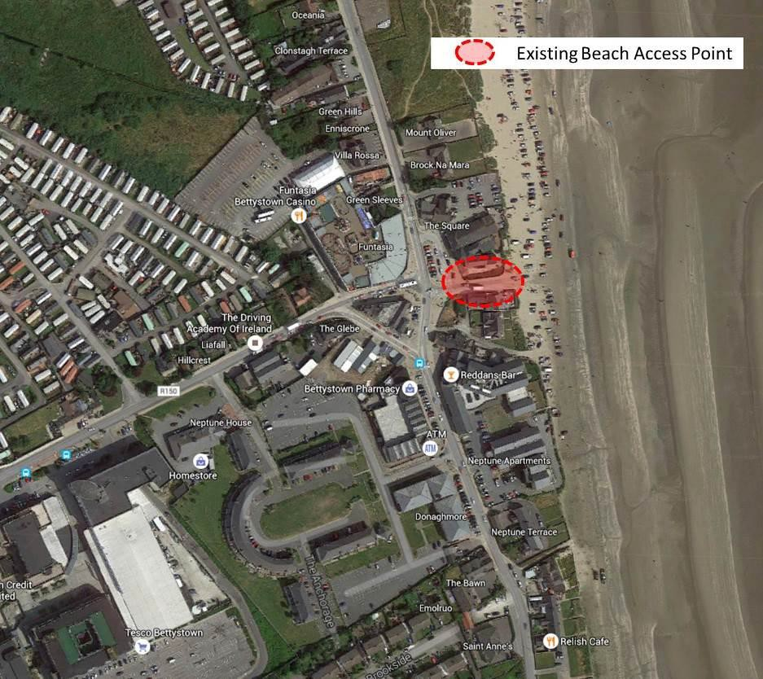
Figure 2.1: Existing Beach Access in Context of Bettystown (© Google Streetview)

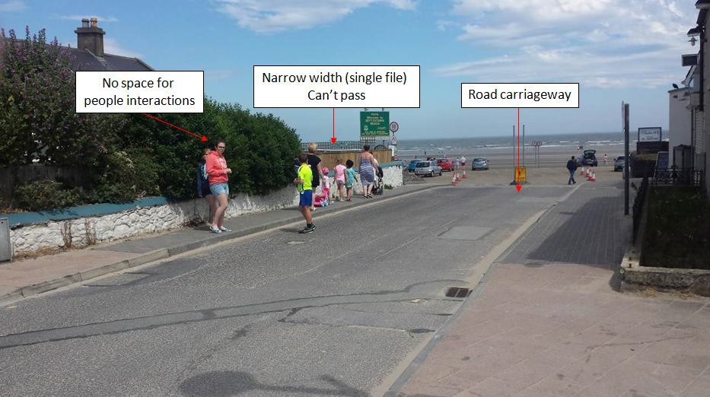
Figure 2.2: Existing Beach Access at Seaview Terrace
Some of the main issues with the current access include:
- Narrow footpaths (pedestrians walk in single file)
- Pedestrians walking on road and potential interaction with vehicles
- Existing space underutilised (Buildings not interacting with street)
- Vehicles blocking back through access during periods of high demand
- Vehicles double parking or delivery vehicles serving surrounding restaurants and take-aways parking on- road / footpath on southern side of road
- No means of controlling access to beach, beach accessible 24/7
- Inadequate amenity provision, no public toilets
- Generally unattractive access and unwelcoming
- No space for interactions for people
- Mix of materials, street furniture and signage
The current beach access is constrained in terms of space with a limited cross section existing between the property boundaries on Seaview Terrace. The existing width (including footpaths) varies from approximately 7m at its narrowest point to around 8.5m at the widest point approaching the beach. With both pedestrians and vehicular traffic entering at this point, there is limited space to appropriately accommodate different users and the area feels uninviting.

Objectives
The objectives of improving the existing beach access are:
- Improve accessibility and functionality for all users, especially pedestrians.
- Improve the aesthetics of the area.
- Improve the amenities available at, or adjacent to, the entrance to the beach.
Following the stakeholder consultation and by assessing the existing issues/conditions the following proposals were identified.
Proposal 1: Purchase land on Seaview Terrace. Upgrade access to improve pedestrian route and public realm space. Construct a purpose built seafront building and provide for a range of facilities/services in the new building.
Proposal 2: Create one-way system with one-way in from Seaview Terrace and outbound from laneway near Neptune Terrace.
Proposal 3: Controlling Access to the Beach during Off-Peak hours.

Proposal 1: Purchase Land and Houses on Seaview Terrace
There currently is housing on Seaview Terrace at the entrance to the beach. These buildings have been acquired by Meath County Council with a view to developing community facilities and improving beach access.
This acquisition offers the potential to significantly improve the existing beach access and provide for a purpose built seafront building that could offer a range of amenities for beach users.
The following benefits could be achieved:
- Provide a purpose built seafront building with a mixed use facility that would provide a range of facilities to beach users. These amenities would generate revenue, some of which could be reinvested in the maintenance and upkeep of the beach. Alternatively, this revenue could be invested in additional resources for policing of foreshore bye laws or cleaning of the beach.
- Provide for a greatly improved access, which is attractive and accommodates the needs of all users, in particular pedestrians.
- Provide improved public realm / civic space at the entrance to beach.
- Provide a potential location for public toilets, showers and changing facilities (with a view to increasing the attractiveness of the beach as a destination for beach activities and events)
- Any facilities provided where people may congregate e.g. a café, will provide a form of passive surveillance and help deter anti-social behaviour in the vicinity of any public toilets.
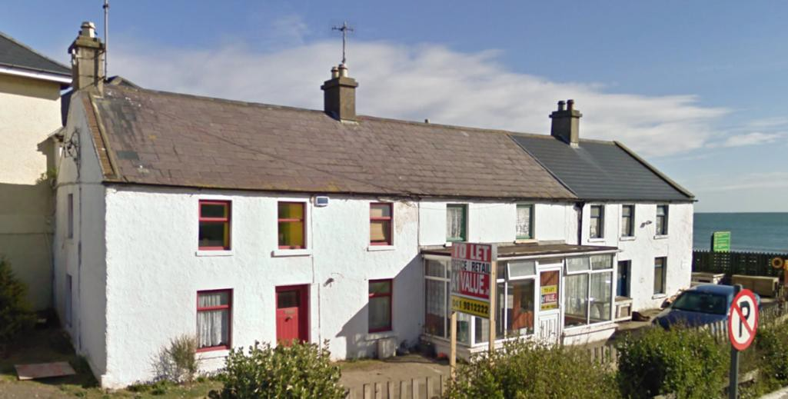
Figure 2.3: Existing Terrace of Houses on Seaview Terrace (© Google Streetview)
Figure 2.4: Available Space at Front of Properties
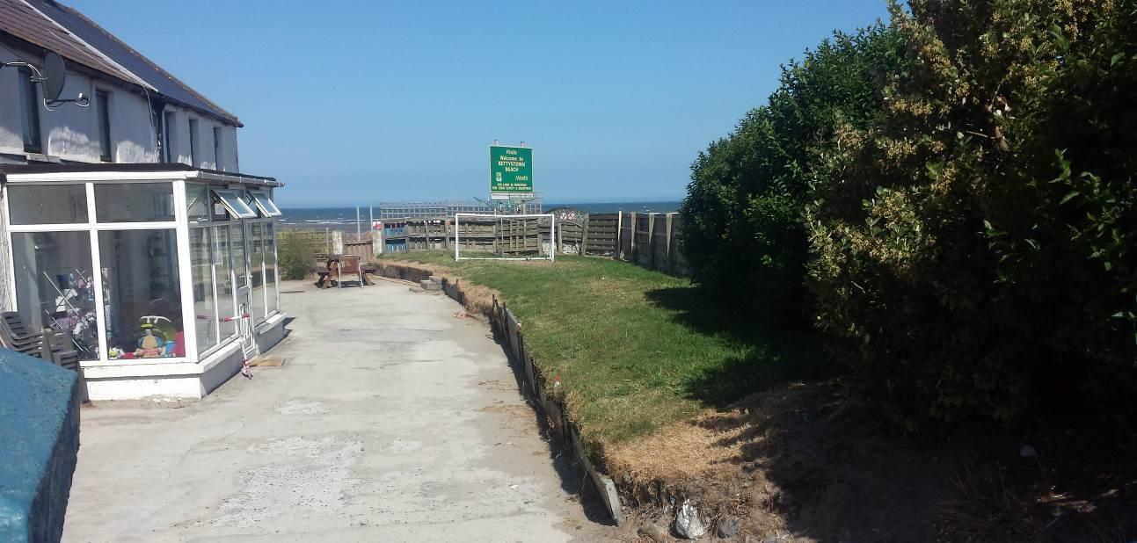
A lifeguard’s tower could be accommodated on the upper floor of a seafront building. This would provide improved lifeguard facilities over those currently provided on the beach and a more centralised location to observe beach activities. Currently, lifeguards located away from where the majority of activity is occurring. The property could be used by MCC to store equipment relating to upkeep and maintenance of the beach and could also be used to securely store beach wheelchairs if available. Beach wheelchairs should become available when a purpose built seafront building becomes available. A summary of the advantages and disadvantages of this option are summarised in Table 2.1 below. Figure 2.5 provides an example of a beach café in the UK and closely resembles how such a facility could sit on the context of Bettystown beach if developed.
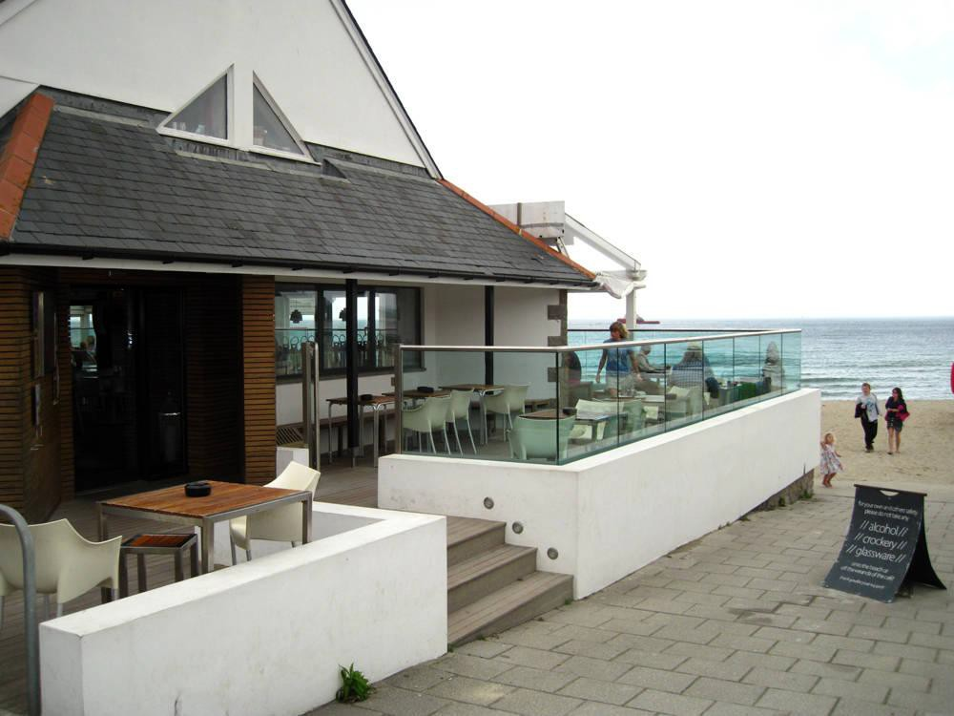
Figure 2.5: Café/Restaurant at Beach Entrance
Table 2.1: Proposal 1 - Advantages and Disadvantages
Advantages | Disadvantages
Improved amenities | High initial capital cost
Provision of public toilets | Development costs
Income stream for MCC | Finding and retaining tenants for potential commercial and residential space
Passive surveillance of area
Widened footpaths
Generally improved aesthetics
Safety improvement by not having to walk to Funtasia to use toilets

Project Ref: Recommendation 1

Action: Purchase houses on Seaview Terrace and provide a range of amenities within a custom built building. Develop community facilities at Seaview Terrace.

Proposed Project Partners: Meath County Council and Beach Management Committee.

Proposal 2: Create one-way system with one-way in from Seaview Terrace and outbound from laneway near Neptune Terrace.
An additional proposal would be to introduce a one-way system on the beach.
Pedestrian facilities can be improved on Seaview Terrace with the introduction of a one-way system on the beach. By converting Seaview Terrace to one-way, there is an opportunity to reallocate some of the existing road space for pedestrians. The existing road carriageway width on Seaview Terrace is approximately 5m wide. With the introduction of a one-way system there is the opportunity to reduce the road carriageway to 3.0m wide. The remaining 2.0m can be redistributed as footpath, thus providing an improved facility for pedestrians.
The proposed one-way system on the beach is shown in Figure 2.8, with motorists accessing the beach via Seaview Terrace, parking in the new parking zone to the south of the access, and exiting through Neptune Terrace to the south. The laneway on Neptune Terrace will require minor improvement works in order to provide for vehicular traffic. Any alterations to Neptune Terrace would require detailed design to ensure the safety of pedestrians and motorists at this location. A comprehensive traffic and parking study will be commissioned by the MCC Transportation Department in 2019, looking at this proposal and others. Photos of the existing laneway are shown below.

Figure 2.6: Neptune Terrace / R150 | Figure 2.7: Neptune Terrace / Bettystown Beach
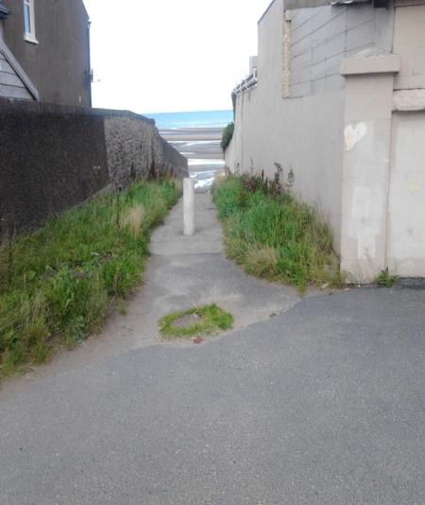
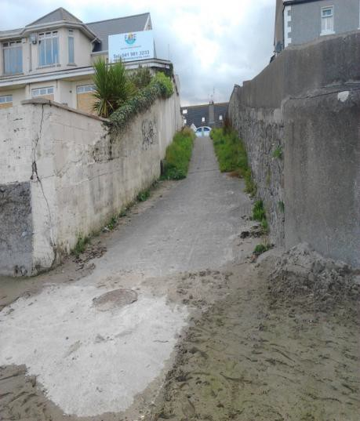

Figure 2.8: Proposed One-way System on Bettystown Beach
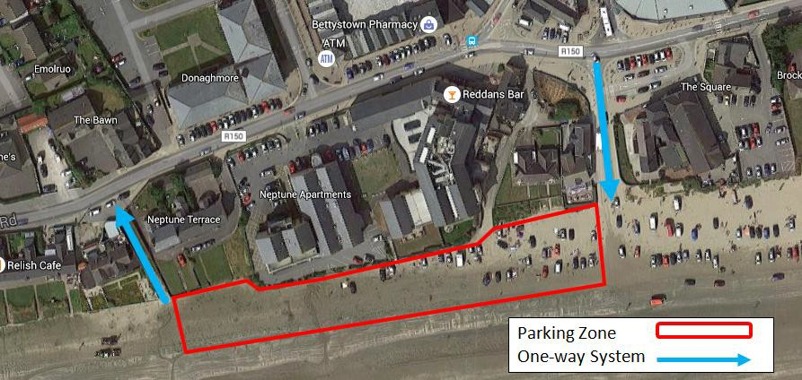

Project Ref: Recommendation 2

Action: Examine creation of a one way system for beach traffic during busy periods.

Proposed Project Partners: Meath County Council and Beach Management Committee.

It is recommended that the provision of the one way system is assessed in further detail, including the bollards required to set out the parking zone, and the upgrades required at Neptune Terrace to provide a safe road access.

Proposal 3: Controlling Access to the Beach during Off-Peak hours
A number of local residents raised concerns regarding anti-social behaviour on the beach, in particular during the night time period. People bring their cars onto the beach to drive dangerously and recklessly causing concern to local residents, and posing a safety risk to all on the beach.
In order to control the access to the beach it is proposed to consider access controls to prevent vehicles etc. entering the beach during the night time. MCC and the beach wardens will have control of the raising bollard and the time that the access to the beach is open. Bollards will be required at Seaview Terrace and Neptune Terrace. Emergency vehicles will also be able to gain access by a variety of means that activate the control feature, such as on-board electronic devices or card keys.

Project Ref: Recommendation 3

Action: Examine Access Controls to the beach.

Proposed Project Partners: Meath County Council, Beach Management Committee, Beach Wardens, Emergency Services and Gardai.

Car Parking

Overview
This section has been prepared following discussions with MCC officials, local engineers and members of the public. The following sets out the existing issues associated with the car parking on Laytown, Bettystown and Mornington Beach and outlines proposals and recommendations for future beach related parking in the area.

Existing Parking
The MCC Foreshore Bye-Laws (2010) allows parking within a designated area on the beach. At present this permits vehicles to access and park on the beach all year round in the area between River Nanny in Laytown to a point 150m north of the Seaview Terrance in Bettystown. The majority of motorists currently park within a 150m long area to the north of Seaview Terrace entrance. North of this area is a lifeguard patrol zone where vehicles are not permitted to enter.

Existing Parking Demand
For the majority of the year the number of vehicles parking on the beach is low. On a typical, dry, warm, summers day there may be up to several hundred vehicles parked on the beach. During periods of exceptionally warm weather however, there may be a demand of over a thousand vehicles on the beach.
The primary issue associated with these times of exceptionally high parking demand is the safety of beach users, children in particular, interacting with vehicles on the beach. Traffic congestion in the town was also flagged as a significant issue when the beach is this busy.
Currently, parking capacity on the beach is dependent on the tide and how many cars can be accommodated on a given day. There is no set parking capacity. Counts of parked vehicles were carried out by the Beach Warden on the beach between the 13th and 26th of August 2015. These counts were carried out three times daily at 11am, 3pm and 6pm. The counts showed a max of 450 vehicles parked on the beach at 3pm on both the 13th and the 18th. On these days, the temperatures were 21°c and 18°c and sunny. The average numbers of parked vehicles on the beach on these two days were also high at 252 and 250 vehicles. Aside from these two days the numbers of vehicles parking on the beach are relatively modest with the next highest number being 150 at 3pm on the 16th and 24th of August 2015.

Future Beach Parking Proposals
From discussions with MCC officials, local engineers and the general public, the consensus is that the existing parking situation on the beach is not a sustainable long term solution. This was also highlighted in the SRUNA report. However, it was also considered that removing car parking from the beach entirely is not an achievable target in the short or medium term. With this in mind it is thought that complete removal of car parking from the beach needs to be viewed as a long term objective. In the shorter term, parking volumes will be reduced and better managed with a view to continually reducing parking capacity over time as alternative parking sites arise and behaviours change.

Project Ref: Recommendation 4

Action: Complete, but phased removal of parking from the Mornington/Bettystown/Laytown beach, subject to the availability of appropriate alternative parking.

Proposed Project Partners: Meath County Council and Beach Management Committee.

Short / Medium Term Parking Proposals
Based on the current levels of parking demand and the expected number of spaces which will be made available in the alternative parking sites (see Section on Alternative Parking Locations below) it is considered that maintaining a quantum of parking on the beach of between 200 and 300 vehicles strikes a good balance between continuing to cater for demand whilst also offering a significant reduction in the existing on beach parking.
In addition to limiting the level of parking on the beach, it is also proposed to move the area of parking from north of Seaview Terrace to an area south of Seaview Terrace. It has been noted by MCC that members of the public enjoy parking close to, and north of, the Seaview Terrace entrance as the sand is softer in this area. Moving the car parking to the area of harder sand south of Seaview Terrance, which is less coveted by beach users, will ensure that this area of soft sand will be available for all beach users to enjoy. Moving the area of parking also presents the possibility of extending the Lifeguard patrol zone further south as far as the Seaview Terrace entrance where the majority of beach users congregate.
The proposed parking area would be set out by cones or temporary bollards. Motorists would be discouraged from travelling outside the parking area with a line of cones or temporary bollards which would extend towards the shoreline, setting out a location for rows of vehicles to park.
There are a number of bollard options available. A composite bollard with a wooden finish would be the best option as the plastic finish would be less susceptible to corrosion.
Some of the bollards could be made to look aesthetically pleasing or an artistic feature, an example of bollards found in a beach in Geelong, Australia shown below.

Figures: 3.1 & 3.2: Geelong bollards | Figure 3.3: Composite Square Bollards
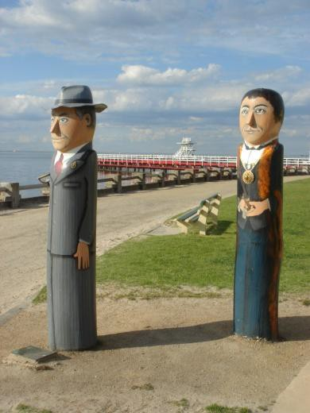


At the location where the car parking is proposed, there is an issue of surface water flowing on to the beach. It is recommended that this be examined with a view to intercepting and finding an alternative type outfall.

Project Ref: Recommendation 5

Action: Restrict and co-ordinate parking in parking zones, using cones and temporary bollards, preferably south of Seaview Terrace.

Proposed Project Partners: Meath County Council and Beach Management Committee.

Project Ref: Recommendation 6

Action: The existing Lifeguard Zone is to be relocated south to an area north of Seaview Terrace.

Proposed Project Partners: Meath County Council, Beach Management Committee,

Alternative Parking Locations
Alternative parking locations are required to ensure that haphazard and illegal parking does not become an issue in the town when the volume of parking on the beach is reduced.
The following objectives have been identified for these alternative car parking sites:
  - Good access from the local road network.
  - An adequate number of spaces must be provided.
  - MCC have control over the site or at least an agreement is in place between MCC and the owner / operator.
  - Site is within walking distance of beach or a convenient method of accessing beach can be provided.
  - It should be sustainable to provide parking on the site in the long term and offer good value for money.

Table 3.1 outlines the possible alternative parking sites which have been identified by MCC for assessment and the approximate number of spaces in these locations. It should be noted that the existing car parks, such as The Anchorage, also service existing developments and that the number of spare parking spaces in these car parks is significantly less than the capacity. Figures 3.4 to 3.6 show the location of these sites.
Table 3.1: Car Parking Locations and Approximate Parking Numbers
Location | Car Parking Numbers (Capacity)
1. Greenfield Site North* | 200-395
2. Funtasia | 174
3. Anchorage | 128
4. Tesco | 185
5. Greenfield Site South* | 270-540
6. Schools (Colaiste na hInse)* | 325
7. Schools (Scoil Oilibheir Naofa) | 46
8. Train Station Car Park | 95
9. Greenfield Site – Laytown* | 95
*Approximate - based on area of site

Figure 3.4: Existing Car Parks and Greenfield Sites in Bettystown | Figure 3.5: School Car parks in Bettystown
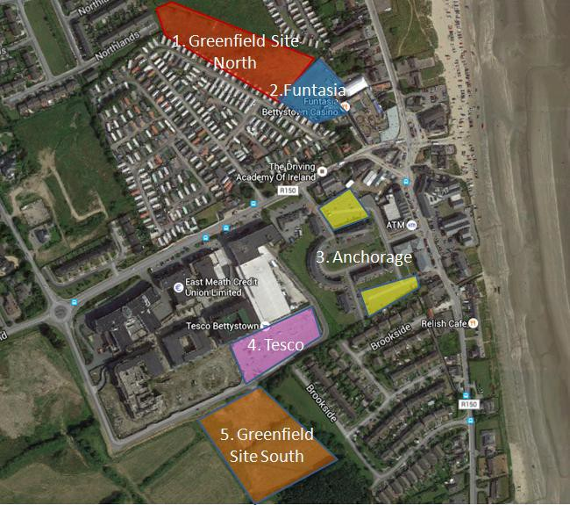
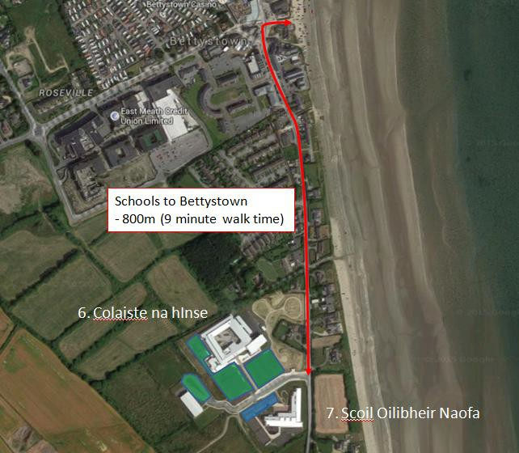
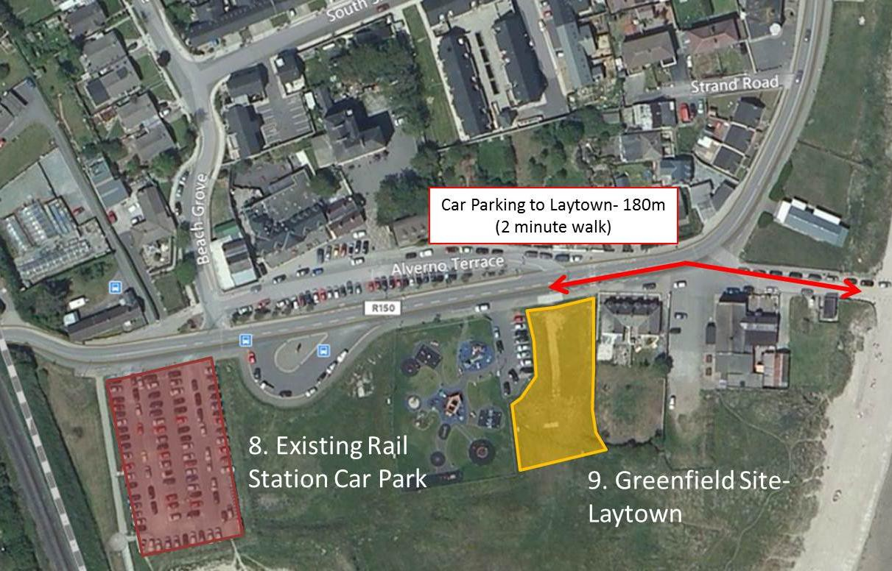
Figure 3.6: Potential Car Parking in Laytown
Table 3.2 below shows the list of sites considered as alternative parking locations in the town and whether the sites meet the objectives identified as part of this study. As shown in the Table, only the schools sites meets all five objectives, while the greenfield site in Laytown meets 4 out of 5 objectives.
Table 3.2: Objectives met by Alternative Car Parking Locations
Site / Objective | 1 | 2 | 3 | 4 | 5 | Total
Greenfield Site North* | ⇩ | ⇧ | ⇩ | ⇧ | ⇩ | 2/5
Funtasia Car park | ⇧ | ⇩ | ⇩ | ⇧ | ⇧ | 3/5
Anchorage (Two Car Parks) | ⇧ | ⇩ | ⇩ | ⇧ | ⇧ | 3/5
Tesco Car Parking | ⇧ | ⇩ | ⇩ | ⇩ | ⇧ | 2/5
Greenfield Site South* | ⇧ | ⇧ | ⇧ | ⇩ | ⇩ | 3/5
Schools (Colaiste na hInse and Scoil Oilibheir Naofa) | ⇧ | ⇧ | ⇧ | ⇧ | ⇧ | 5/5
Train Station Car Park | ⇧ | ⇩ | ⇩ | ⇧ | ⇧ | 3/5
Greenfield Site - Laytown | ⇧ | ⇩ | ⇧ | ⇧ | ⇧ | 4/5

It is anticipated that commuters will park on the beach until the number of parking spaces there is exhausted. At this time, motorists will be directed to the schools and finally, if required, the greenfield parking site in Laytown. In conjunction with this strategy, signage will need to be provided. Ideally this signage would consist of Variable Message Signs which would be used to inform drivers of parking availability in the town so they don’t automatically proceed to the beach if there are no spaces available.

School parking
The quantum of parking provided at the schools is provided below:
- Colaiste na hInse - 325 car parking spaces
- Scoil Oilibheir Naofa - 46 car parking spaces
All sites are within the control of MCC or, in the case of the schools, can be controlled in cooperation and consultation with the boards of managements of the schools. These sites also meet the other criterion in that they provide good access to/from the local road network.
Project Ref: Recommendation 7

Action: Agree and implement overspill beach parking during the summer months in the school car parks if required.

Proposed Project Partners: Meath County Council, Beach Management Committee, Department of Education, Colaiste na hInse and Scoil Oilibheir Naofa

Laytown parking
An additional option for overspill parking is to utilise the school car parks in Colaiste na hInse and Scoil Oilibheir Naofa in combination with the existing greenfield site in Laytown which is currently utilised on the day of the Laytown Races. The quantum of parking at Laytown is noted below.
- Greenfield Site / Laytown - 95 car parking spaces
This combined with the parking on the beach will be more than sufficient to accommodate the demand in most circumstances.

Project Ref: Recommendation 8

Action: Consider overspill beach parking during the summer months in the existing greenfield site in Laytown.

Proposed Project Partners: Meath County Council and Beach Management Committee.

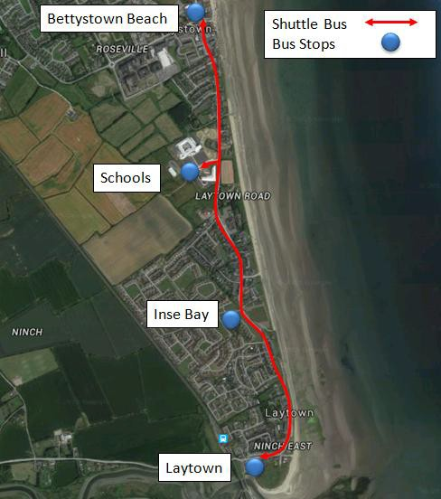
Bus service
It is noted that the site in Laytown is a significant distance from the main soft sand area in Bettystown and is outside of the distance that people would usually walk. In order to mitigate this it is proposed to provide a shuttle bus service during periods of good weather in the summer months. This bus will pick up at Laytown, Inse Bay and the schools and drop off at Bettystown. It is estimated that the shuttle bus will be required for around ten days during the summer months of July and August each year to cope with peak demand.
This bus service would be appointed through a tender process. The bus would operate in a loop and would also allow for people to be dropped down to the Laytown beach area as well as to the Bettystown beach area.

Figure 3.7: Proposed shuttle bus route

Project Ref: Recommendation 9

Action: Provide a shuttle bus to connect school carparks and Laytown parking (greenfield site) to Bettystown Beach during the summer months if required.

Proposed Project Partners: Meath County Council, Beach Managaement Committee

Car free days
It is recommended that ‘car free days’ are trialled at the beach in order to introduce the new parking strategy, in order to see how the beach, and the wider town area, operates with the beach parking removed. The aim of ‘car- free days’ would be to demonstrate to the local residents how the beach can be a more attractive and safer environment with the parking removed and to garner support for further parking restrictions on the beach in the future. These ‘car-free days’ could run concurrently with beach events such as a sand yachting competition, for example, where the car parking would be removed to facilitate the competition.

Project Ref: Recommendation 10

Action: Introduce car free days at the beach during beach events.

Proposed Project Partners: Meath County Council and Beach Management Committee.

Beach Warden
The time of year and weather very much dictates parking demand and it will be up to the Beach Manager and/or Beach Warden to coordinate with his/her staff regarding the need for additional parking provision. The Beach Manager will be responsible for checking if the good/exceptional weather is expected over the following 3/5 days and planning appropriately.
MCC staff will be required to manage the car parking at the two locations and to enforce the Foreshore Bye-Laws with regards to parking on the beach.

Project Ref: Recommendation 11

Action: The Beach Warden responsibilities should include managing and coordinating when the overspill parking is required.

Proposed Project Partners: Beach Wardens, Meath County Council and Beach Management Committee.

Litter and Waste Management
Throughout Phase 2 of the study, littering on the beach was consistently raised as an issue by local residents. Many local residents who attended the open evening are regular beach users and also volunteer litter pickers. There are currently 18 litter bins provided on the beach which are emptied on a daily basis by MCC during the summer. Figure 4.1 below is typical of the standard of bin provided by MCC on the beach. These bins are provided at the back of the beach and are primarily concentrated within the car parking area. No litter bins are provided between the Seaview Terrace entrance as far south as the Sacred Heart Church, approximately 1km in distance.
Following the review of the existing situation and the consultation process the following issues in relation to litter have been identified:
- No recycling facilities (on the beach or nearby)
- Over-flowing bins
- Horse and Dog fouling
- Litter on Beach
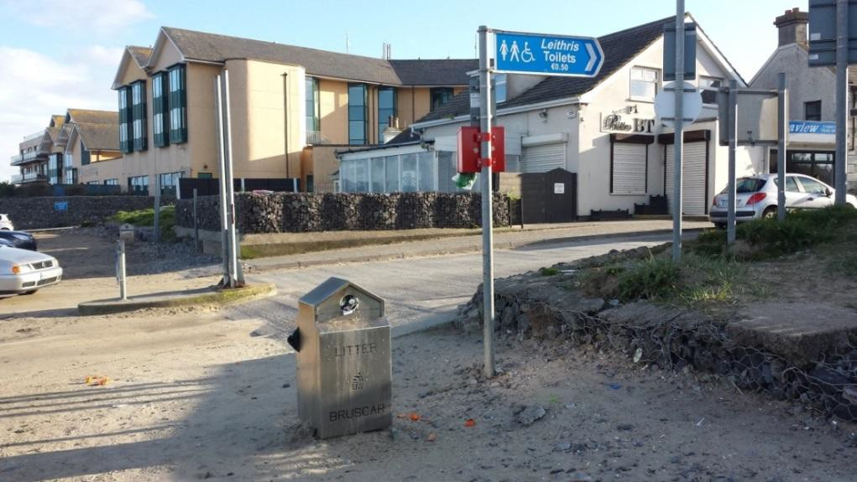

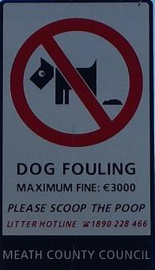
- Dumping of litter beside bins Figure 4.1: Litter Bin on Beach

Dog fouling
Dog fouling was a problem on the beach that was raised by a number of local residents during the open evening with the public. In partnership with the community, it is recommended the following measures be implemented.

Project Ref: Recommendation 12

Action: Increase the fine for dog fouling to the maximum that is permissible under the either the Section 22 of the Litter Pollution Act or MCC Foreshore Bye-Laws.

Proposed Project Partners: Meath County Council and Beach Management Committee.

Project Ref: Recommendation 13

Action: Increase enforcement of byelaws, litter and waster legislation by MCC officials and beach wardens during the summer months.

Proposed Project Partners: Beach Wardens, Meath County Council and Beach Management Committee.

Project Ref: Recommendation 14

Action: New signage campaign regarding Dog Fouling.

Proposed Project Partners: Meath County Council and Beach Management Committee.

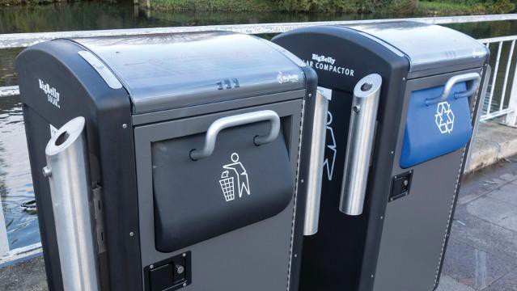

Littering
Figure 4.2: Bigbelly bins
Whilst the immediate response to litter may be to provide for more bins on the beach, these will have to be provided with a broader campaign to reduce litter on the beach. The responsibility for the creation of rubbish lies with the people who visit the beach and these people should be encourage to take their rubbish with them.

Project Ref: Recommendation 15

Action: Provide for larger capacity bins during the summer season.
Proposed Project Partners: Meath County Council.

Bins should be located on hardstanding, and provided at numerous locations north to south within the Draft Plan area, including and in particular on appropriate on-sensitive areas within the Mornington dune system. A screening for AA should be completed by MCC of proposed bin locations, where within or in the vicinity of the European site boundaries.

Project Ref: Recommendation 16

Action: Adopt ‘Leave–no-trace’ policy for the beach or for a section of the beach.
Proposed Project Partners: Meath County Council and Beach Management Committee.

Project Ref: Recommendation 17

Action: Provide for recycling facilities, either nearby or on the beach.
Proposed Project Partners: Meath County Council and Beach Management Committee.

Project Ref: Recommendation 18

Action: Encourage greater community involvement and run awareness campaigns regarding waste, litter, dog fouling etc.
Proposed Project Partners: Local community and Beach Management Committee.

Animal Control
Furthermore, it is proposed to provide a dog free zone on the beach. The dog free zone would be located in the lifeguard patrol area. This area is the most popular area for children to play. Between the hours of 11:00 a.m. and 6:00 p.m. during the Summer Season dogs should not be permitted in the lifeguard patrol area. This is similar to the beach bye laws in place in Co. Clare, which have been in place for the last 7 years. Restrictions on horses onto the beach will be considered by MCC if and when the Bye Laws are being amended.

Project Ref: Recommendation 19

Action: Prohibit dogs in the lifeguard patrol area between 11a.m. - 6p.m. during the summer months.
Proposed Project Partners: Meath County Council and Beach Management Committee.

Project Ref: Recommendation 20

Action: Control of dogs within the River Nanny Estuary and Shore SPA i.e. dogs to be leashed from September to March inclusive.
Proposed Project Partners: Meath County Council and Beach Management Committee.

Project Ref: Recommendation 21

Action: Restriction of horses from the dunes at Mornington within the Boyne Coast and Estuary SAC.
Proposed Project Partners: Meath County Council and Beach Management Committee.

Project Ref: Recommendation 22

Action: Restriction of horses from the shoreline within the Nanny Estuary and Shoreline SPA from September to March inclusive (except for the Laytown Strand Races).
Proposed Project Partners: Meath County Council and Beach Management Committee.

Signage

Existing situation
There is a wide variety of signage provided along the coastline in Laytown, Bettystown and Mornington at present on the R150 / R151 Coast Road as well as the beach itself.

Road Signage
On the Coast Road, on both the northern and southern approaches, there is an obvious lack of signage. There are also brown information signs welcoming people to Bettystown on both the northern and southern approaches to the town.
There is a lack of information signage on the approaches to the town in relation to car parking on the beach.
On the beach itself there is an assorted array of signage. Upon entrance to the beach there are a number of signs outlining the foreshore bye laws and the various restrictions on the beach. On the beach itself, there is signage specifying the 10kph speed limit and delineating the extent of the car parking area and the beginning of the Lifeguard patrol zone.
Figure 5.1: Location and Extent of Signage on the Beach
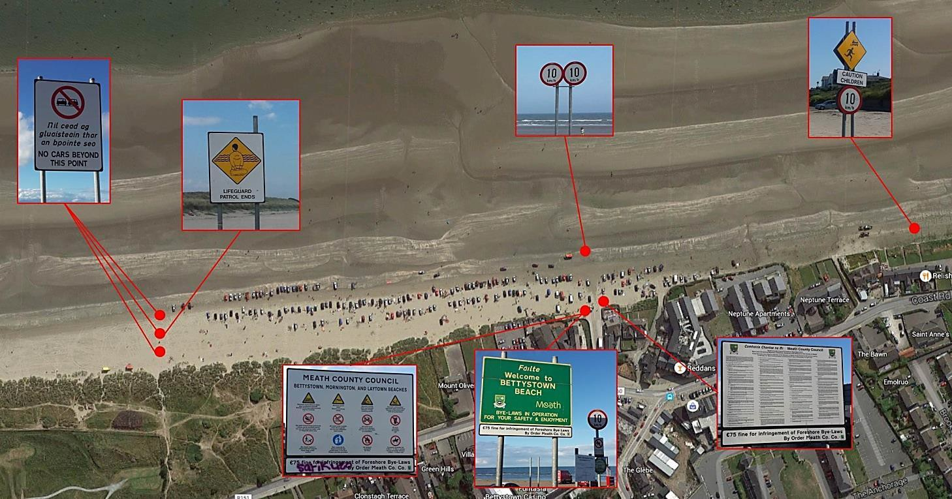

Review and Replace Existing signs
A creative illustrator and a communications consultant should be commissioned by MCC to review existing signage (Figure 5.1). This review should be conducted in close consultation with the MCC Environment Department who review the signage annually. The review should identify which signs should be removed, to include any which may be perceived over-long (and therefore are less likely to be read; e.g. the detailed sign showing all existing Bye-Laws in Figure 5.1 above; lower right hand side); and/or are deemed for other reasons unlikely to foster and promote voluntary compliance. Additional environmental signage will be considered as appropriate.

Project Ref: Recommendation 23

Action: Review existing signage and, where necessary, develop new signage incorporating 'softer', playful and/or eye-catching graphics/text phrasing, to promote a sense of stewardship and self-policing amongst beach users.
Proposed Project Partners: Meath County Council and Beach Management Committee.

Proposed information and way finding signage
The proposal for signage at Laytown, Bettystown and Mornington beach is to provide for a co-ordinated and consistent suite of signage in Bettystown. This signage would cover information signs, way finding signage and interpretative signage.
The signage must be consistent with the style of other Meath County Council interpretative signage and wayfinding signage (as recommended in the Meath Tourism Strategy).
The following signage would be provided in line with the design style of the overall signage suite:
- Wayfinding signage - with walking and cycling times
- Parking (including cycle parking)
- Bio-Diversity Interpretative signage at the following locations – Seaview Terrace, Mornington, Laytown
- Heritage Interpretative signage – Bettystown and Laytown
- Information signage at Seaview Terrace and Laytown
Some signage such as regulatory signage in relation of the Fore Shore Bye Laws and parking will have to be provided in accordance with the relevant regulatory requirements.

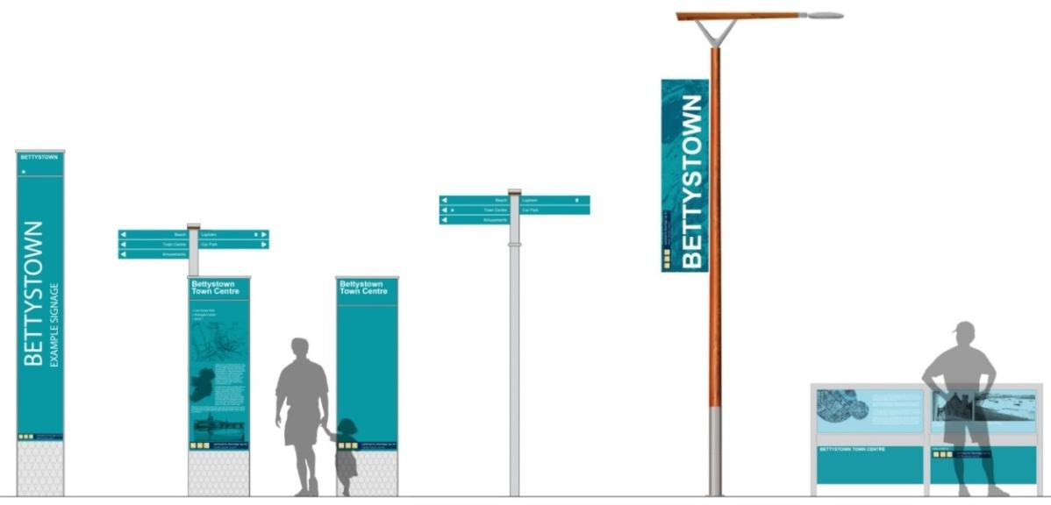
Figure 5.2: Potential Bettystown Signage

Project Ref: Recommendation 24

Action: Provide for a co-ordinated and consistent suite of signage to promote a sense of pride in the local area.

Proposed Project Partners: Meath County Council and Beach Management Committee.

Bio-diversity interpretative signage
Appropriate signage can have a significant effect on human behaviour near sensitive bird habitats. Six studies (two replicated and controlled, two before-and-after and two small studies) from across the world found increased numbers of breeders, higher reproductive success or lower levels of disturbance in waders and tems following the start of access restrictions of the erection of signs near nesting areas (Williams et al., 2017). If correctly designed, these signs can be effective in promoting compliance with reduced regulation, thereby reducing the enforcement burden on public authorities.

Project Ref: Recommendation 25

Action: Review the indicative locations for signage and ensure signage pertaining to the Nanny River Estuary and Shore SPA is located at the point of entry into, and within the site.

Proposed Project Partners: Meath County Council and Beach Management Committee.

Beach Tourism and Activities
Laytown, Bettystown and Mornington Beach possesses significant potential as a destination for beach tourism and beach activities and events. The beach itself is already extremely popular with beach goers. Anecdotally as well as from consultation, it is clear that potential exists to attract a different kind of user to the beach, a more active beach goer who wants to exploit its potential as a destination to participate in beach events.
With its lengthy, uninterrupted stretch of sandy beach it is considered to have significant, currently unexploited potential as a destination for leisure events such as sand yachting and kite landboarding. These types of events are already held successfully in other locations in Ireland such as on Dollymount Strand.
There are a number of events which take place on Bettystown Beach throughout the year. These include the following;
- Sand yachting – held Feb/March
- Cricket Ireland Competition (held midsummer)
- Sand Castle Competition – held June
- Laytown Horse Races – held 10th September.
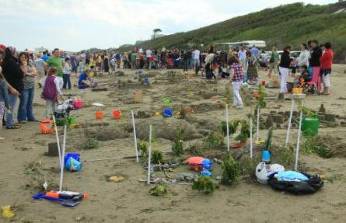
Sand castle building took place in June 2015, on the same weekend a beach cricket competition took place. Figure 6.1: Sandcastle Building Competition on Bettystown Beach in 2011

Beach Activities
The following potential future opportunities for tourism and activities on the beach were identified during the development of the BMP:
Proposed Project Partners: Beach Warden, Meath County Council and Beach Management Committee.
Eco-tourism Kiting – festivals Fishing Volleyball Sailing
Sand yachting Sandcastles
Bird watching with the erection of bird watching huts/stands
Provision of space for clubs to meet/change etc
•
•
•
•
•
•
•
•
Car Free Days
Canoeing with jetties on the River Nanny Beach Football
Creating designated area for sports
Swimming lessons / Life-saving programs for all Attraction of Maidens Tower of Mornington
East Coast Cycle Route Tara Brooch
Greenway Mornington to Drogheda Fishing
Triathlons
•
•
•
•
•
•
•
•
•
•
•
Project Ref: Recommendation 26

Action: Increase beach tourism and activities in spring and summer only (April to August inclusive), outside the wintering bird season), including:

Blue Flag Status
The Blue Flag programme is operated by An Taisce on behalf of the international, non-governmental, non-profit organisation the Foundation for Environmental Education (FEE). A Blue Flag is awarded to beaches that comply with 33 criteria under the following headings:
- Environmental Education & Information Provision;
- Water Quality;
- Environmental Management; and
- Safety & Services.
It is understood that a previous application was made for a Blue Flag for Bettystown Beach in February 2007. The application was subsequently withdrawn in March 2007 due to opposition amongst local residents and business owners to the restriction of parking on the beach, which was proposed in the application. The following sets out the current identified obstacles for Laytown, Bettystown and Mornington beaches in achieving Blue Flag status.
Identified Obstacles - The criteria for awarding Blue Flag status are presented in a document entitled “Blue Flag Beach Criteria and Explanatory Notes 2015”, available from the website www.blueflagireland.org, run by An Taisce. A table presenting all 33 criteria required to achieve Blue Flag status and whether potential obstacles were identified to satisfying these criteria is presented in the Appendix E. As outlined in the table, potential obstacles were identified for two of the listed criteria. These are discussed further below.
Water Quality – Clarifications from An Taisce are required in relation to the period of water quality data that is needed to demonstrate compliance with Criteria 2.10. In addition, it is likely that water quality data will be required from surface water discharge points to the sea along the beach.
Environmental Management - Any future plans for the beach will need to address the prevention of damage to the local natural environment. This will likely comprise measures to limit parking on the beach and limit access to the dune system.
Clarification from An Taisce should be sought in relation to the identified obstacles. Following on from this, a programme of works can be developed to address data gaps and prepare for a Blue Flag application.

Blue Flag requirements
The potential opportunities to achieve a blue flag include:

Project Ref: Recommendation 27

Action: Maintain high quality water.
Proposed Project Partners: Meath County Council and Beach Management Committee.

Project Ref: Recommendation 28

Action: Implement a phased removal of parking from the beach. These proposals will reduce and manage the parking on the beach, with the future aim of removing all parking on the beach in the future.
Proposed Project Partners: Meath County Council and Beach Management Committee.

Project Ref: Recommendation 29

Action: Limit the access to the dunes in Mornington by closing off the vehicular access to the parking area to better control and manage vehicle movements in the area. Consider providing a limited number of car parking spaces on the adjacent road.
Proposed Project Partners: Meath County Council and Beach Management Committee.
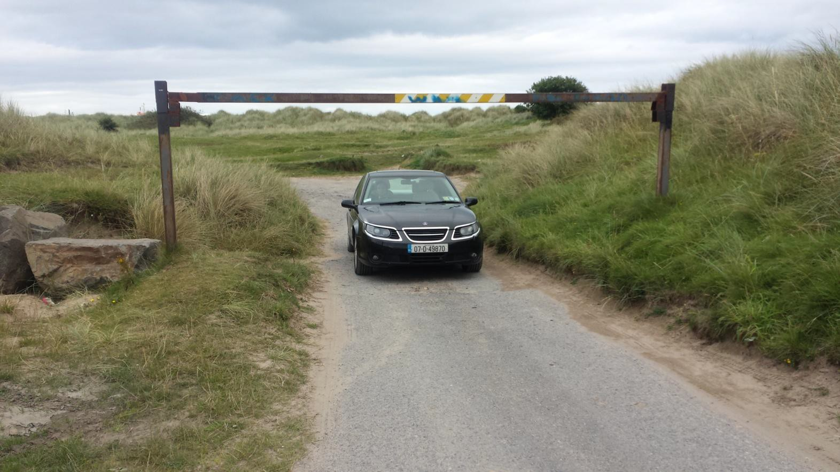
Figure 7.1: Existing Access to Mornington Beach should be closed off to vehicular traffic

Recommendations summary

Project Ref. | Recommendation | Action
Recommendation 1 | Improve Beach access | Purchase houses on Seaview Terrace and provide a range of amenities within a custom built building. Develop community facilities at Seaview Terrace.
Recommendation 2 | Improve Beach access | Examine creation of a one way system for beach traffic during busy periods.
Recommendation 3 | Improve Beach access | Examine Access Controls to the beach.
Recommendation 4 | Beach parking management | Complete, but phased removal of parking from the Mornington/Bettystown/Laytown beach, subject to the availability of appropriate alternative parking.
Recommendation 5 | Beach parking management | Restrict and co-ordinate parking in parking zones, using cones and temporary bollards, preferably south of Seaview Terrace.
Recommendation 6 | Beach parking management | The existing Lifeguard Zone is to be relocated south to an area north of Seaview Terrace.
Recommendation 7 | Beach parking management | Agree and implement overspill beach parking during the summer months in the school car parks if required.
Recommendation 8 | Beach parking management | Consider overspill beach parking during the summer months in the existing greenfield site in Laytown.
Recommendation 9 | Beach parking management | Provide a shuttle bus to connect school carparks and Laytown parking (greenfield site) to Bettystown Beach during the summer months, if required.
Recommendation 10 | Beach parking management | Introduce car free days at the beach during beach events.
Recommendation 11 | Beach parking management | The Beach Warden responsibilities should include managing and coordinating when the overspill parking is required.
Recommendation 12 | Tackle dog fouling | Increase the fine for dog fouling to the maximum that is permissible under the either the Section 22 of the Litter Pollution Act or MCC Foreshore Bye-Laws.
Recommendation 13 | Tackle dog fouling | Increase enforcement of byelaws, litter and waster legislation by MCC officials and beach wardens during the summer months.
Recommendation 14 | Tackle dog fouling | New signage campaign regarding Dog Fouling
Recommendation 15 | Litter management | Provide for larger capacity bins during the summer season.
Recommendation 16 | Litter management | Adopt ‘Leave–no-trace’ policy for the beach or for a section of the beach.
Recommendation 17 | Litter management | Provide for recycling facilities, either nearby or on the beach.
Recommendation 18 | Litter management | Encourage greater community involvement and run awareness campaigns regarding waste, litter, dog fouling etc.
Recommendation 19 | Implement animal control | Prohibit dogs in the lifeguard patrol area between 11a.m. - 6p.m. during the summer months.
Recommendation 20 | Implement animal control | Control of dogs within the River Nanny Estuary and Shore SPA i.e. dogs to be leashed from September to March inclusive.
Recommendation 21 | Implement animal control | Restriction of horses from the dunes at Mornington within the Boyne Coast and Estuary SAC.
Recommendation 22 | Implement animal control | Restriction of horses from the shoreline within the Nanny Estuary and Shoreline

 |  | SPA from September to March inclusive (except for the Laytown Strand Races).
Recommendation 23 | Improve signage | Review existing signage and, where necessary, develop new signage incorporating 'softer', playful and/or eye-catching graphics/text phrasing, to promote a sense of stewardship and self-policing amongst beach users.
Recommendation 24 | Improve signage | Provide for a co-ordinated and consistent suite of signage to promote a sense of pride in the local area.
Recommendation 25 | Improve signage | Review the indicative locations for signage and ensure signage pertaining to the Nanny River Estuary and Shore SPA is located at the point of entry into, and within the site.
Recommendation 26 | Increase beach tourism and activities in spring and summer only (April to August inclusive), outside the wintering bird season), | Organise beach events, including: Car Free Days  Canoeing with jetties on the River Nanny Beach Football  Creating designated area for sports.  Swimming lessons / Life-saving programs for all. Attraction of Maidens Tower of Mornington  East Coast Cycle Route Tara Brooch  Greenway Mornington to Drogheda Fishing  Triathlons Eco-tourism  Kiting – festivals Volleyball Sailing  Sand yachting Sandcastles  Bird watching with the erection of bird watching huts/stands.  Provision of space for clubs to meet/change etc.
Recommendation 27 | Achieve blue flag status | Maintain high quality water.
Recommendation 28 | Achieve blue flag status | Implement the car parking proposals as outlined in this Recommendations appendix. These proposals will reduce and manage the parking on the beach, with the future aim of removing all parking on the beach in the future.
Recommendation 29 | Achieve blue flag status | Limit the access to the dunes in Mornington by closing off the vehicular access to the parking area to better control and manage vehicle movements in the area.  Consider providing a limited number of car parking spaces on the adjacent road.

1
Laytown, Bettystown & Mornington Beach Management Plan

Prepared for: Meath County Council AECOM
25
1
1
1
1
1
1
1
1
1 Appendix B: Complaints Procedure 1

1
1
1
1
1
1
1
1
1

1
1
1
1
Laytown, Bettystown & Mornington Beach Management Plan

Meath County Council Complaints Procedure
Meath County Council is committed to delivering the best possible care to our customers. Above all else, people expect and deserve courtesy, sensitivity, a unique response to their needs and the minimum delay when contacting their County Council. However, it is recognized that there may be, from time to time, cause for complaint.

You have the right to complain if you feel:
- You have been unfairly treated by Meath County Council
- That a service to which you are entitled is not being provided
- That a service, that is being provided, is inadequate
- That a decision made with regard to you is wrong or did not take into consideration all of the facts
- That a request for service / information has been ignored.
This Complaints Handling Procedure aims to ensure that any and all complaints are deal with in a consistent, equitable and transparent manner.
Customer Complaints Procedure
Stage 1 - A customer who is dissatisfied with a service from Meath County Council should make contact with the relevant department. As far as possible, we will try to resolve any issues at this stage.
Stage 2 - If issues are not resolved at Stage 1, a customer may lodge a formal complaint. Complaints should be submitted in writing or by email to the Complaints Officer, Corporate Services, Meath County Council, County Hall, Navan, County Meath or by email to customerservice@meathcoco.ie
Stage 3 - Complaints will be acknowledged within one week of receipt.
Stage 4 - Customer complaints will be investigated by the Complaints Officer.
- A response will issue within four weeks of receipt of a complaint. Where this is not possible, an interim reply will issue setting out the reasons for the delay.
- Where a complaint relates to a specific staff member, that staff member will be consulted in relation to the complaint.
- Where a mistake has been made, an apology and explanation will be offered and every effort made to rectify the matter.
- Where a complaint highlights deficiencies in our processes or procedures, every effort will be made to remedy the situation as quickly as possible.
Stage 5 - If you are unhappy with the response you receive to your complaint, you can refer your complaint to the Office of the Ombudsman. By law, the Ombudsman can investigate complaints about any of our administrative actions or procedures as well as delays or inaction on our behalf. TheOmbudsman provides a free, impartial and independent dispute resolution service. The contact details for the Office of the Ombudsman are:
Office of the Ombudsman 18 Lower Leeson Street Dublin 2
Tel: Lo-call 1890 22 30 30
Tel: 01 639 5600
Email: ombudsman@ombudsman.gov.ie Web: www.ombudsman.ie

Prepared for: Meath County Council AECOM
26
Laytown, Bettystown & Mornington Beach Management Plan

Prepared for: Meath County Council AECOM
27

Appendix C: Risk Assessment Template
Laytown, Bettystown & Mornington Beach Management Plan

Meath County Council Risk Assessment Template

Risk Assessment |  |  |  |  |  | RA No.
Section / Location: |  |  |  |  |  | Revision No.
Description of the job / task / activity:
 |  | Current Risk |  |  |  |  | Revised Risk
Hazard and Risk | Risk Group | L x S | RR | Control Measures | Responsible Person |  | L x S |  | RR

Prepared for: Meath County Council AECOM
28
Earlsfort House, Earlsfort Terrace, Dublin 2

Prepared for: Meath County Council AECOM
29

Appendix D: Contacts List

Earlsfort House, Earlsfort Terrace, Dublin 2

Name | Organisation | Role | Phone | Email

Prepared for: Meath County Council AECOM
30
Earlsfort House, Earlsfort Terrace, Dublin 2

Prepared for: Meath County Council AECOM
31

Appendix E: Blue Flag Criteria

