FAQs

What is the Navan Cycle Scheme?
The Navan Cycle Scheme comprises of pedestrian and cycle routes identified as being of strategic importance to the town of Navan in the 2013 Greater Dublin Area Cycle Network Plan published by the National Transport Authority (NTA). Within the 2013 Greater Dublin Area Cycle Network Plan, Route NA3 begins at Circular Road in Navan Town Centre transiting the Convent Road and R153 until turning off the R153 to link up with the M3 inter urban route linking Navan to Drogheda. The portion of Route NA3 identified as part of this Scheme is between the Convent Road tie-in and the Athlumney Road/Metges Road Junction.

What is the main purpose of the scheme?
The proposed Scheme sees the continued improvement of cycling provision in Navan Town and will support the ever-growing network of safe and sustainable cycling infrastructure in the town. This network is hoped to reduce the dependency on cars in both Navan, and the wider County Meath. By promoting sustainable transport, the scheme plays a vital role in combatting climate change and fostering eco-friendly transport trends in Navan and the Greater Dublin Area (GDA).

What is happening now?
The NA3 scheme is currently at Phase 2 Concept Design and Option Development. Following the Option Assessment and Identification process, the project team has now selected an Emerging Preferred Route for Convent Road to Metges Road and will present the concept design for this at the non-statutory public consultation.

What are we consulting on?
Meath County Council now wishes to consult with the public on the Convent Road to Metges Road Emerging Preferred Route. The proposed route will deliver high quality cycle and pedestrian facilities and improved public realm amenities along a 1.4km route corridor from the Convent Road to Athlumney Road/Metges Road Junction. The Emerging Preferred Route will link the Convent Road Filtered Permeability Scheme to the Metges Road Junction to the east of Navan town. The Emerging Preferred Route shall introduce improved cycling and pedestrian infrastructure between Convent Road and Metges Road with new 2-way cycle tracks running for the majority of the route.
The Emerging Preferred Route corridor is shown in the Route Corridor Map below.
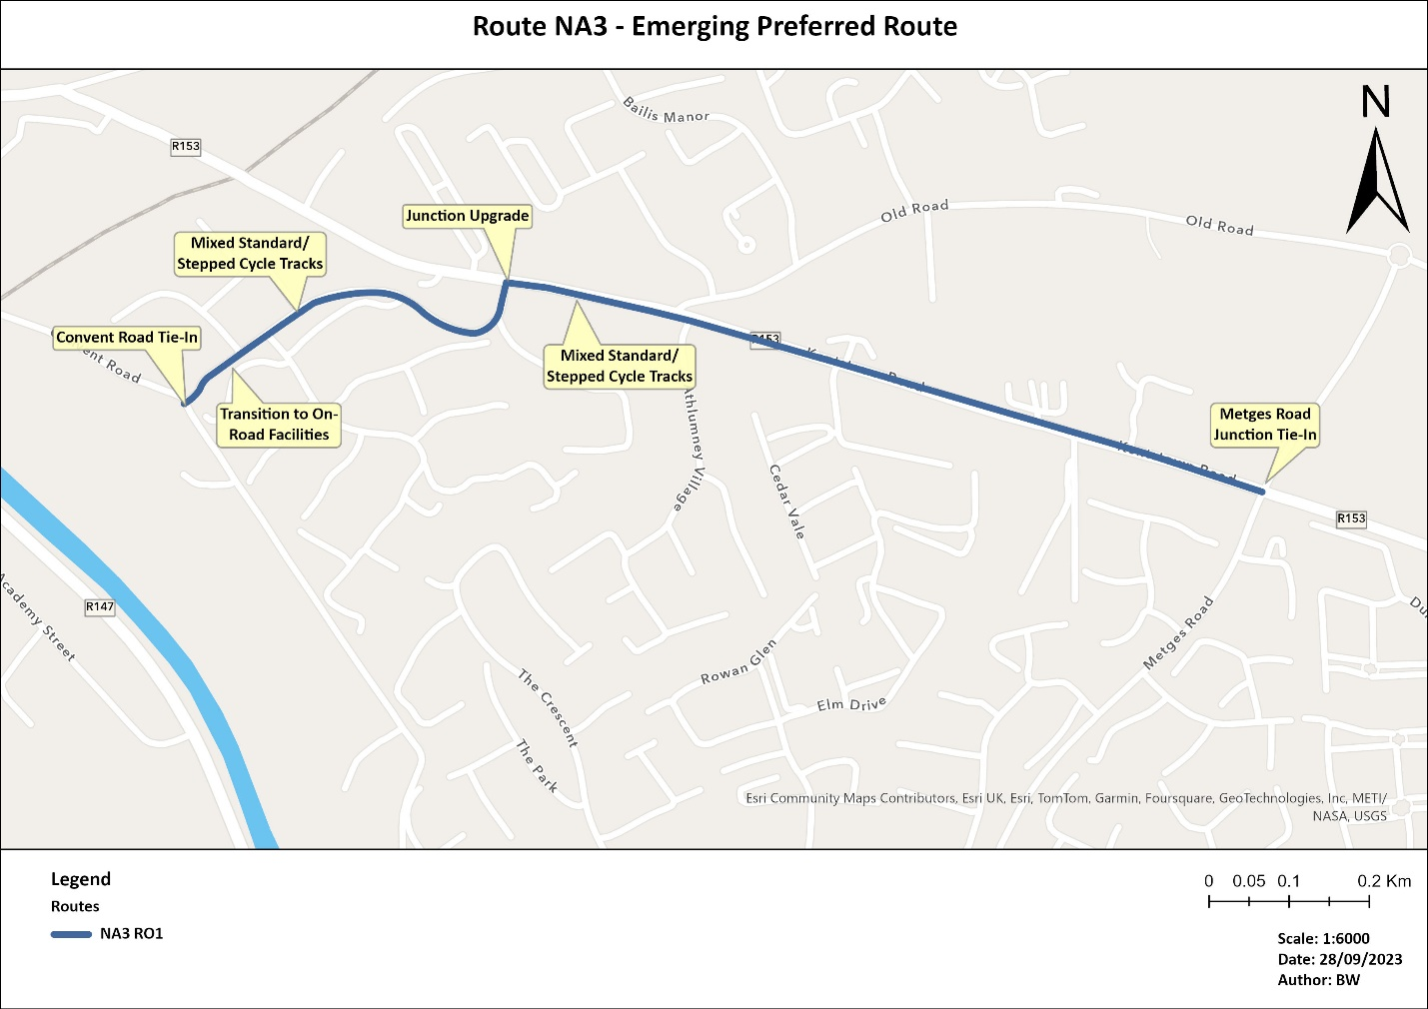

What is an Emerging Preferred Route?
The Emerging Preferred Route is the route which has been assessed to have the best combination of benefits and impacts for this project. The route has been found through analysis and appraisal by an experienced engineering team and is now subject to local feedback and comment. Once local stakeholders have contributed their knowledge and say to the emerging preferred route, feedback can be taken onboard, and the preferred route formed.

What are we doing with the consultation feedback?
All feedback will be reviewed by the Navan Cycle Scheme Project Team. Submissions received will be acknowledged but will not be individually responded to and will be summarised in a post-consultation report. Submissions from individuals will be reported anonymously and feedback from organisations will be attributed to them. This report will be used to demonstrate how consultation was considered as part of the development of the cycle scheme process and will be submitted as part of the Planning application.
Feedback received outside the scope of the Navan Cycle Scheme will be identified as such in the post-consultation report and not considered as part of this public consultation process.
Meath County Councils privacy notice can be viewed here.

Will there be further opportunity to comment on the scheme?
Following the Emerging Preferred Route Non-Statutory Public Consultation, submissions received will be reviewed and considered by the project team when developing the Preferred Route. Later in 2024, there will be a Statutory public consultation on the Preferred Route (Planning Application) where stakeholders will have another opportunity to provide feedback on the scheme. Stakeholders will be notified via Meath County Councils main communication channels once the dates for the Preferred Route Statutory Public Consultation have been confirmed.

What surveys have been conducted?
The following surveys have been completed:
- Topographical Surveys
- Traffic Surveys
- Ecological Surveys

How will the project/construction affect residents in the area?
While this project is expected to be of relatively low impact for a cycle scheme, there will still be localized disruption to footpaths and entrances which are along the route footprint. The construction of this scheme will be phased and managed in a manner to limit local impact and maintain constant access for residents to and from their homes.

How is the scheme addressing environmental considerations?
The Scheme seeks to make a transition to sustainable modes of walking and cycling a more attractive prospect and reduce the impact of emissions from private vehicles in the local area through this transition.

What happens next?
A non-statutory public consultation on the Emerging Preferred Route will run for 4 weeks from Wednesday 6th March to Wednesday 3rd April 2024. Following this non-statutory public consultation, submissions received will be reviewed and summarised in a post-consultation report. Feedback from stakeholders will be considered by the project team when developing the Preferred Route which will be consulted on later in 2024.

How is the project being funded?
The Scheme is funded by the Department of Transport through the National Transport Authority.

How long will this stage of the project take?
The following is currently the timeline foreseen:
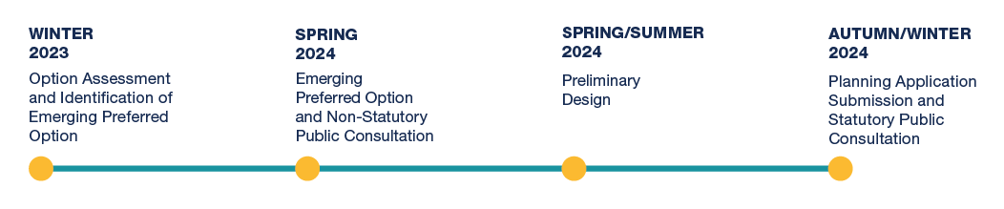

How can I get in contact with the project team?
If you have a query about the scheme, you can contact the Navan Cycle Scheme Project Team by:
- Email: activetravel@meathcoco.ie
- Phone: (046) 9097150

How will the local community benefit?
The scheme will have the following benefits for local community:
- Improve local access for cyclists and pedestrians from Navan Town Centre to residential areas to the east of Navan.
- Improve cycle and pedestrian safety.
- Create a sustainable mode of active-travel access to the primary and secondary schools in the greater urban area of Navan.
- Provide a consistent and coherent standard of cycle facilities into Navan Town Centre
- Improve pavement quality and width, increasing comfort for cyclists.
- Provide safe and convenient junction layouts for pedestrians and cyclists.
- Provide additional recreational links by linking the local communities to future Greenway and Cycling routes for Navan.
- Deliver an optimum level for the management of traffic in and out of Navan which shall assist in the transition of a modal shift from the use of private vehicles and contribute to the achievement of the targets set out in the Climate Action Plan 2021.
- Contribute towards the aims and goals of the ‘National Sustainable Mobility Policy 2022’ in delivering additional daily active travel and public transport journeys and achieving a reduction in kilometers driven by fossil-fuel powered vehicles.

Will access to private land be required?
Where access to private land is required, landowners will be contacted to arrange necessary details and permissions prior to access.

How do I find out more information?
If you would like further information on the scheme, please visit: https://consult.meath.ie.

